**The Virginia Tech Roller Rig: Commissioning Report**

|  |  |
| --- | --- |
| Milad Hosseinipour  Research Assistant | Mehdi Ahmadian  Professor and Director |



Railway Technologies Laboratory,

Center for Vehicle Systems and Safety,

Mechanical Engineering Department,

Virginia Tech,

Blacksburg, VA

Contents

[Chapter 1. Introduction 1](#_Toc455075605)

[Chapter 2. Delivered Mechanical Setup 4](#_Toc455075606)

[2.1 Floor Plate 4](#_Toc455075607)

[2.1.1 Floor Plate Design 4](#_Toc455075608)

[2.1.2 Floor Plate Functionality 6](#_Toc455075609)

[2.2 Load Frame 7](#_Toc455075610)

[2.2.1 Frame Design 8](#_Toc455075611)

[2.2.2 Structural and Modal Analysis 9](#_Toc455075612)

[2.2.3 Functionality 11](#_Toc455075613)

[2.3 Positioning Systems 12](#_Toc455075614)

[2.3.1 Angle of Attack (AoA) Positioning System 12](#_Toc455075615)

[2.3.2 Lateral Positioning System 17](#_Toc455075616)

[2.3.3 Cant Angle Positioning System 20](#_Toc455075617)

[2.3.4 Vertical Positioning System 22](#_Toc455075618)

[2.4 Powertrain 23](#_Toc455075619)

[2.4.1 Component Selection 24](#_Toc455075620)

[2.4.2 Rotational Bodies 33](#_Toc455075621)

[2.4.3 Linear Actuators 37](#_Toc455075622)

[Chapter 3. Delivered Electromechanical Systems 41](#_Toc455075623)

[3.1 Power Architecture 41](#_Toc455075624)

[3.1.1 Mains Network 41](#_Toc455075625)

[3.1.2 Isolating Transformer 44](#_Toc455075626)

[3.1.3 Power Filtering 47](#_Toc455075627)

[3.1.4 DC Power 49](#_Toc455075628)

[3.1.5 DC-Bus 51](#_Toc455075629)

[3.2 Grounding 52](#_Toc455075630)

[3.2.1 Star Ground Topology 52](#_Toc455075631)

[3.2.2 Shield Grounding 54](#_Toc455075632)

[3.2.3 Additional Measures 56](#_Toc455075633)

[3.3 Safety and Monitoring 57](#_Toc455075634)

[3.3.1 Safe-Torque-OFF (STO) Safety Circuit 61](#_Toc455075635)

[3.3.2 Hardware Enable Safety Circuit 63](#_Toc455075636)

[3.3.3 Ready-to-Operate (RTO) Safety Function 64](#_Toc455075637)

[3.3.4 Logic ON-OFF 66](#_Toc455075638)

[3.3.5 Dynamic Braking 67](#_Toc455075639)

[3.3.6 Holding Brake 72](#_Toc455075640)

[3.3.7 Emergency Stop 74](#_Toc455075641)

[3.4 Noise Attenuation 77](#_Toc455075642)

[3.4.1 Material Selection 81](#_Toc455075643)

[3.4.2 Models 82](#_Toc455075644)

[3.4.3 Simulations 84](#_Toc455075648)

[3.4.4 Implementation and Experimental Results 93](#_Toc455075649)

[Chapter 4. Commissioned Capabilities of the Virginia Tech Roller Rig 97](#_Toc455075650)

[4.1 Novel Motion Control and Data Acquisition Architecture: Fast, Low-Noise, High-Performance, and Plug-n-Play 97](#_Toc455075651)

[4.1.1 Motion Controller 106](#_Toc455075652)

[4.1.2 Data Acquisition Units 107](#_Toc455075653)

[4.1.3 Network Update Rate 112](#_Toc455075654)

[4.2 Flexible Motion Programming Interface (MPI) 115](#_Toc455075655)

[4.2.1 High-Level Motion Programming Interfaces 118](#_Toc455075656)

[4.2.2 Packet Timing 123](#_Toc455075657)

[4.3 Precise Independent Velocity Control 124](#_Toc455075658)

[4.3.1 Roller Rig Demand Modes 125](#_Toc455075659)

[4.3.2 Servo Tuning 129](#_Toc455075660)

[4.3.3 D-Rate 143](#_Toc455075661)

[4.4 Precise Wheel-Rail Positioning 143](#_Toc455075662)

[4.4.1 Scaling PID Parameters for Different Controller Update Rates 152](#_Toc455075663)

[4.5 Accurate Measurement of Contact Forces and Moments 152](#_Toc455075664)

[4.6 Accurate Torque Measurement 162](#_Toc455075665)

[4.7 Unified Operating User Interface for Non-Electrically Certified Personnel 168](#_Toc455075666)

[4.8 Hardware-In-The-Loop Testing Infrastructure 169](#_Toc455075667)

[Chapter 5. Realizable Tests with the Virginia Tech Roller Rig 173](#_Toc455075668)

[5.1 Precise Measurement of Creep-Creepage Curves 173](#_Toc455075669)

[5.2 Accurate Measurement of Contact Geometry 174](#_Toc455075670)

[5.3 Precise Evaluation of Third Body Layers 174](#_Toc455075671)

[5.4 Dynamic Creepage Analysis 174](#_Toc455075672)

[5.5 Wheel-rail Vibration Analysis 175](#_Toc455075673)

[5.6 Wheel-Rail Wear Analysis 175](#_Toc455075674)

[5.7 Derailment Mechanics 176](#_Toc455075675)

[5.8 Hardware-in-the-loop (HIL) Operation 176](#_Toc455075676)

[Chapter 6. References 178](#_Toc455075677)

List of Figures

[Figure ‎1‑1: Final design of the VT Roller Rig. Arrows indicate the adjustable degrees of freedom 1](#_Toc455075464)

[Figure ‎1‑2. The final enclosure for the control tower of the VT Roller Rig 2](#_Toc455075465)

[Figure ‎2‑1: T-slotted floor plate and its solid model showing bi-directional t-slots on top surface and reinforced ribbing structure at the bottom 5](#_Toc455075466)

[Figure ‎2‑2: Left: 28H12 T-slots and clamping hardware including T-nuts, stud, nut, triangular lock, and clamp strap for mounting components on the floor plate. Right: Precision bubble leveler used for leveling the floor plate 5](#_Toc455075467)

[Figure ‎2‑3: VRC wedge-mount precision levelers manufactured by AirLoc [4] 6](#_Toc455075468)

[Figure ‎2‑4: Structural analysis of the mounting plate for evaluating the performance (static deflection of plate) of wedge-mounts using ABAQUS 6](#_Toc455075469)

[Figure ‎2‑5: Finite element analysis of the floor plate using ABAQUS 7](#_Toc455075470)

[Figure ‎2‑6: Solid model and fabricated reaction load frame 9](#_Toc455075471)

[Figure ‎2‑7: The wire frame model of reaction load frame in ABAQUS using beam elements 10](#_Toc455075472)

[Figure ‎2‑8: The angular position of the wheel about the rail known as angle of attack (AoA) 13](#_Toc455075473)

[Figure ‎2‑9: Schematic drawing of the cross roller ring manufactured by THK [6] 14](#_Toc455075474)

[Figure ‎2‑10: Solid model of the AoA and lateral positioning systems, and their actuation mechanisms. Green arrows indicate the lateral and AoA degrees of freedom 14](#_Toc455075475)

[Figure ‎2‑11: Left: Solid model of the rig. Right: Schematic drawing of the rig that shows how the contact forces are reacted at the lateral positioning system, AoA positioning system, and vertical positioning system 15](#_Toc455075476)

[Figure ‎2‑12: Free body diagram of AoA and lateral positioning systems 16](#_Toc455075477)

[Figure ‎2‑13: The linear position of the wheel about the rail known as lateral displacement 18](#_Toc455075478)

[Figure ‎2‑14: Schematic drawing of the caged ball LM guides [6] 19](#_Toc455075479)

[Figure ‎2‑15: The vertical inclination of the wheelset about the rail is known as cant angle 20](#_Toc455075480)

[Figure ‎2‑16: Schematic drawing of the designed cradle and rotating mechanism for providing the cant angle motion. Green arrows indicate the vertical and cant degrees of freedom 21](#_Toc455075481)

[Figure ‎2‑17: The wire frame model of the cradle in ABAQUS using beam elements 22](#_Toc455075482)

[Figure ‎2‑18: Front (left) and rear (right) views of the rig showing hardware development and assembly 23](#_Toc455075483)

[Figure ‎2‑19: Schematic drawing of basic drive circuit for AC servomotors [2] 25](#_Toc455075484)

[Figure ‎2‑20: Key design features of Kollmorgen’s permanent magnet synchronous machine [8] 26](#_Toc455075485)

[Figure ‎2‑21: Exploded view of the AC synchronous servomotor [8] 26](#_Toc455075486)

[Figure ‎2‑22: Performance curve for AKM84T servomotor [8] 27](#_Toc455075487)

[Figure ‎2‑23: Picture of S772 servo drive offered by Kollmorgen [9] 28](#_Toc455075488)

[Figure ‎2‑24: Left) Wiring diagram of the S772 servo drives [9]. Right) Installed S772 servo-drives controlling the servomotors that drive the wheel and roller drivelines 29](#_Toc455075489)

[Figure ‎2‑25: BDB330 precision gearbox offered by Mijno [10] 30](#_Toc455075490)

[Figure ‎2‑26: Unique features of the UT018-005 true planetary gearhead offered by Micron [11] 31](#_Toc455075491)

[Figure ‎2‑27: Left) Double row spherical roller bearing. Middle) Pillow block spherical roller bearing FSYE series selected for the rig and offered by SKF [12]. Right) Installed roller driveline’s bearing 32](#_Toc455075492)

[Figure ‎2‑28: Schematic of Concentra mounting design configuration [12] 32](#_Toc455075493)

[Figure ‎2‑29: The detailed drawing of AREMA 136-lbs RE rail section [13] 34](#_Toc455075494)

[Figure ‎2‑30: Left: Fenner Drive Keyless Locking Device functions as a mechanical interference fit. Right: A simple wedge principal used to apply a uniform pressure distribution [14] 35](#_Toc455075495)

[Figure ‎2‑31: Roller driveline during assembly process 35](#_Toc455075496)

[Figure ‎2‑32: Left) The detailed drawing of AAR-1B wide-flange wheel profile. Right) Fabricated wheels with flat cylindrical and AAR-1B profiles 36](#_Toc455075497)

[Figure ‎2‑33: Solid model (top) and installed hardware (bottom) of the roller (left) and wheel (right) drivelines 37](#_Toc455075498)

[Figure ‎2‑34: Left) EC4 electric cylinder incorporates an AKM servomotor and a ballscrew to control the linear motion precisely. Right) Installed AKD servo drives controlling six electric cylinders that control the motion of positioning systems 38](#_Toc455075499)

[Figure ‎2‑35: Cut-away drawing of the EC series electric cylinders with the key design features [15] 38](#_Toc455075500)

[Figure ‎2‑36: The thrust-speed performance curve for the AKM52G servomotors [15] 39](#_Toc455075501)

[Figure ‎2‑37: Hall-effect end-of-travel sensors for signaling the end of stroke for EC4 cylinders [15]. Right) Installed Hall-effect sensor in action 40](#_Toc455075502)

[Figure ‎3‑1. TN-C System 42](#_Toc455075503)

[Figure ‎3‑2. TN-CS System 42](#_Toc455075504)

[Figure ‎3‑3. TN-S System 43](#_Toc455075505)

[Figure ‎3‑4. AEP specifications for 600A to 800A service upgrade [19] 44](#_Toc455075506)

[Figure ‎3‑5. Application of an isolating transformer [9] 47](#_Toc455075507)

[Figure ‎3‑6. Schaffner FN 258-100-35 filter and its block diagram [23] 49](#_Toc455075508)

[Figure ‎3‑7. Uninterruptible auxiliary DC power system of the VT Roller Rig 50](#_Toc455075509)

[Figure ‎3‑8. Parallel connection of DC power systems for redundancy [24] 51](#_Toc455075510)

[Figure ‎3‑9. DC-Bus link topology. The actual DC-Bus link is marked in red 52](#_Toc455075511)

[Figure ‎3‑10. Correct star ground connection (left) versus incorrect daisy chain ground (right) [25] 53](#_Toc455075512)

[Figure ‎3‑11. Earth resistance testing 54](#_Toc455075513)

[Figure ‎3‑12. Coupled noise source due to connection between ground earth and neutral line 56](#_Toc455075514)

[Figure ‎3‑13. The enclosure for the control tower of the VT Roller Rig 57](#_Toc455075515)

[Figure ‎3‑14. Wiring example for stop Category 0 [9] 58](#_Toc455075516)

[Figure ‎3‑15. Wiring example for stop Category 1 [9] 59](#_Toc455075517)

[Figure ‎3‑16. Wiring example for stop Category 2 [9] 59](#_Toc455075518)

[Figure ‎3‑17. Comparison between stop categories 60](#_Toc455075519)

[Figure ‎3‑18. Dual-channel SIL CL2/PLd Cat3 STO control circuit for eight axes 62](#_Toc455075520)

[Figure ‎3‑19. Hardware Enable control circuit for eight axes 64](#_Toc455075521)

[Figure ‎3‑20. RTO intermittent circuit 66](#_Toc455075522)

[Figure ‎3‑21. Logic ON-OFF and Emergency Stop circuits for the VT Roller Rig 67](#_Toc455075523)

[Figure ‎3‑22. Regenerative Dynamic Braking circuit 69](#_Toc455075524)

[Figure ‎3‑23. Typical connection for 3 phase PM motor for dynamic braking 70](#_Toc455075525)

[Figure ‎3‑24. Motor-Short Dynamic Braking circuit 72](#_Toc455075526)

[Figure ‎3‑25. Special sequence for switching off the output stage of the servo-amplifier with the Holding Brake signal [9] 74](#_Toc455075527)

[Figure ‎3‑26. Eight digital servo drives run the VT Roller Rig testing facility. The drives are part of the control tower that is responsible for motion control and safety of the system. 79](#_Toc455075528)

[Figure ‎3‑27: The Simplified 2D model of the electromagnetic source and perforated shield 84](#_Toc455075529)

[Figure ‎3‑28: Mesh quality of the physical model in COMSOL Multiphysics 85](#_Toc455075530)

[Figure ‎3‑29: a) Electric displacement field norm (D), and b) magnetic field density norm (B) at 100kHz without any EMI shielding 86](#_Toc455075531)

[Figure ‎3‑30: Magnetic field density norm (B) at 100kHz with a) full Aluminum shield, and b) Aluminum grid shield 87](#_Toc455075532)

[Figure ‎3‑31. Electric displacement field norm (D) with full Aluminum shield at different frequencies along a line in the middle of the 2D domain. a) full shield and b) grid shield 88](#_Toc455075533)

[Figure ‎3‑32: *SMdB* of different materials at different frequencies. Shields are grid in all cases 90](#_Toc455075534)

[Figure ‎3‑33: *ΔSMdB* of different materials at different frequencies. Grid shields are the same in all cases 90](#_Toc455075535)

[Figure ‎3‑34: *SMdB* of copper, steel, and PVC at different frequencies. Shields are grid in all cases 91](#_Toc455075536)

[Figure ‎3‑35: Effect of thickness on *SMdB*of steel at different frequencies. All shields are grid. 92](#_Toc455075537)

[Figure ‎3‑36. The final enclosure for the control tower of the VT Roller Rig 94](#_Toc455075538)

[Figure ‎3‑37. Measurements inside the cabinet. Left figure is the time signal, and right figure is the FFT using Hanning window 95](#_Toc455075539)

[Figure ‎3‑38. Measurements at a location adjacent to cabinet when the door is closed. Left figure is the time signal, and right figure is the FFT using Hanning window 96](#_Toc455075540)

[Figure ‎3‑39. Measurements at a location at 4ft away from the cabinet when the door is closed. Left figure is the time signal, and right figure is the FFT using Hanning window 96](#_Toc455075541)

[Figure ‎4‑1. Node-to-node signaling in the Virginia Tech Roller Rig is full duplex 99](#_Toc455075542)

[Figure ‎4‑2. An illustration of motor-axis mapping concept 100](#_Toc455075543)

[Figure ‎4‑3. Gantry axes of the VT Roller Rig (left: vertical, right: cant) 100](#_Toc455075544)

[Figure ‎4‑4. Gantry motion control scheme using two encoders 102](#_Toc455075545)

[Figure ‎4‑5. Common motion control network topologies 103](#_Toc455075546)

[Figure ‎4‑6: The Virginia Tech Roller Rig’s control, power, and data acquisition architecture 105](#_Toc455075547)

[Figure ‎4‑7. QMP-SynqNet-GB-PCIe-RJ motion controller 106](#_Toc455075548)

[Figure ‎4‑8. Cable shield grounding at local nodes to prevent ground loop in the VT Roller Rig control loop [57] 107](#_Toc455075549)

[Figure ‎4‑9. SQIO communication through SPI serial busses. A digital module (DIN32DOUT32) and an analog module (ADC4DAC4) are cascaded to the SQID 109](#_Toc455075550)

[Figure ‎4‑10. Current configuration of each data acquisition node on the VT Roller Rig SynqNet network 110](#_Toc455075551)

[Figure ‎4‑11. The relation between background, foreground, and transmit times 115](#_Toc455075552)

[Figure ‎4‑12. An example of the Roller Rig controller timing 115](#_Toc455075553)

[Figure ‎4‑13. Objects used in the VT Roller Rig Motion Programming Interface 118](#_Toc455075554)

[Figure ‎4‑14. MechaWare Simulink Plugin 119](#_Toc455075555)

[Figure ‎4‑15. A snapshot of Roller Rig Motion Console user interface 120](#_Toc455075556)

[Figure ‎4‑16. An overview of the Roller Rig Motion Scope user interface (data for lateral axis) 121](#_Toc455075557)

[Figure ‎4‑17. A snap-shot from the Roller Rig Bode Tool user interface (plant frequency response) 123](#_Toc455075558)

[Figure ‎4‑18. MechaWare schematic of PID servo algorithm in Torque Mode 126](#_Toc455075559)

[Figure ‎4‑19. MechaWare schematic of PIV servo algorithm in Torque Mode 127](#_Toc455075560)

[Figure ‎4‑20. MechaWare schematic of the position compensator in PIV servo algorithm 127](#_Toc455075561)

[Figure ‎4‑21. MechaWare schematic of the velocity compensator in PIV servo algorithm 128](#_Toc455075562)

[Figure ‎4‑22. MechaWare schematic of PID servo algorithm in Velocity Mode 129](#_Toc455075563)

[Figure ‎4‑23. A snap-shot of Bode Tool ready for FFT measurement 131](#_Toc455075564)

[Figure ‎4‑24. Selecting the reference point for the Bode Tool Auto-tuner (plant frequency response). The simulated and measured open-loop responses are identical. 132](#_Toc455075565)

[Figure ‎4‑25. An example of acceptable Auto-tuning results using the Lead/Lag method 133](#_Toc455075566)

[Figure ‎4‑26. Simulated and measured stabilities using PID (compare with Figure ‎4‑25) 134](#_Toc455075567)

[Figure ‎4‑27. Simulated and measured stability in Nyquist plot 135](#_Toc455075568)

[Figure ‎4‑28. Multiple gain and phase margin in the bode plot 136](#_Toc455075569)

[Figure ‎4‑29. Flowchart of PIV velocity fine tuning 138](#_Toc455075570)

[Figure ‎4‑30. Instantaneous velocity error of the wheel axis at *91.553rpm* 140](#_Toc455075571)

[Figure ‎4‑31. Instantaneous velocity error of the roller axis at *51.090rpm* 141](#_Toc455075572)

[Figure ‎4‑32. Velocity control accuracy of the VT Roller Rig for the wheel axis at *91.553rpm* with 90% probability band: *0.206rpm* 142](#_Toc455075573)

[Figure ‎4‑33. Velocity control accuracy of the VT Roller Rig for the roller axis at *51.090rpm* with 90% probability band: *0.104rpm* 142](#_Toc455075574)

[Figure ‎4‑34. Trapezoidal motion profile 144](#_Toc455075575)

[Figure ‎4‑35. S-Curve motion profile 144](#_Toc455075576)

[Figure ‎4‑36. PID servo tuning with step behavior 146](#_Toc455075577)

[Figure ‎4‑37. Positioning accuracy of the VT Roller Rig in a *20mm* lateral motion at *22.52mm/s*: *66.350µm* error in motion, *5.398nm* error at steady state 148](#_Toc455075578)

[Figure ‎4‑38. Positioning accuracy of the VT Roller Rig in a *20mm* vertical motion at *19.3mm/s*: *3.579µm* error in motion, *8.567nm* error at steady state 149](#_Toc455075579)

[Figure ‎4‑39. Positioning accuracy of the VT Roller Rig in a *20mm* cant motion at *19.15mm/s*: *17.79µm* error in motion, *16.07nm* error at steady state 150](#_Toc455075580)

[Figure ‎4‑40. Positioning accuracy of the VT Roller Rig in a *20mm* AoA motion at *17.2mm/s*: *21.14µm* error in motion, *10.17nm* error at steady state 151](#_Toc455075581)

[Figure ‎4‑41. Contact creep forces are reacted by the positioning system 153](#_Toc455075582)

[Figure ‎4‑42: The path for the contact forces to the ground includes two routes: one through the wheel bearings, and the other one through the motor mounting plate (force shunt) 154](#_Toc455075583)

[Figure ‎4‑43: Top view of the rig showing wheel and motor dynamometers installed under the wheel driveline 154](#_Toc455075584)

[Figure ‎4‑44: Contact force measurement dynamometers consist of four triaxial sensors preloaded between two plates (left: motor, right: wheel) 155](#_Toc455075585)

[Figure ‎4‑45: Arrangement of loadcells in each dynamometer [74] 155](#_Toc455075586)

[Figure ‎4‑46. Accumulative baseline error of both dynamometers in X direction with no motion and wheel drive disabled (*∑Fxmotor dyno + ∑Fxwheel dyno*) 158](#_Toc455075587)

[Figure ‎4‑47. Accumulative baseline error of both dynamometers in X direction at *91.553rpm* (*∑Fxmotor dyno + ∑Fxwheel dyno*) 158](#_Toc455075588)

[Figure ‎4‑48. Force measurement accuracy of both dynamometers in X direction at *91.553rpm with 90% probability band* (*∑Fxmotor dyno + ∑Fxwheel dyno*): *13.59N* 159](#_Toc455075589)

[Figure ‎4‑49. Accumulative baseline error of both dynamometers in Y direction with no motion and wheel drive disabled (*∑Fymotor dyno + ∑Fywheel dyno*) 159](#_Toc455075590)

[Figure ‎4‑50. Accumulative baseline error of both dynamometers in Y direction at *91.553rpm* (*∑Fymotor dyno + ∑Fywheel dyno*) 160](#_Toc455075591)

[Figure ‎4‑51. Force measurement accuracy of both dynamometers in Y direction at *91.553rpm with 90% probability band* (*∑Fymotor dyno + ∑Fywheel dyno*): *11.48N* 160](#_Toc455075592)

[Figure ‎4‑52. Accumulative baseline error of both dynamometers in Z direction with no motion and wheel drive disabled (*∑Fzmotor dyno + ∑Fzwheel dyno*) 161](#_Toc455075593)

[Figure ‎4‑53. Accumulative baseline error of both dynamometers in Z direction at *91.553rpm* (*∑Fzmotor dyno + ∑Fzwheel dyno*) 161](#_Toc455075594)

[Figure ‎4‑54. Force measurement accuracy of both dynamometers in Z direction at *91.553rpm with 90% probability band* (*∑Fzmotor dyno + ∑Fzwheel dyno*): *10.57N* 162](#_Toc455075595)

[Figure ‎4‑55: KiTorq measuring system comprising of a KiTorq measuring flange and a KiTorq stator evaluation unit. Each torque flange is connected to the shaft via a torsion-proof multi-disk coupling [76,77] 163](#_Toc455075596)

[Figure ‎4‑56. Permissible shaft misalignments in the wheel and roller drivelines [77] 164](#_Toc455075597)

[Figure ‎4‑57. An example of torque measurements in the wheel axis of the VT Roller Rig (no motion and drive disabled) 165](#_Toc455075598)

[Figure ‎4‑58. An example of torque measurements in the roller axis of the VT Roller Rig (no motion and drive disabled) 166](#_Toc455075599)

[Figure ‎4‑59. Wheel torque measurement in the VT Roller Rig at *91.553rpm* constant speed 166](#_Toc455075600)

[Figure ‎4‑60. Torque measurement accuracy of the VT Roller Rig for the wheel axis at *91.553rpm* with 90% probability band: *4.94Nm* 167](#_Toc455075601)

[Figure ‎4‑61. Roller torque measurement in the VT Roller Rig at *91.553rpm* constant speed 167](#_Toc455075602)

[Figure ‎4‑62. Torque measurement accuracy of the VT Roller Rig for the roller axis at *51.090rpm* with 90% probability band: *6.10Nm* 168](#_Toc455075603)

[Figure ‎4‑63: The control cabinet of the rig including S700 drives, AKD drives, regenerative and dynamic brake resistors, safety/control circuits, etc. All the components are placed inside a Faraday cage and are controlled through operator interface panel. 169](#_Toc455075604)

List of Tables

[Table ‎2‑1: Comparison table for FEM results of the load frame 11](#_Toc455075284)

[Table ‎2‑2: Maximum estimated creep forces at the contact patch 15](#_Toc455075285)

[Table ‎2‑3: Required specifications for the AoA positioning system 16](#_Toc455075286)

[Table ‎2‑4: Main specifications for AKM84T (480 V) AC servomotor [8] 27](#_Toc455075287)

[Table ‎2‑5: Main characteristics of the BDB330 precision gearbox manufactured by Mijno 30](#_Toc455075288)

[Table ‎2‑6: Main specifications of the UT018-005 true planetary gearhead provided by Micron [11] 31](#_Toc455075289)

[Table ‎2‑7: Required specifications for the bearings 33](#_Toc455075290)

[Table ‎2‑8: Design calculation of load and life in hours for driveline bearings 33](#_Toc455075291)

[Table ‎2‑9: Inertia and mass specifications of the drivelines 36](#_Toc455075292)

[Table ‎2‑10: System specifications for Kollmorgen EC4 electric cylinder 39](#_Toc455075293)

[Table ‎2‑11: Selected EC4 electric cylinders for different positioning systems 40](#_Toc455075294)

[Table ‎3‑1. Minimum estimated power, voltage, and load requirement of the VT Roller Rig 43](#_Toc455075295)

[Table ‎3‑2. Specifications for the VT Roller Rig isolating transformer 46](#_Toc455075296)

[Table ‎3‑3. Technical data of 3-phase Schaffner FN 258-100-35 filters [23] 48](#_Toc455075297)

[Table ‎3‑4. Function of safety circuits in the VT Roller Rig 61](#_Toc455075298)

[Table ‎3‑5. Possible servo-amplifier status between STO and HW-Enable 63](#_Toc455075299)

[Table ‎3‑6. Internal faults that cause the RTO contact to open 65](#_Toc455075300)

[Table ‎3‑7. Iterative calculations for sizing motor-short dynamic braking resistors 71](#_Toc455075301)

[Table ‎3‑8. Electrical specifications of S772 and AKD digital servodrives [9,43] 79](#_Toc455075302)

[Table ‎3‑9: Material properties of aluminum (Al), copper (Cu), Iron (Fe), carbon steel, and PVC 81](#_Toc455075303)

[Table ‎3‑10: Material properties of air 85](#_Toc455075304)

[Table ‎3‑11: Skin depth for some common materials [49] 92](#_Toc455075305)

[Table ‎4‑1. SPI rate of different data acquisition modules 109](#_Toc455075306)

[Table ‎4‑2. SPI delays for the VT Roller Rig data acquisition units depending on the SPI load 111](#_Toc455075307)

[Table ‎4‑3. Update rate of digital servodrives used in the Virginia Tech Roller Rig 113](#_Toc455075308)

[Table ‎4‑4. Network latency for each update rate 113](#_Toc455075309)

[Table ‎4‑5. Comparison between common servo tuning methods [68] 130](#_Toc455075310)

[Table ‎4‑6. A comparison between phase and gain margin versus stability measurement 137](#_Toc455075311)

[Table ‎4‑7. Stability of the VT Roller Rig Axes 137](#_Toc455075312)

[Table ‎4‑8. Velocity control accuracy of the VT Roller Rig after servo tuning 139](#_Toc455075313)

[Table ‎4‑9. Comparison between Trapezoidal and S-Curve motion parameters 145](#_Toc455075314)

[Table ‎4‑10. Positioning accuracy of the VT Roller Rig after servo tuning 147](#_Toc455075315)

[Table ‎4‑11. Compensations for PID parameters at different controller update rates 152](#_Toc455075316)

[Table ‎4‑12: Maximum estimated creep forces at the contact patch 153](#_Toc455075317)

[Table ‎4‑13: Technical specification of piezoelectric triaxial loadcells [74] 156](#_Toc455075318)

[Table ‎4‑14. Force measurement accuracy of the VT Roller Rig in three directions 157](#_Toc455075319)

[Table ‎4‑15: Measurement specification of the Roller Rig torque measuring system (Including a KiTorq-4550A measuring unit and a KiTorq-4542A evaluation unit) [76,78] 163](#_Toc455075320)

[Table ‎4‑16. Permitted misalignments in the wheel and roller multi-disk couplings 164](#_Toc455075321)

[Table ‎4‑17. Torque measurement accuracy of the VT Roller Rig for the wheel and roller axes 165](#_Toc455075322)

# Introduction

The VT Roller Rig is comprised of a wheel and a roller in a vertical configuration that simulate the single-wheel/rail interaction in one-fourth scale. The roller is five times larger than the scaled wheel, to keep the contact patch distortion that is inevitable with such a setup to a minimum. This setup is driven by two independent AC servomotors that control the velocity of the wheel and the roller using state-of-the-art motion control technologies. Six linear actuators allow for adjusting the simulated load, wheel angle of attack, rail cant, and lateral position of the wheel on the rail, including flanging. All motion controls are performed using digital servo drives, manufactured by Kollmorgen, VA, USA.

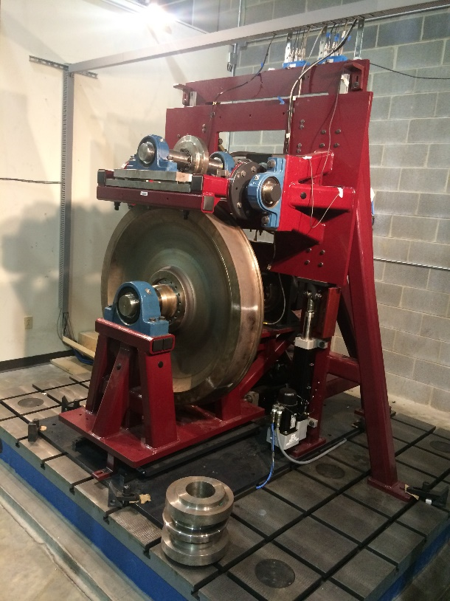

Figure ‑: Final design of the VT Roller Rig. Arrows indicate the adjustable degrees of freedom

A number of sensors measure the contact patch parameters including, but not limited to force, torque, displacement, rotation, speed, acceleration, and contact patch geometry. A unified communication protocol between the actuators and sensors minimizes data conversion time, allowing for servo update rates of up to 48kHz. This provides an unmatched bandwidth for performing vibration analyses that are accounted as contributors to wear, noise, and ride discomfort [1]. A high-speed vision system, incorporated into the Rig, is capable of capturing the instantaneous geometry of the contact patch and synchronizes it with other measurements for post processing purposes. As shown in Figure ‎1‑1, the Rig’s configuration accommodates the addition of third-body layers at the wheel/rail interface for studying the effect of surface conditioning elements.

A TN-S power system equipped with an isolating transformer and passive power filters delivers clean, symmetrical 3phase power to the motion control drives of the Rig. A customary Faraday Cage for the control tower of the Rig (Figure ‎3‑13) ensures maximum signal-to-noise ratio and EMI shielding. The efforts towards proper grounding, shielding, and safety of the Rig satisfy the EMC and IEC codes.

|  |  |
| --- | --- |
| C:\Users\MHP\Google Drive\CVeSS\Roller Rig\Pics\Cabinet\Final\IMG_0086.JPG | C:\Users\MHP\Google Drive\CVeSS\Roller Rig\Pics\Cabinet\Final\IMG_0077.JPG |

Figure ‑. The final enclosure for the control tower of the VT Roller Rig

Extensive instrumentation and motion control systems for the Rig, along with multi-layer safety systems, allow for investigating phenomena such as derailment and flanging. The flexible motion programming interface of the Rig is compatible with the majority of existing rail vehicle dynamics models for performing hardware-in-the-loop operations. The immediate benefits from HIL are advanced train control algorithms and better traction/braking procedures. Further details about the design and components of the Rig can be found in [2] and [3].

# Delivered Mechanical Setup

In this chapter, the engineering approach to the hardware design and construction of the Virginia Tech Roller Rig is discussed. The design specifications and functionality of each major component are detailed. It begins with the design of the load frame and base frame. Following, are described in detail discussions of the rig’s structure and positioning systems. The chapter discusses alternative designs for each component and how the design is optimized.

## Floor Plate

To have the most control over the laboratory environment, the dynamics and behavior of the testing facility must not be influenced by external noise and vibration. To this end, a very rigid basement is needed to isolate the rig from surrounding equipment in the laboratory. Also, the basement must provide a very flat base for accommodating the rig.

### Floor Plate Design

The Virginia Tech Roller Rig has a footprint of approximately 91 x 80 inch. A one-inch thick steel plate, which is sitting underneath all the components, functions as a base for the lateral linear guides that is discussed in positioning systems section. Therefore, the deflection of this plate is limited by the manufacturer’s permissible error for the linear guides’ mounting plate. Also, the floor plate should function as a rigid basement for the entire rig. It should take all the loadings and preferably isolate the rig from the surroundings.

A cast iron T-slotted plate is designed to make a rigid, multipurpose basement for the rig (Figure ‎2‑1). It is a resin-sand casted plate made of iron HT250. It is a purpose-built plate with 2200 x 2500 x 250 mm dimensions and top-surface flatness accuracy of +/- 0.03 mm manufactured by Cangzhou Kuntai Machinery & Equipment Co., Ltd, China. It weighs approximately 5000 kg. The plate is hollow with a stiffening rib structure on the underside (Figure ‎2‑1).

|  |  |  |
| --- | --- | --- |
|  |  |  |

Figure ‑: T-slotted floor plate and its solid model showing bi-directional t-slots on top surface and reinforced ribbing structure at the bottom

The working surface of the plate has cast-in 28H12 T-slots in both directions with 250 mm spacing. Casted T-slots enable the basement to insert or remove T-nuts for mounting the specimen in different configurations. The load frame and linear guides’ plate are secured to the base plate using the T-slots and the appropriate hardware shown in Figure ‎2‑2-Left. Because of the massive weight of the plate, it ensures a very rigid basement for the rig.

|  |  |
| --- | --- |
|  |  |

Figure ‑: Left: 28H12 T-slots and clamping hardware including T-nuts, stud, nut, triangular lock, and clamp strap for mounting components on the floor plate. Right: Precision bubble leveler used for leveling the floor plate

The base plate is anchored to the floor via ten 1 inch anchors, one for each hole of the plate. The laboratory floor was marked for the exact location of the anchors. The 1-inch all-thread anchors were secured to the 5-inch thick concrete floor with epoxy. With the epoxy cured, the base plate was lowered down over the anchors. Using shimming method, the plate was leveled within 0.04-inch tolerance in all the directions (Figure ‎2‑2-Right). Once the plate was leveled, jam nuts fixed the position of the plate to the anchors. With the plate fixed in place, it was then filled with a non-shrinking grout. The grout filled the underside completely and allowed the plate to distribute loads over its entire footprint onto the floor. The fully anchored plate is an extension of the concrete floor (Figure ‎2‑1).

It must be noted that an alternative method of using anti-vibration wedge-mounts for mounting the rig to the ground was considered. The AirLoc anti-vibration mounts include a vibration absorber pad, and function as a precision leveler under heavy loads (Figure ‎2‑3). Although the mounts could serve as a leveler to precisely level the rig, and could isolate the vibration of the entire rig through the anti-vibration pads, finite element analysis showed that they failed to provide a rigid basement for the rig. Results show that the deflection of lateral linear guides’ plate would be more than what the manufacturer recommends, as illustrated in Figure ‎2‑4.

|  |  |
| --- | --- |
|  |  |

Figure ‑: VRC wedge-mount precision levelers manufactured by AirLoc [4]

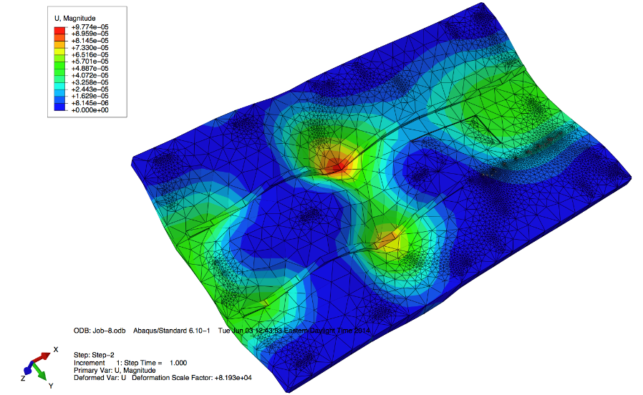

Figure ‑: Structural analysis of the mounting plate for evaluating the performance (static deflection of plate) of wedge-mounts using ABAQUS

### Floor Plate Functionality

The reinforced ribbing structure of the plate makes it extremely heavy and rigid. Since grout could not fill out the entire underside of the plate due to lacking of air holes to let the air out of the gap, finite element analysis is conducted to ensure the rigidity and strength of the plate. The solid model of the plate was imported to ABAQUS software package. The loading from the weight of the rig and the contact forces was applied to the top surface of the plate. For the boundary conditions, all the mounting holes in the underside of the plate in the model were rigidly fixed in all six directions, as the holes are bolted down to the concrete floor using epoxy anchors. A mesh type of tetrahedron with 2,116,674 elements was used for static and modal analyses of the plate (Figure ‎2‑5). The results show that the maximum deflection of the plate is *0.01 mm*, and the first natural frequency is *313 Hz*. The deflection is well below the manufacturer recommended value (0.12 mm). The modal analysis ensures that the plate has much higher natural modes than the test specimen, which helps to reduce error in tests. The plate is leveled within desirable accuracy to ensure that the forces being introduced into the system are well defined. Misalignment/tilting of the rig would introduce undefined forces at the contact patch; the weight of the components would not be along the vertical axis. This could decrease the accuracy of force estimation at the contact. In summary, T-slotted base plate secures the rig in place and ensures a rigid basement for the rig to reduce unwanted noise in test signals.

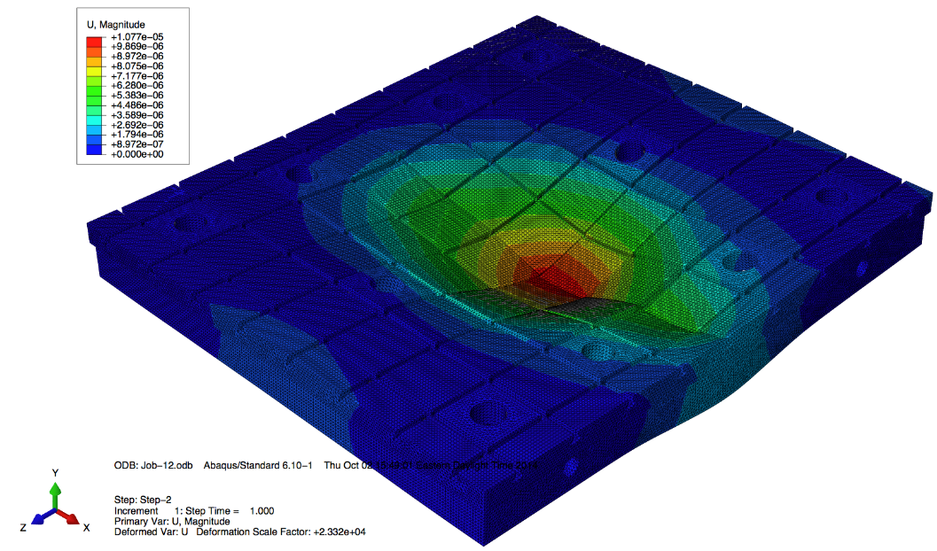

Figure ‑: Finite element analysis of the floor plate using ABAQUS

## Load Frame

In addition to the base plate, the reaction load frame needs to be unyielding. It should be able to take all the contact force loading with minimized deflection to avoid generation of any unwanted vibration. In another word, the dynamics of the frame should not affect the dynamics of the test specimen. Together, the reaction load frame and the base plate should provide an excellent rigid structure for conducting the contact mechanics tests with minimized external noise and vibration. Additional functionality of the frame lies in the ability to accommodate all the powertrain and positioning components. The frame should make enough room for placing two drivelines.

### Frame Design

To meet all the required specifications for the frame, different design solutions were investigated. The advantages and disadvantages of these solutions were discussed, and the best cost effective solution was selected. The first step in the design of the rig was deciding on the frame’s construction material. Extruded aluminum and low carbon steel tubing were compared. Aluminum frames assembled using bolts, nuts, and brackets can result in unwanted flexibility in the structure. The flexibility could lead to unwanted vibrations and deflections, which would possibly ruin the accuracy level of measurements and control capabilities of the rig. The goal is to reduce excitations from outside sources including rig’s structure to have maximized precision level for sensor measurements and speed regulations. Hence, low carbon steel tubing was chosen for fabricating the load frame.

Next, different design layouts for the structure of the frame were investigated. Most importantly, triangular and rectangular shaped frames were considered. The rectangular frame would result in a larger footprint without adding considerable rigidity to the structure. The triangular frame could provide better access to the rotating bodies for maintenance and allow for easy replacement of the wheel or roller in future. Therefore, a triangular structure was chosen for the frame. Based on engineering intuition, several modifications were made to strengthen the reaction load frame: sidebars, cross bars, gusset plates. Two sidebars were designed on each side of the structure to strengthen it in side directions. By doing so, the frame was fortified against longitudinal creep force at the contact.

Once the frame structure is designed, different steel tubing sizes were considered. Finite element analysis, detailed below, indicated that 4 x 4-inch steel square tubing with a 3/8-inch wall thickness resulted in a better trade-off between mass and rigidity. Other overall dimensions were designed based on the size of rig’s drivelines and the other main components. A 1-inch thick steel plate is added in front of the frame for mounting the vertical positioning system, as well as strengthening the frame. Furthermore, provisional holes were adapted on the steel tubings for filling inside the tubes with some expandable foam for further attenuating any unwanted vibrations in the system (increasing the natural frequency of the frame), if needed in the future. Figure ‎2‑6 shows the finalized design of the frame.

|  |  |
| --- | --- |
|  |  |

Figure ‑: Solid model and fabricated reaction load frame

### Structural and Modal Analysis

To optimize the rigidity and strength of the load frame, finite element analysis was conducted using ABAQUS package. To this end, a finite element model of the frame was created using beam elements. A grid system using 3D deformable wires was adopted to describe the location of the structural elements (steel tubings). The model adequately represented all the main structural elements in the load frame. However, some simplifications were taken into account. The weldments in the structure were not modeled as the entire structure was modeled as a one piece. This could be justified with the proper welding of the frame that could even make a stronger connection than the steel tubing. Moreover, the steel front plate and gusset plates were not modeled in the FE model. This could underestimate the strength of the load frame, as welding the gusset plates and a solid steel plate in front would strengthen the structure. So, it merely added a safety factor to the analysis. Figure ‎2‑7 shows the wire frame and beam element model of the frame in ABAQUS. For the boundary conditions, all six frame feet in the model were rigidly fixed in all six directions, since the frame feet are bolted down to the base plate, which is anchored down to the floor.

|  |  |
| --- | --- |
|  |  |

Figure ‑: The wire frame model of reaction load frame in ABAQUS using beam elements

After modeling the frame in ABAQUS, two types of analyses were conducted to study the design of the structure. First, the static analysis was carried out to predict the deflections of the frame due to contact forces. The contact forces on the wheel are reacted at the frame through the cradle bearing assembly. The contact forces on the roller are reacted directly at the base plate through the AoA weldment frame. The FEM analysis was just to ensure the strength of the load frame under maximum operating loading conditions. To minimize the deflections, as well as maximize the first natural frequency, different tubing sizes for the structure were studied. Minimizing the deflection of the frame was necessary to reduce friction created by vertical bearing rails, which mount directly to the frame. The results of the simulations for different tubing sizes are shown in Table ‎2‑1. Maximum deflection, maximum stress, and maximum strain are compared.

In addition to static deflection analysis, modal analysis for estimating the natural frequencies of the structure was investigated with finite element ABAQUS package. Using the same beam model and boundary conditions as before, a free vibration modal analysis was performed. The results of the analysis are summarized in Table ‎2‑1 for different tube sizing. The first vibration mode of the frame is the first side-bending mode. The longitudinal contact force could excite this mode of vibration. The second mode is the first bending mode in the direction of front and aft. The lateral contact force could excite this mode of vibration. The third vibration mode is the first torsional mode around a vertical axis.

Table ‎2‑1: Comparison table for FEM results of the load frame

|  |  |  |  |  |
| --- | --- | --- | --- | --- |
| Design (cross section) | Max. stress (Mpa) | Max. defl. (mm) | Modal freq. (Hz) | Weight (kg) |
| No side bar ($4×4×\frac{3}{8}in$) | $$15.6$$ | $$0.23$$ | 75, 139, 157, 181, 216 | 636 |
| Half-length side bar ($4×4×\frac{3}{8}in$) | $$19.8$$ | $$0.13$$ | 89, 141, 161, 196, 222 | 690 |
| Full-length side bar ($4×4×\frac{3}{8}in$) | $$15.9$$ | $$0.072$$ | 96, 135, 159, 206, 216 | 735 |
| Full-length side bar ($4×4×\frac{1}{2}in$) | $$12.8$$ | $$0.057$$ | 94, 135, 157, 201, 212 | 980 |
| Full-length side bar ($4×4×\frac{1}{4}in$) | $$22.4$$ | $$0.101$$ | 97, 136, 160, 212, 221 | 490 |
| Full-length side bar ($3×3×\frac{3}{8}in$) | $$29.5$$ | $$0.126$$ | 85, 128, 145, 164, 178 | 531 |
| Full-length side bar ($5×5×\frac{3}{8}in$) | $$45.5$$ | $$0.126$$ | 106, 140, 170, 249, 250 | 938 |

To optimize the structure regarding rigidity, overall mass, and first natural frequency, the finite element results presented in Table ‎2‑1 were compared together. The comparison showed that 4 x 4-inch steel square tubing with a 3/8 in wall thickness would result in the best compromise between maximizing the stiffness (minimizing the deflection) and minimizing the mass (maximizing the first natural frequency).

The result for 4 x 4-inch steel square tubing with a 3/8 in wall thickness shows that the first natural frequency is 95 Hz. This is comparable to the first natural frequency of another load frame similar to our Roller Rig’s frame [5]. The resonant frequencies of the frame could be well above all the resonances of interest for studying vehicle dynamics and contact mechanics. However, squeal noise frequency, which commonly happens in railway vehicles especially while negotiating a curve, could be in the same range. Also, the results indicated that the deflection of the frame is less than 0.07 mm due to extreme loading condition, which is significantly below the allowable misalignment of 375μm/500mm (rail length) for vertical linear bearings, specified by the bearing manufacturer (THK). This could ensure proper bearing operation under different loading conditions.

### Functionality

A triangular reaction load fame, made of low carbon steel tubing, is designed to serve as a rigid structure for the rig. The frame is optimized to accommodate all the drivetrains’ components, as well as to be rigid enough for minimizing unwanted vibrations. The FEM results indicated that the frame is very rigid compared to the rest of the components. This guarantees that sensor noise from excitation of the load frame would be minimal. To make the frame fully functional, small steel pads (1 in thickness) were welded to the bottom of each foot. These pads are used to clamp the fixture to the base plate and floor plate.

A steel plate was welded in front of the frame to serve as a suitable platform for mounting the vertical linear guides. After the frame was fully welded, the entire load frame was machined as a unit. The feet were all milled to within 0.005-inch flatness of one another. The level of machining precision, as well as the rigid floor plate, ensure that the rig is very stable and does not flex, as it is anchored down to the concrete floor. Next, the front 1-inch plate was milled to within 0.001 in flatness (the allowable misalignment of the bearing rails per the manufacturer). Also, the front face was milled to within 0.005 in perpendicularity of the bottom feet.

## Positioning Systems

The Virginia Tech Roller Rig is equipped with various positioning systems to actively control the relative angular and linear displacements between the two rotating wheels. These relative displacements are the angle of attack (AoA), cant angle, lateral shift, and vertical displacement. The setup allows for real-time positioning of these relative displacements to closely replicate boundary conditions of actual railway vehicles. For each one of the degrees of freedom, multiple design solutions were considered. The advantage and disadvantages were compared, and the best cost-effective solution was selected.

### Angle of Attack (AoA) Positioning System

The angular attitude of the wheel about the rail (or to the roller in a roller rig) is commonly known as the angle of attack (Figure ‎2‑8). The angle of attack of the rolling stock wheels and rails/rollers is one of the main indices of the interaction between the rolling stock and railroad. It has a primary and determining role related to lateral creepage and spin creepage. As a result, it is a key parameter for contact mechanics, wear, and safety against derailing studies.

The Roller Rig is equipped with an AoA positioning system capable of actuating in real-time. A suitable cost-effective mechanism was designed such that it can meet all the requirements regarding accuracy and rigidity.



Figure ‑: The angular position of the wheel about the rail known as angle of attack (AoA)

#### Component Design and Functionality

To configure the AoA positioning system, different design options were investigated. Various mechanisms such as two sliding plates with a circular guidance groove, a sliding post in which components pivot around the post, and off-the-shelf turntables (slewing ring or cross roller ring) were thoroughly discussed. Rigidity, ease of implementation, rotation around the contact patch center, cost, and required actuation force were among design criteria. Considering a vast number of vendors and manufacturers, as well as consulting the application engineers, a cross roller ring offered by THK was selected. It is capable of highly accurate rotational motion, as well as taking all the required loading in the system. As depicted in Figure ‎2‑9, cross roller ring consists of inner and outer rings, which are in rolling contact via a cylindrical roller that is arranged perpendicular to the adjacent roller. As a result, the cross roller ring can take loads in all directions including radial, axial, and moment loads. The spacer retainer keeps the roller in place and prevents them from skewing. It allows a bigger contact area between rollers and the rings, thus, significantly increases the load capacity. Also, since inner and outer rings are designed to be separable, a preload can be applied to the bearing for adjusting the clearance [6].

Figure ‎2‑10 shows a schematic view of the cross roller ring implemented in the Roller Rig. The cross roller ring is bolted down to the upper and lower plates via two circular hole patterns. The top plate, which is bolted to the inner ring, is welded to the roller bearing posts. The bottom plate functions as an intermediate mounting plate between the cross roller ring (AoA positioning system) and linear guides (lateral positioning system). This mechanism provides the AoA degree of freedom for the roller about the wheel. The design is such that the pivot point (center of rotation) is set exactly underneath the contact patch. This provides two advantages: i. When the roller rotates around the vertical axis (AoA changes), other displacements (lateral, cant) are kept fixed. ii. The rotation requires minimum moment around the vertical axis since the moment arm is kept minimal. Finally, the rotational motion of the cross roller ring is controlled via a linear actuator, which is discussed in the linear actuator section (Section ‎2.4.3).

|  |
| --- |
|  |
|  |

Figure ‑: Schematic drawing of the cross roller ring manufactured by THK [6]



Figure ‑: Solid model of the AoA and lateral positioning systems, and their actuation mechanisms. Green arrows indicate the lateral and AoA degrees of freedom

#### Component Sizing

In addition to accuracy requirement, the positioning system should be capable of taking all the required loadings in the system. Maximum forces and torques that react at each positioning system are calculated based on the contact forces. Table ‎2‑2 shows the maximum creep forces at the contact.

Table ‎2‑2: Maximum estimated creep forces at the contact patch

|  |  |  |  |
| --- | --- | --- | --- |
| Unit | Longitudinal ($F_{x}$) | Lateral ($F_{y}$) | Vertical ($F_{z}$) |
| Newton (N) | +/- 4265 | +/- 4265 | -10664 |

The contact forces are reacted at the positioning systems. Figure ‎2‑11 shows how the contact creep forces are reacted at the positioning systems.

|  |  |
| --- | --- |
|  |  |

Figure ‑: Left: Solid model of the rig. Right: Schematic drawing of the rig that shows how the contact forces are reacted at the lateral positioning system, AoA positioning system, and vertical positioning system

Besides the contact forces, AoA positioning system needs to take the gravitational forces and moments applied by the weight of components. Taking all into consideration, Figure ‎2‑12 presents the free body diagram of the AoA positioning system and Table ‎2‑3 shows all the required dimensions and weights.

The cross roller ring was selected and sized with assistance from THK America Corporation engineers and product documentation [6]. Following assumptions are made to calculate the safety factor:

* Perfect system rigidity including the mounting surface for the inner and outer ring
* No contamination
* Adequate lubrication
* No induced loads due to misalignment
* The acceleration due to gravity *g* = 9.81 *m/s^2*



Figure ‑: Free body diagram of AoA and lateral positioning systems

Table ‎2‑3: Required specifications for the AoA positioning system

|  |  |
| --- | --- |
| Parameter | Magnitude |
| L1 (in) | 21.5 |
| L2 (in) | 16.5 |
| L3 (in) | 1 |
| L4 (in) | 25 |
| L5 (in) | 50 |
| WC.G.1 (lb) | 1500 |
| WC.G.2 (lb) | 2000 |

Following the standard sizing practice recommended by THK, the safety factor of the cross roller ring is calculated. The equivalent loading ($Q_{0}$) is calculated as follows:

|  |  |  |
| --- | --- | --- |
|  | $$Q_{0}=X_{0}.\left(F_{radl}+\frac{2M}{dp}\right)+Y_{0}.F_{axl}$$ | (‎2‑1) |

Where $F_{radl}$, $F_{axl}$, and $M$ are radial force, axial force, and moments applied to the cross roller ring, respectively. For the maximum loading capabilities, the biggest available cross roller ring (RU445) is selected. For RU445, $X_{0}$, $Y_{0}$, $C_{0}$, and $dp$ are 1.0, 0.44, 447 kN, and 445.4 mm, respectively. According to Figure ‎2‑12, Table ‎2‑2, and Table ‎2‑3, we have:

|  |  |  |
| --- | --- | --- |
|  | $$F_{radl}=F_{x}+F_{y}=4963+4456=9419N$$ $$F_{axl}=F_{z}+W_{C.G.1}+W_{C.G.2}=12103+4448+8896=25447 N$$ $$M=\left(W_{C.G.1}.L_{2}-W_{C.G.2}.L_{1}\right)+\left( F_{x}.L_{3}\right)+\left( F_{y}.L_{3}\right)=14334.7 Nm$$ | (‎2‑2) |

Therefore, the safety factor ($f_{s}$) for the cross roller ring is:

|  |  |  |
| --- | --- | --- |
|  | $$Q_{0}=1*\left(9419+\frac{2*14334.7}{.4455}\right)+0.44*25447=84983 N$$ $$f_{s}= \frac{C_{0}}{Q_{0}}=5.56$$ | (‎2‑3) |

The cross roller ring (RU445G) has an outer ring with 540 mm outer diameter (OD) and 445.5 mm inner diameter (ID), and an inner ring with 445.5 mm OD and 350 mm ID. For the rotational accuracy grade of P4, selected for the Roller Rig, the axial and radial run-out tolerances are 12 $μm$ for the inner ring, and 16 $μm$ for the outer ring. This could minimize the rattle space between the rings, hence could minimize the parasitic vibrations during tests. To increase the rigidity, preload class of CC0 is selected. The preload class adds between 25 to 50 N.m torque to the running torque of the cross roller ring, according to the manual. The running torque of the designed cross roller ring will be the summation of preload torque, frictional torque, and moment torque. The frictional torque is the multiplication of the rolling friction coefficient (~0.01), radial and axial loadings on the bearing (~20 kN), and the effective radius (~0.2227m), which will be around 44 N.m, and the moment torque is the torque due moment (M) created due to off-center loading. According to manual, the moment torque is calculated as 1.15\*M\*mu, where mu is the friction of coefficients of the ball guides (~0.003). As a result, the total running moment for the designed cross roller ring is around 100 Nm. This information is used for multibody modeling of the rig in SIMPACK (Chapter 8).

The cross roller ring is designed such that the static and dynamic friction coefficient does not differ considerably. As a result, closed loop force controlling of these bearings becomes a much easier task.

### Lateral Positioning System

The linear position of the wheel about the rail/roller is called lateral displacement (Figure ‎2‑13). Wheelset displacement is the main manifestation of wheel/rail dynamic interaction when a train is running on a railway track. Lateral displacement is of great importance in railway vehicles dynamics, since when the wheelset is displaced to one side, the diameters of the regions of contact and hence the (linear) velocities of the wheels, are different (due to the tapered design of wheel profile).



Figure ‑: The linear position of the wheel about the rail known as lateral displacement

The setup is equipped with a lateral positioning system capable of actuating in real-time. To this end, a suitable cost-effective mechanism was designed such that it can meet all the requirements regarding accuracy and rigidity.

#### Component Design and Functionality

Similar to the AoA positioning system, different design options for lateral positioning system were investigated. Various mechanisms were considered, such as two sliding plates, off-the-shelf linear bearings, and a tapered bushing, which goes in between the roller and axle, and allows for a lateral shift of roller against the axle. Rigidity, ease of implementation, cost active control possibility and required actuation force were among design criteria. Contacting a vast number of vendors and manufacturers, a caged ball linear motion guide offered by THK was selected. It is suitable for highly accurate linear motion, as well as taking all the required loading in the system.

As depicted in Figure ‎2‑14, caged ball linear motion (LM) guide model SHS consists of LM blocks and LM rails that has a recirculating ball bearing design. Balls roll in four rows of raceways precision-ground on an LM block and an LM rail. The LM block incorporates ball cages and endplates that allow the ball to recirculate. Ball rows are placed at a contact angle of 45 degrees. As a result, the LM block can take an equal load for both lateral and radial directions. Moreover, a preload can be applied to the LM guide for increasing the rigidity in all directions, while maintaining a constant low friction coefficient [6].

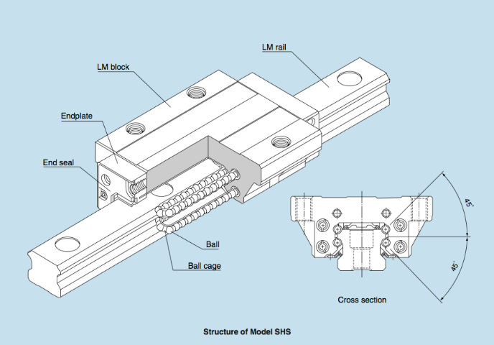

Figure ‑: Schematic drawing of the caged ball LM guides [6]

Figure ‎2‑10 shows a schematic view of the lateral LM guides implemented in the Roller Rig. The LM blocks are bolted down to the intermediate plate, which is bolted to the cross roller ring from the top side. The LM rails are bolted down to 1-inch thick bottom plate, which is mounted to the t-slotted base plate. This configuration provides the lateral degree of freedom for the roller about the wheel. Similar to other degrees of freedom, the lateral motion of the LM guide is controlled via a linear actuator that is discussed in linear actuator section (Section ‎2.4.3).

#### Component Sizing

To select the proper sizing of linear guides, the standard sizing practice recommended by THK was followed. The reaction loadings of the lateral positioning system are similar to AoA positioning system (Figure ‎2‑12, and Table ‎2‑3) except the weight of the cross roller ring should be added. The factor of safety for lateral linear guides is calculated similar to cross roller ring, and calculation shows that the factor of safety for the lateral LM guide is 5.55.

The lateral LM guide has two rails: one with lengths of 1160 mm that carries two LM blocks and the other one with a length of 1960 mm that carries three LM blocks. Two rails operate parallel to each other and provide a smooth linear motion between the roller and wheel. For the accuracy grade of SP (super precision grade), running parallelism value for LM rail of length 1160 mm is five $μm$, and for the length of 1960 is 5.5 $μm$. This could minimize the rattle space between the rail and block, hence would minimize the parasitic vibrations during tests. A preload grade of C0 is selected for lateral LM guides. The dynamic friction force due to preload is 33.3-39.1 N per block. This is used in multibody dynamic modeling of the rig (Chapter 8).

Similar to cross roller ring, the LM guides are designed such that the static and dynamic friction coefficient does not differ considerably. As a result, closed loop force controlling of these bearings becomes a much easier task.

### Cant Angle Positioning System

Cant angle of a [railway](http://en.wikipedia.org/wiki/Railway) track is the difference in elevation (height) between the two rails. This results in an inclination of moving wheelset from the vertical line on the rail (Figure ‎2‑15). Cant angle (also known as superelevation) has a considerable effect on the dynamic behavior of railway vehicles in the negotiation of a curved track. Also, the vertical inclination of the wheel about the roller distorts the contact patch and produces spin creepage. Therefore, to test real-life conditions for the contact, the rig needed to be equipped with the can angle degree of freedom.



Figure ‑: The vertical inclination of the wheelset about the rail is known as cant angle

#### Component Design and Functionality

One of the most challenging parts of the design was configuring the cant angle rotation mechanism. The fact that the rotation needed to be around the contact point, as well as required to be implemented in real-time made it a very challenging task. After considering many different design solutions, a very rigid and quite simple mechanism is configured. This mechanism consists of a cradle that embraces the wheel (Figure ‎2‑16). The cradle is attached to two separate shafts that are in line with the wheel-roller interface patch. Two bearings hold the two aligned shafts. Therefore, the configuration of shafts and cradle can easily rotate around the centerline of the shafts, which is in line with the contact patch. This provides the cant angle degree of freedom for the wheel about the roller. Since the pivot point (center of rotation) is closest to the contact patch, this provides two advantages: i. When the wheel rotates around the cant angle axis solely the cant angle changes, and the other displacements (lateral, AoA) are kept fixed. ii. The cant rotation requires minimum moment since the moment arm is kept minimal.

All the wheel driveline components (servomotor, gearhead, coupling, torque-sensor), as well as force dynamometers, mount on the cradle. To obtain enough rigidity and strength, 3 x 3-inch steel square tubing with a 3/8 inch wall thickness were used. Two linear actuators are used to actively control the motion of cant positioning system. The actuators mount to the rear side of the cradle from one side and on the other side, they mount to the back plate of the vertical positioning system (Figure ‎2‑16).



Figure ‑: Schematic drawing of the designed cradle and rotating mechanism for providing the cant angle motion. Green arrows indicate the vertical and cant degrees of freedom

#### FEM analysis

Similar to FE model for the load frame, a finite element model of the cradle was created using beam elements. Figure ‎2‑17 shows the wire frame and beam element model of the cradle in ABAQUS. For the boundary conditions, the linear actuators’ mounting surfaces were rigidly fixed in all six directions, and the aligned shafts were fixed in all five directions, except for the cant rotation.

|  |  |
| --- | --- |
|  |  |

Figure ‑: The wire frame model of the cradle in ABAQUS using beam elements

After modeling the frame in ABAQUS, two types of analyses were conducted to study the design of the structure. First, the static analysis was carried out to predict the deflections of the frame due to contact forces and driveline loadings. The contact forces on the wheel are reacted at the cradle. In addition to static deflection analysis, modal analysis for estimating the natural frequencies of the structure was investigated. The results show that for the extreme loading conditions the maximum deflection of the cradle is less than 0.2 mm, and the first natural frequency is 127 Hz. It must be noted that the FE model of the cradle does not include the dynamometers’ base plate that is bolted down to the cradle. The FEM analysis could underestimate the strength of the cradle as the thick steel dynamometer plates would strengthen the structure.

### Vertical Positioning System

In addition to AoA, cant angle, and lateral displacement degrees of freedom, the rig is equipped with a vertical degree of freedom between the wheel and roller (Figure ‎2‑18). This would provide the ability to control the normal force (contact normal pressure) between two rotating bodies. Moreover, because of the conical shape of the wheel profile, the vertical and lateral motion of the wheel are coupled. In another word, as the wheel shifts laterally on the roller, it shifts vertically as well. Therefore, the vertical positioning system needed to accommodate the lateral shift.

To set up the rig with this degree of freedom, a proper sizing LM guides from THK is designed. Similar to lateral LM guides, SHS35 is selected for the vertical positioning system. Following the THK recommended sizing practice; the safety factor for the LM guide is calculated as 8.55. Two linear actuators are employed to simulate the required normal loading at the contact based on the INRET scaling strategy.

|  |  |
| --- | --- |
|  |  |

Figure ‑: Front (left) and rear (right) views of the rig showing hardware development and assembly

## Powertrain

To design the proper powering system, differential and independent drivelines were thoroughly discussed. The advantages and disadvantageous of both the drivelines were fully discussed with application engineers from multiple differential gearbox manufacturers, as well as multiple electrical motor manufacturers. In addition to power and creepage requirements, the feasibility of implementation of the concepts, ease of installation, cost, and time were deeply taken into account. Finally, the best cost-effective solution was proposed.

Initially, the differential concept looked a much better configuration for the rig’s drivelines. It needs much lower power-rated drive motors and produces a much higher resolution for the creepage control. However, consultation with the application engineers shed more light on the concept and revealed some problems implementing the idea. One of the biggest problems with the differential concept is that it requires flexible power transmission lines. The rig is equipped with positioning systems, and two rotating wheels change their relative displacements (cant, AoA, lateral) about each other. As a result, the transmission line requires compliant connections such as CV joints to accommodate these relative displacements. Compliant connections such as CV joints in the driveline could produce axial vibrations due to shudder motion and the rotational delay between the driver and driven components [7]. Direct driveline, however, delivers maximum accuracy in speed control from an electric motor. After many discussions with the motor supplier, a direct driveline was highly recommended to mount the rotational bodies (roller and wheel) to the motors directly, without any joint compliance.

In the differential driveline, flexible transmission lines such as belt or chain from reducer to differential gearbox is inevitable to accommodate the exact distance between the two wheel and roller drive-shafts. Two rotational bodies could get worn out due to friction at the interface. This causes the distance between the driveshafts to reduce. A flexible transmission line is needed to accommodate the variable distance between the driveshafts. In addition to inefficiencies associated with the flexible transmission line, it superimposes nonlinearities such as backlash to the driveline that could drastically affect the accuracy of the velocity regulation.

Moreover, the rated power of the drive motors in the differential driveline configuration greatly depends on the reducer gear ratio. A specific gear ratio for the reducer would lead to the minimized needed power of the drive motors. However, based on the diameters of the rotating bodies, and the available off-the-shelf differential gearboxes, the calculated optimum gear ratio (5.74) for the reducer with required loading specification was not commercially available. Made-to-specification (customized) gearbox could cost as high as three times the available ones.

On the other hand, independent driveline concept supports mounting the rotational bodies (roller and wheel) to the motors directly, without any joint compliance. This eliminates axial vibrations and the rotational delay between the driver and driven components. To get the desired creepage regulation, servo drives are selected such that the differential speed between two servo-motors (which drive the wheel and roller) would be controlled using electronic gearing (digital master-slave mode) with a high level of precision.

All in all, the independent driveline is designed for powering the rotational bodies, and producing the slip at the interface. Although the differential concept looks beneficial regarding power consumption, it has the disadvantage of employing compliant joints that alarmingly influence the performance of servomotors.

### Component Selection

The desired speed profile against time varying load for both the rotational bodies is supplied via two independent three-phase permanent magnet servomotors. To this end, various electrical motor suppliers and products have been considered and carefully compared. Manufacturers such as Kollmorgen, Baldor, Parker, Yaskawa, and Marathon, as well as products such as vector duty AC induction motor, permanent magnet servomotor, and DC motor, are among the long list of discussed options. After consultation with the application engineers and reviewing their solutions for the rig’s powertrain, AKM84T AC synchronous servomotor offered by Kollmorgen is selected. Servomotors give the best performance in motion control applications. They outperform another type of motors regarding accuracy in speed regulation. The largest standard Kollmorgen shafted brushless servomotor (AKM84T) met all the required power specifications for the powertrain.

AC servomotors with permanent magnets are intended for conventional electronically controlled electric drives with a wide control range, excellent dynamical properties, a high level of precision. The servomotors are three-phase synchronous motors with excitation by permanent magnets on the rotor operating as brushless DC electric motors. This function of the motors is ensured by transistor converters with DC intermediate circuit and feedback control by a position sensor (e.g. resolver) embedded in the servomotor. Basic diagram of the drive with an AC servomotor is shown in Figure ‎2‑19.

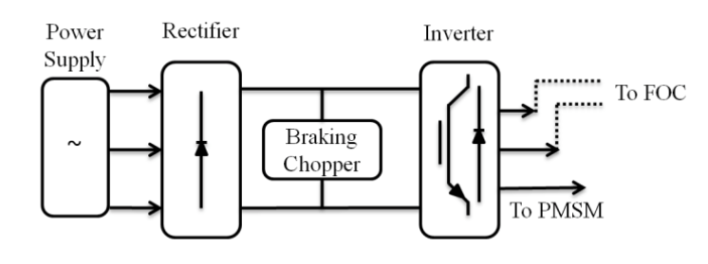

Figure ‑: Schematic drawing of basic drive circuit for AC servomotors [2]

The three-phase rectifier, braking chopper, three-phase inverter, the field-oriented controller (FOC), and speed controller are the main parts of the drive [2]. The permanent magnet synchronous machine (PMSM) and the position sensor are the main parts inside the motor housing. An optional mechanical brake may also be added. The PMSM has permanent magnets mounted on the surface of the rotor, with a uniform air gap and no saliency. Figure ‎2‑20 shows the key design features of the permanent magnet synchronous machine, and Figure ‎2‑21 shows the exploded view of the machine [8].

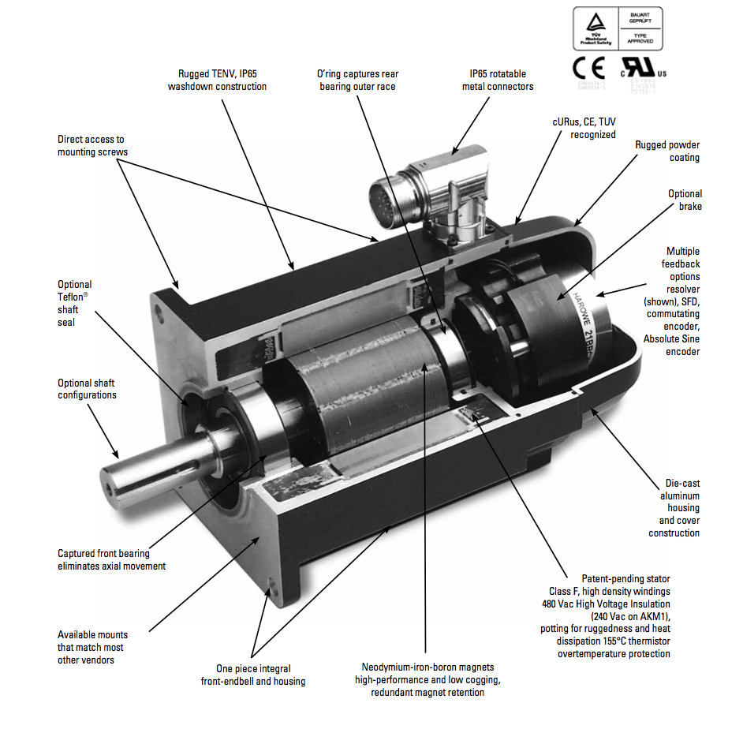

Figure ‑: Key design features of Kollmorgen’s permanent magnet synchronous machine [8]

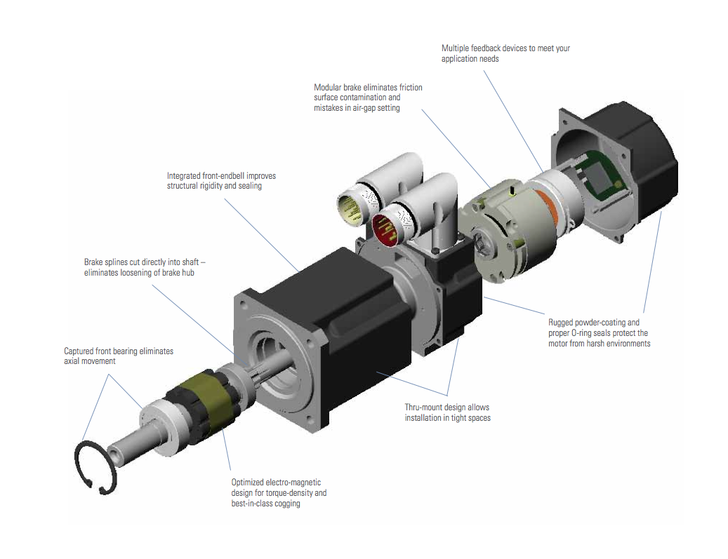

Figure ‑: Exploded view of the AC synchronous servomotor [8]

Table ‎2‑4 shows specifications of the AKM84T motor, and the performance curve of the motor is presented in Figure ‎2‑22. The AKM84T servomotor outputs continuous power of 19.5 kW for a rated speed of 2500 RPM. The servo-machine is equipped with a single turn absolute sine encoder (DA).

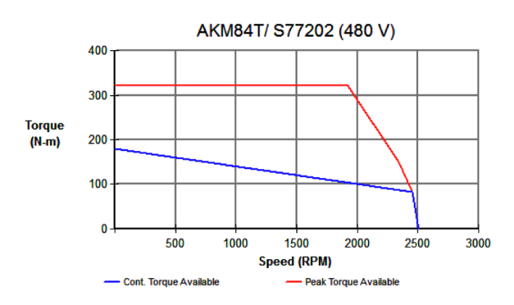

Figure ‑: Performance curve for AKM84T servomotor [8]

Table ‎2‑4: Main specifications for AKM84T (480 V) AC servomotor [8]

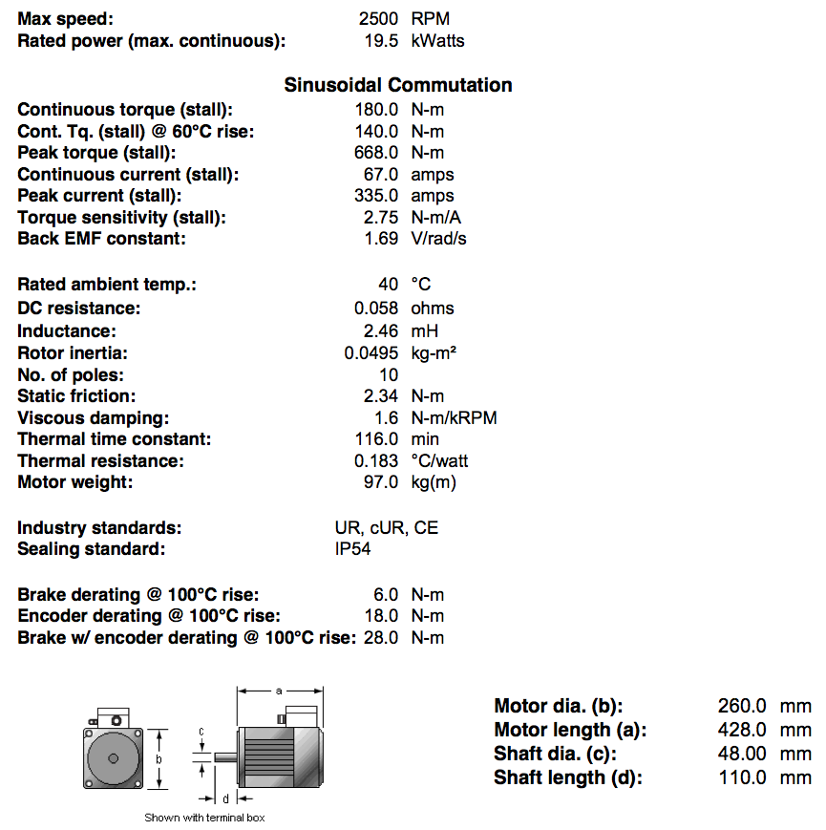

AkM84T servomotors are controlled by a digital servo drive (S772) offered by Kollmorgen (Figure ‎2‑23). Kollmorgen servo drive is specifically designed for the versatility, communications, and power needed to expand machine performance and increase integration speeds. The motor setup is plug-and-play, and multiple Ethernet connectivity options provide both open and closed protocols. Online troubleshooting and data verification enable faster, bug-proof programming. Moreover, a broad power range in a smaller, compact design allows using these robust drives with a single interface while experiencing industry-leading, high-performance servo loops [9].

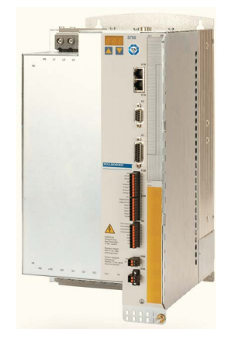

Figure ‑: Picture of S772 servo drive offered by Kollmorgen [9]

The S700, which is based on the SERVOSTAR® 300 architecture and features the same kind of processor, is a fully digital servo amplifier that is ideal for complex drive tasks. It incorporates onboard Ethernet connectivity for use with EtherCAT® and SynqNet™ and the optional MMC memory card enables parameter records and firmware to be easily backed up in the field. A Safe Torque Off function is standard, and other safety functions can be added. The S772 integrates a Safe Torque Off function. A digital input disables the amplifier’s power output stage, thereby implementing the Safe Torque Off function (safe stop). Advanced safety functions such as limited safety speed could be applied using a safety expansion card. The S772 can read data from a wide range of feedback systems (including an encoder, resolver, hall effect sensor, etc.) and evaluate up to three of them in parallel. This feature ensures a high level of flexibility where integration of the S772 into different applications is concerned. The S772 stands out on account of the high standard of flexibility that it offers when integrated into network environments. Virtually all of the most popular Fieldbus connections can be accommodated (RS232, EtherCat, CAN standard ISO 11898), thereby enabling the servo amplifier to communicate with any standard controller [9]. The wiring diagram of the components of the servo drive is depicted in Figure ‎2‑24.

|  |  |
| --- | --- |
|  |  |

Figure ‑: Left) Wiring diagram of the S772 servo drives [9]. Right) Installed S772 servo-drives controlling the servomotors that drive the wheel and roller drivelines

To deliver the needed torque to the rotating body, a proper-size gearbox is designed to transmit power from the servomotor to the roller. Different vendors (products) are considered including Micron (UT022), Stober (PHQ932, C812), Wittenstein (TP 500S, TP 300S)), Mijno (BDB330), and Apex (AE235). Comparing all the available options, BDB330 precision gearbox manufactured by Mijno offers the best cost-effective solution that meets all the required specifications (Figure ‎2‑25).

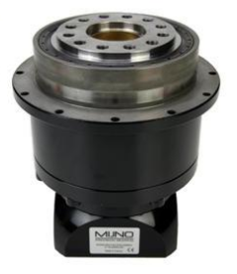

Figure ‑: BDB330 precision gearbox offered by Mijno [10]

Table ‎2‑5 shows the technical characteristics of gearbox BDB330-028. BDB planetary gearbox is a high rated-torque gearhead suitable for heavy duty, low backlash, high rigidity servo applications. It has a rotating output flange instead of the traditional output shaft. It is supported by two angular contact bearings or tapered roller bearings for maximal radial and axial load acceptance. Satellite gear is double-supported on hardened and ground shaft with full complement needle bearings for increased torsional stiffness [10]. The gearhead comes with an adaptor that is compatible with Kollmorgen servo-motor (AKM84T) for direct face mounting.

Table ‎2‑5: Main characteristics of the BDB330 precision gearbox manufactured by Mijno

|  |  |  |  |  |  |  |
| --- | --- | --- | --- | --- | --- | --- |
| Type | Ratio | Weight (kg) | Inertia Kg.cm^2 | Tors. Stiffness Nm/(arc-min) | Max speed : Continuous (cycl.)-RPM | Efficiency % |
| Planetary (inline) | 28 | 80 | 40 | 1969.7 | 2000 (3000) | >94 |
| Backlash (arc-min) | Rated Output torque-Nm | Max accl. Torque-Nm | E-stop Torque-Nm | Output type | Axial Load (N) | Radial Load (N) |
| <3 | 6250 | 8950 | 15000 | flange | 25000 | 55000 |

Similar to roller driveline, for the wheel driveline, identical servomotor and S772 digital servo drive offered by Kollmorgen are employed based on the selection of independent drive configuration. However, since the nominal speed of the wheel driveline is almost five times faster than the roller driveline, a proper gearhead offered by Thomson Linear is selected. Similar to Mijno gearhead, UT018-005 precision gearhead comes with a standard adaptor compatible with Kollmorgen motor for direct face mounting. UT018-005 incorporates helical crowned true planetary gearing, which offers high torque capacity, low backlash, smooth operation, greater load sharing, and whisper quiet. Figure ‎2‑26 shows the unique features of the Ultra True gearheads. Table ‎2‑6 shows the performance specifications of the UT018-005 planetary precision gearhead.

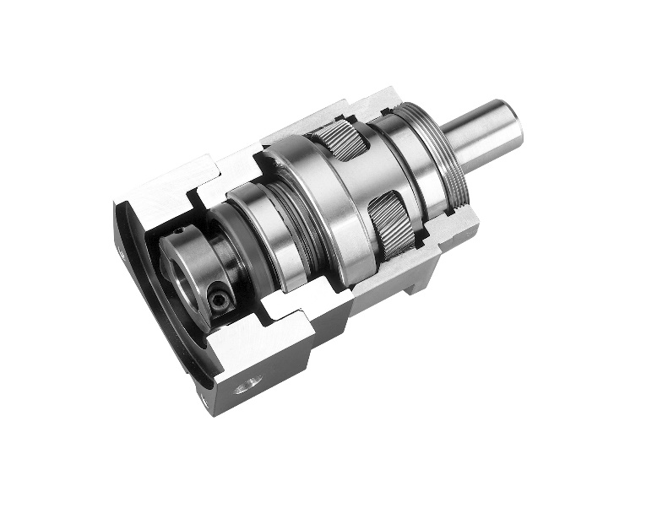

Figure ‑: Unique features of the UT018-005 true planetary gearhead offered by Micron [11]

Table ‎2‑6: Main specifications of the UT018-005 true planetary gearhead provided by Micron [11]

|  |  |  |  |  |  |  |
| --- | --- | --- | --- | --- | --- | --- |
| Type | Ratio | Weight (kg) | Inertia Kg.cm^2 | Tors. Stiffness Nm/(arc-min) | Max Speed: Continuous (cycle.)-RPM | Efficiency % |
| True Planetary (inline) | 5 | 40 | 20 | 150 | 2000 (5000) | 95 |
| Backlash (arc-min) | Rated Output Torque (1000 RPM)-Nm | Rated Output Torque (5000 RPM)-Nm | Peak Torque-Nm | Output type | Axial Load (N) | Radial Load (N) |
| <4 | 1333 | 1058 | 2654 | shaft | 16000 | 16500 |

To hold the rotating shaft in each one of the drivelines, two bearing sets are designed. Spherical roller bearing offered by SKF is selected as the best cost-effective solution for the Roller Rig project. Spherical roller bearings have two rows of rollers, a common sphered outer ring raceway, and two inner ring raceways inclined at an angle to the bearing axis. The center point of the sphere in the outer ring raceway is to the bearing axis. Therefore, the bearings are self-aligning and insensitive to misalignment of the shaft about the housing, which can be caused, for example, by shaft deflection. Spherical roller bearings are designed to accommodate heavy radial loads, as well as heavy axial loads in both directions. Symmetrical rollers self-adjust and provide optimal load distribution along the roller length. This keeps stresses low under all load conditions and extends bearing service life. Also, the rollers in an SKF spherical roller bearing are manufactured to extremely tight tolerances. Each roller is virtually identical in size and shape to the other rollers in the set. This optimizes load distribution over the rollers to maximize bearing service life.

|  |  |  |
| --- | --- | --- |
|  |  |  |

Figure ‑: Left) Double row spherical roller bearing. Middle) Pillow block spherical roller bearing FSYE series selected for the rig and offered by SKF [12]. Right) Installed roller driveline’s bearing

The SKF ConCentra locking concept is based on two sets of inclined planes (serrations): one set in the bearing bore, the other on the stepped sleeve. When the set (grub) screws in the mounting collar are tightened, the bearing is displaced axially, forcing the inner ring to expand. This does two things: it sets the correct internal clearance within the bearing, and it exerts pressure on the stepped sleeve, forcing it to contract around the circumference of the shaft for a true concentric, tight fit (Figure ‎2‑28). On the opposite side of the bearing, set (grub) screws for dismounting are located [12].

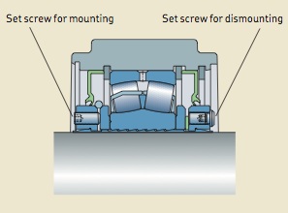

Figure ‑: Schematic of Concentra mounting design configuration [12]

The selected pillow block bearings allow for 1.5° degree misalignment. To accommodate any potential thermal expansion of the shaft, on each axle, one bearing is designed to be floating unit. The heat loss at the contact patch due to the friction between wheels at the interface is about three hp. Unlike tapered roller bearing, spherical roller bearing allows for float mounting configuration.

The SKF bearings were selected and sized with assistance from SKF engineers and product documentation [12]. Following the standard sizing practice recommended by SKF, the bearing life is calculated. The loading conditions for the bearings are tabulated in Table 3.

Table ‎2‑7: Required specifications for the bearings

|  |  |  |  |  |  |  |
| --- | --- | --- | --- | --- | --- | --- |
| Item | Shaft diameter (in) | Axial loading (kN) | Radial loading (kN) | Max speed (RPM) | Mounting option | Quantity |
| Roller axle bearing | 4 | 6 | 12 | 70 | Pillow block | 2 |
| Wheel axle bearing | 3 | 6 | 8 | 385 | Pillow block | 2 |
| Cant angle bearing | 3 | 6 | 8 | 20 | Pillow block | 2 |

The spherical roller bearing with pillow block mounting (FSYE-4-N, FSYE-4-NH) is selected for the roller driveline. Similar bearings with a 3-inch inner diameter (SYE-3-N, SYE-3-NH) are chosen for the wheel driveline. According to the SKF catalog, static and dynamic basic loadings for the bearings are determined. Based on the calculated parameters, and the given formula, the basic rating life for the bearings are calculated. The results are tabulated in Table ‎2‑8. Another bearing set is designed for the cant angle positioning system to allow for the relative angular displacement between the wheel and roller. Since the loading condition of the cant bearings is very similar to the wheel driveline’s bearings, the similar bearing set is selected for the cant axis.

Table ‎2‑8: Design calculation of load and life in hours for driveline bearings

|  |  |  |
| --- | --- | --- |
| Bearing | Wheel/Cant axis | Roller |
| Type | SYE 3 NH | FSYE 4 NH |
| Dynamic basic load ratings (kN) - C | 212 | 425 |
| Static basic load ratings (kN)- C0 | 240 | 490 |
| E, Y2, Y0 | 0.22,0.46,2.8 | 0.24,4.2,2.8 |
| Equivalent dynamic loading (kN) $$P=0.67×F_{r}+Y_{2}×F_{a}$$ | 32.96 | 33.2 |
| Equivalent static loading (kN) $$P_{0}=F_{r}+Y_{0}×F_{a}$$ | 24.8 | 28.8 |
| Basic rating life $L_{10}={(C/P)}^{10/3}$ | 494.8 | 4907.2 |
| Basic life in hours $$L_{10h}=\frac{{10}^{6}}{60×n (speed-RPM)}×L_{10}$$ | 21,423 | 1,168,400 |

### Rotational Bodies

To keep the cost of the setup manageable and also to maintain the contact patch distortion at the wheel-roller interface (compared with wheel-rail contact patch) to a minimum, I/4th scaling factor, according to INRETS scaling strategy, with a roller-to-wheel diameter ratio of 5 is selected. As a result, the length-scaling factor for the geometry of the contact compared with the railroad wheel-rail contact is 1/4th. Therefore, the wheel profile and the roller-head profile need to be 1/4th scaled down version of railroad wheel and rail-head profiles, respectively. As such, scaled down version of AREMA 136-lbs RE rail section is machined on a locomotive wheel donated by AMSTED rail to function as the roller in the rig. Figure ‎2‑29 shows the detailed drawing of AREMA 136-lbs RE rail section.

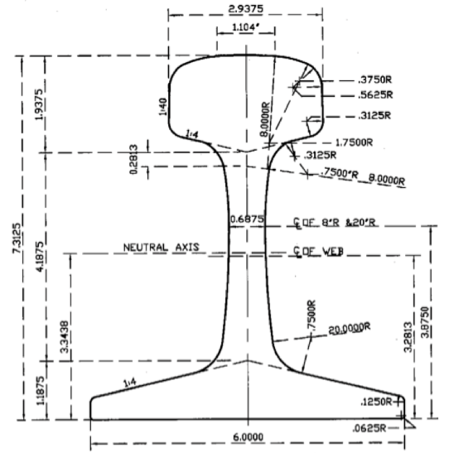

Figure ‑: The detailed drawing of AREMA 136-lbs RE rail section [13]

A rotating shaft made of 1045 carbon steel is machined to the required specifications for mounting to the bearings and torque sensors coupling, as shown in Figure ‎2‑31. Finite element analysis is conducted to optimize the diameter of the shaft for taking the required loadings. Different mounting methods such as interference fit (shrink and press), key and keyway, and splines are considered for mounting/locking the wheel to the shaft. A keyless locking device offered by Fenner Drives offers the most efficient way of mounting the roller to the shaft, as it optimizes the productivity while minimizing material and cost. Fenner Drive Keyless Locking Device functions as a mechanical interference fit with a uniform pressure distribution similar to a shrink or press fit. It is a true zero backlash shaft-to-hub connection. Additionally, the keyless bushing offers straightforward and easy installation, adjustment, and removal, even in the field. This allows to easily replacing the wheel or roller due to fatigue/wear or testing different wheels with different head profiles. The keyless locking device operates using simple wedge principle. A series of annular screws apply an axial force to engage circular steel rings with mating tapers, as depicted in Figure ‎2‑30. The resulting wedge action creates a radial force on the tapered rings, one of which squeezes the shaft while the other presses into the wheel hub [14].

|  |  |
| --- | --- |
|  |  |

Figure ‑: Left: Fenner Drive Keyless Locking Device functions as a mechanical interference fit. Right: A simple wedge principal used to apply a uniform pressure distribution [14]

The product of the radial force applied to the shaft, the radius of the shaft, and the coefficient of friction between the joined surfaces determines the rated torque capacity of the connection. According to the dimensions and the required loading capacities, two heavy-duty keyless bushings (B122300, B122700) are selected. B122700, which has a bore diameter of 7-inch, can take a maximum torque of 90619 ft.lb, and a maximum thrust force of 310695 lbs. This is employed to mount the rig’s roller to its shaft, as shown in Figure ‎2‑31. Similarly, B122300, which has a bore diameter of 3-inch, can take a maximum torque of 10252 ft.lb, and a maximum thrust force of 82017 lbs. This locking device mounts the wheel to its shaft.



Figure ‑: Roller driveline during assembly process

According to the designed scale factor, a custom made disc that is a cutout from railroad axles donated by Standard Steel, functions as the wheel in the rig, shown in Figure ‎2‑32-right. The wheel has a 1/4th scaled down version of the wheel profile AAR-1B wide-flange for freight car wheels. To initialize the experimental tests, another wheel with a flat cylindrical profile is also machined from railroad axle and is temporarily assembled to the rig (the cylindrical wheel is replaced by the AAR-1B wheel to study the railroad wheel-rail contact mechanics). Similar to roller’s axle, a shaft made of steel carbon 1045 is machined to the required tolerances for mounting the bearings and locking collar. Figure ‎2‑32 shows the detailed drawing of AAR-1B wide-flange wheel profile of which the scaled down version is machined to the rig’s wheel. The mass and mass moment of inertia’s specifications of the wheel and roller and their axles are tabulated in Table ‎2‑9.

Table ‎2‑9: Inertia and mass specifications of the drivelines

|  |  |  |
| --- | --- | --- |
| Part | Mass (kg) | Mass moment of inertia (kg.m^2) |
| Roller | 669.5 | 96.3 |
| Roller axle | 83.1 | 0.25 |
| Wheel | 15.6 | 0.13 |
| Wheel axle | 12.4 | 0.01 |

|  |  |
| --- | --- |
|  |  |

Figure ‑: Left) The detailed drawing of AAR-1B wide-flange wheel profile. Right) Fabricated wheels with flat cylindrical and AAR-1B profiles

Figure ‎2‑33 shows the detailed drawings of the roller and wheel drivelines. The servomotor-gearhead assembly is bolted to a mounting bracket. A jackscrew mechanism (anti-vibration leveler offered by Advanced Antivibration Components) is designed for supporting all the cantilever beam weight of the face-mounted assembly of the motor and gearhead.

|  |  |
| --- | --- |
|  |  |
|  |  |

Figure ‑: Solid model (top) and installed hardware (bottom) of the roller (left) and wheel (right) drivelines

### Linear Actuators

As discussed, to closely replicate boundary conditions of actual railway vehicles, The Virginia Tech Roller Rig is equipped with different positioning systems to actively control the relative angular and linear displacements between the two rotating wheels. These relative displacements are the angle of attack (AoA), cant angle, lateral shift, and normal contact loading (vertical displacement). For each one of these degrees of freedom, a linear actuator is designed for real-time positioning of the displacements. Different actuation methods (electric, hydraulic, and pneumatic) were considered. In addition to possessing many of the same unique design characteristics of hydraulic and pneumatic cylinders, electric cylinders benefit from a cleaner and simpler power transmission. As opposed to hydraulic or pneumatic actuators, electric cylinders do not require compressed air or hydraulic pump. Electric linear actuators offer direct power transmission and electronic control, maximum thrust efficiency and superior mounting flexibility, low maintenance performance including the ability to isolate the motor and main cylinder body from the work area. Moreover, the electric cylinders offered by Kollmorgen are highly compatible with the rest of powertrain, as well as with SynqNet data acquisition system selected for the rig.

Kollmorgen offers EC4 electric cylinder drive mechanisms designed around ballscrews. Ballscrews, being more efficient than the lead screw, utilize ball-nuts riding on recirculating ball bearings resulting in higher speeds, loads and cycle rates. However, the design of ballscrew technology is back driven when power is removed. As a result, precautions such as electric brakes or counter loading need to be taken, if necessary [15].

|  |  |
| --- | --- |
|  |  |

Figure ‑: Left) EC4 electric cylinder incorporates an AKM servomotor and a ballscrew to control the linear motion precisely. Right) Installed AKD servo drives controlling six electric cylinders that control the motion of positioning systems

Figure ‎2‑35 shows a cut-away drawing of the EC series electric cylinders with its key design features. The EC4 Series provides robust electric cylinders for heavy-duty thrust loads. Precision-rolled ball screw types yield quiet operation, low backlash, and high accuracy, with a selection of motor-to-screw reduction types. The selected cylinders include exceptionally durable bearing and drive housings. The special design of these cylinders minimizes the need for routine maintenance.

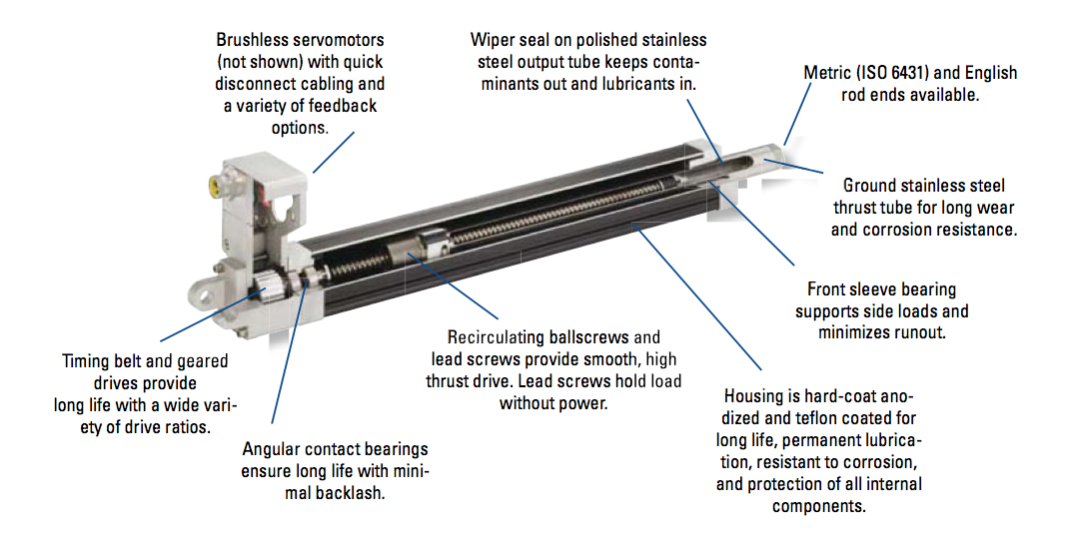

Figure ‑: Cut-away drawing of the EC series electric cylinders with the key design features [15]

AKM52H servomotor with AKD-B00607 digital servo drive provides a robust, precise servo drive system for the selected EC4 electric cylinders. Figure ‎2‑36 shows the thrust-speed performance curve for the AKM52G servomotors. The power of the motor is transmitted to the ball screw mechanism using a belt/pulley system with a reduction ratio of 2:1. A lead of 10 mm per revolution is selected for the actuators. The system specifications for the EC4 electric cylinders are presented in Table ‎2‑10. Different mounting options and stroke lengths are chosen for various positioning axes. The list of employed actuators for various positioning systems is tabulated in Table ‎2‑11.

Table ‎2‑10: System specifications for Kollmorgen EC4 electric cylinder

|  |  |  |  |
| --- | --- | --- | --- |
| Lead (mm/rev) | 10 | Repeatability (mm) | +/- 0.013 |
| Backlash (mm/rev) | 0.30 | Max thrust (lbs) | 2698 |
| Lead Accuracy (mm/300mm) | +/- 0.05 | Continious thrust (lbs) at speed of 5.3 in/s | 1396 |

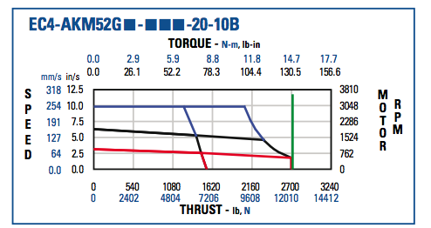

Figure ‑: The thrust-speed performance curve for the AKM52G servomotors [15]

The electric cylinders are equipped with motor brakes. The electrically released, spring set brake prevents back driving when the unit is at rest, or in the case of a power failure. When power is applied, the brake releases and the cylinder is free to move. When power is off, springs engage the brake to hold the load in position. The brake torque is multiplied by the belt reduction ratio. However, if the belt fails, the brake will be inoperative. The brake applies a torque of 14.5 N.m, which is equivalent to a holding force of 36 kN for the electric cylinder.

To maximize cylinder life, end-of-travel “limit switches” (position sensors) are used for all the cylinders. The purpose of an hall-effect end-of-travel sensor is to signal the controller that the cylinder is about to travel beyond its normal safe operating region, and is nearing its real end of the stroke. The controller brings the cylinder to a stop to prevent physical contact and to avoid damage to the cylinder or the machine. The sensors must be located such that an adequate stopping distance is provided between the sensing position and the real end of stroke [15].

Table ‎2‑11: Selected EC4 electric cylinders for different positioning systems

|  |  |  |  |  |
| --- | --- | --- | --- | --- |
| Positioning axis | Stroke length (mm) | Mounting option | Rod end type | # of EC |
| Lateral | 100 | MS2 Side Lugs Parallel | FS2 Spherical Joint Dimensions | 1 |
| Cant angle | 100 | MP3 Clevis Mount with Pivot Base and Pin | FS2 Spherical Joint Dimensions | 2 |
| Angle of attack | 100 | MP3 Clevis Mount with Pivot Base and Pin | FS2 Spherical Joint Dimensions | 1 |
| Vertical | 200 | MS2 Side Lugs Parallel | FS2 Spherical Joint Dimensions | 2 |

|  |  |
| --- | --- |
|  |  |

Figure ‑: Hall-effect end-of-travel sensors for signaling the end of stroke for EC4 cylinders [15]. Right) Installed Hall-effect sensor in action

# Delivered Electromechanical Systems

## Power Architecture

### Mains Network

ServoStar servo-amplifiers are supplied from 3-phase symmetrically grounded (earthed) industrial supply networks. Permissible network types are TN and TT systems with grounded neutral point with no more than 42krms symmetrical amperes rated current at $480{VAC}^{+10\%}$ maximum [16]. In a TN system, the neutral line of the transformer supplying th.e power is earthed. Grounding is performed at this neutral point. TN Systems are subdivided into TN-C, TN-C-S, and TN-S according to the design of the protective conductor.

In TN-C systems, a PEN conductor acts as both protective earth (PE) and neutral line (N). Since the neutral line is a current carrying conductor when the three phases are unevenly loaded, a voltage differential is usually present between the housings of the equipment connected to a PEN conductor and the earth. This voltage difference is generated from the PEN conductor’s resistance due to Ohm’s law. If the PEN conductor is interrupted in a TN-C system, the full outer conductor voltage (i.e. up to 480V) will be applied to the device housings connected downstream of the interrupt point. This is due to the connection between the outer conductor and the PEN conductor within the instrument. IEC 60364 limits the smallest cross section of the PEN conductor to $10 mm^{2}$ copper and $16 mm^{2}$ aluminum, in order to minimize the risk of PEN interruption [17]. Figure ‎3‑1 shows a TN-C system schematically.

Transformer

PE

L1

L2

L3

PEN

Load

Figure ‑. TN-C System

A TN-CS system is similar to TN-C from a transformer point of view. Unlike TN-C, however, the PEN conductor is separated into PE and N at some point downstream of the point where the cross section of the PEN conductor is required to be above the minimum stipulated cross section. After that, the PE and N conductors are channeled separately and must not be combined with the rest of the network.

Transformer

PE

L1

L2

L3

N

Load

PE

Figure ‑. TN-CS System

In a TN-S system, a separate neutral line and protective earth are channeled all the way from the transformer to the consumables. The problems caused by interruption of PEN conductor in TN-C and TN-CS systems do not occur in TN-S systems. Therefore, TN-S is safer than other TN systems. This method is predominantly used in the major industrial systems that are equipped with their transformer and are typically supplied with medium voltage.

Transformer

PE

L1

L2

L3

N

Load

PE

Figure ‑. TN-S System

Periodic over-voltages between phases (L1, L2, and L3) and the housing of the servo-amplifier must not exceed 1000V crest [9]. By IEC 61800, voltage spikes less than 50μs between phases must not exceed 1000V. Moreover, voltage spikes less than 50μs between a phase and the housing must not exceed 2000V [18]. In the case of mains voltage asymmetry more than 3%, a mains choke must be used. Table ‎3‑1 summarizes the power, voltage, and current requirements for the VT Roller Rig.

Table ‎3‑1. Minimum estimated power, voltage, and load requirement of the VT Roller Rig

|  |  |  |  |
| --- | --- | --- | --- |
| Equipment | Power (KVA) | Voltage (V) | Current (A) |
| ServoStar | $$2×50$$ | $$3×208 to 480VAC$$ $$50 to 60Hz$$ | $$2×60$$ |
| AKD | $$6×4.49$$ | $$3×240 to 480VAC$$ $$50 to 400 Hz or DC$$ | $$6×5.4$$ |
| PSU | $$2×1.46$$ | $$3×320 to 575 VAC$$ $$45 to 65Hz$$ | $$2×2.1$$ |
| Other | $$10$$ | $$3×240 to 480 VAC$$ $$50 to 60Hz$$ | $$40$$ |

American Electric Power Company (AEP) agreed to upgrade the existing 3-phase 480/277 VAC service at the CVeSS facility from 600A to 800A. AEP engineers calculated that the additional electrical load could be added to the existing transformer and used a spare 4” PVC conduit to provide an additional 200kVA dedicated to the Roller Rig. To perform the upgrade, CVeSS was required to update the CT cabinet per AEP specifications [19]. CVeSS was also responsible for following the service meter and disconnect regulations provided on the AEP Service Guide [20]. CVeSS sought professional help from Bell Electric of Blacksburg Inc. to perform the required modifications for the service upgrade. Figure ‎3‑4 shows the APCO specifications followed throughout the service upgrade.

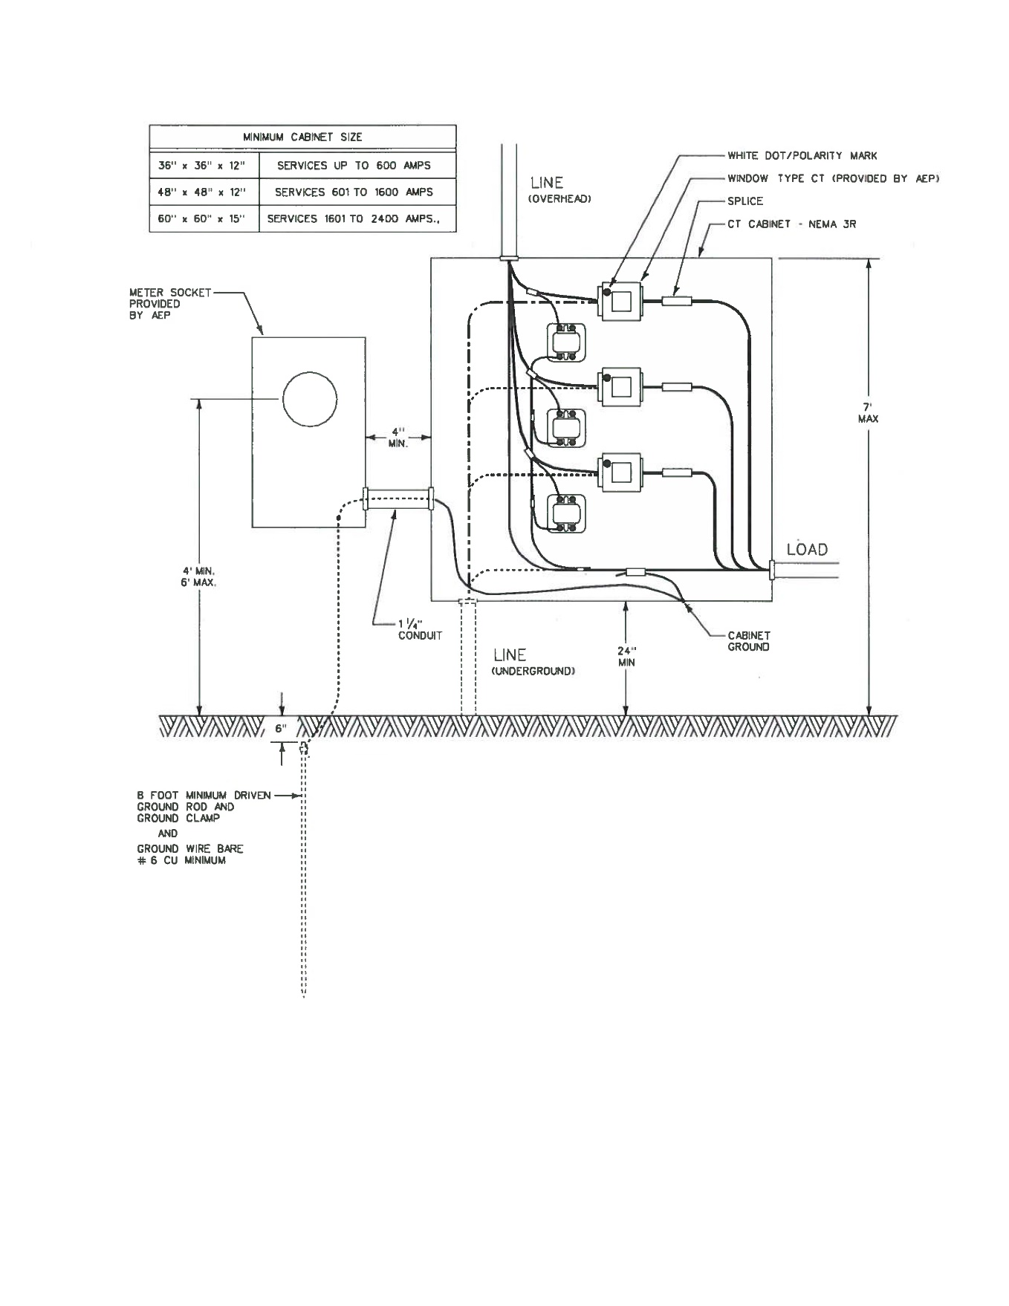

Figure ‑. AEP specifications for 600A to 800A service upgrade [19]

### Isolating Transformer

Considering the high sensitivity of digital drives to the incoming power noise, proper isolation is required to eliminate the electrical noise coming in from the electrical service. Isolating transformers have been considered as a traditional solution for providing high isolation in electronic circuitry without adding too much size, weight, complexity, and cost to the system. They offer an effective means for meeting the requirements of domestic and international safety standards for electronic equipment. In the United States, such standards are set by the Occupational Safety and Health Administration (OSHA), with product testing performed according to appointed laboratories, such as Underwriters Laboratories (UL). Throughout Europe, safety standards are established by the International Electrotechnical Commission (IEC), with testing performed by the laboratories of individual member nations, such as the Verband Deutscher Electrotechniker (VDE) in Germany.

Considering possible future expansions in the VT Roller Rig, the load may incorporate linear power supplies, switched-mode power supplies (SMPS), or a combination of both. A single isolating transformer can help the system design meet all of the isolating requirements now and in the future. SMPSs convert AC voltage to DC directly in an off-line rectifier followed by a capacitive filter. The converted high voltage is switched at frequencies from kHz to MHz. MOSFETs are used to switch the voltage waveforms on and off. The output voltage of the SMPS is proportional to the pulse width of the switched or chopped waveform and duty cycle of the pulse wave.

By modulating the pulse width of the output waveform, the output voltage can be automatically adjusted. Pulse-width-modulated (PWM) voltage is applied to the motor terminals. During both rising and falling edges of the PWM voltages, the motor case tends to follow the voltage applied due to the capacitive coupling from the motor winding to the motor case. Current will flow in the ground wire of a grounded motor when the voltage rises and falls. These current pulses are short in duration and occur at the PWM frequency. Electrical noise due to these pulses can radiate if proper shielding techniques are not used. Shielded motor cables with the ground can prevent the radiated or capacitively coupled noise to other cables. Another effective technique is to use tightly bundled or twisted motor cables with ground. Detailed discussions on electromagnetic shielding and grounding are provided in {ELECTROMAGNETIC SHIELDING PAPER}.

When used with an SMPS, an isolating transformer can prevent higher-order harmonic signals from degrading the performance of consuming circuitry. This is especially important for microprocessors, which rely on harmonically rich, high-frequency clock signals for their timing. Improperly isolated, these harmonic signals can appear as interference to other functions in the system, even resulting in excessive output voltage ripple in the power supply.

Motor manufacturer recommends using an isolating transformer for 400V to 480V networks that are asymmetrically grounded or not grounded as shown in Figure ‎3‑5 [9]. At the CVeSS facility, protection against indirect contact is vital, and the highest level of shock hazard protection is maintained. The ServoStar and AKD drives can be operated via a 3-phase isolating transformer with Wye-N secondary connection, 480Y/277 secondary voltage, Delta primary connection. The latter requirement is due to the existing service available at the CVeSS. Moreover, CSA and UL approvals are required, and the transformer should comply with DOE/TP1 and C802.2 efficiency regulations.

The performance of an isolating transformer can be affected by temperature [21]. As a result, isolating transformers often add cooling requirements to the design. An effective way around this issue is using K-factor transformers instead of regular ones, wherever possible. K-factor transformers are designed to tolerate heating due to harmonics associated with non-linear loads [22]. Harmonics can indicate their presence in many ways: over-heating, device malfunctions, telephone interference, equipment vibration, and breakers tripping.

The HPS Sentinel energy efficient K-factor transformers (Hammond Power Solutions, Inc., WI, USA) are designed to tolerate heating due to harmonics associated with non-linear loads. These components have become a popular means of addressing overheating problems where drives, personal computers, electronic ballasts, telecommunication equipment and other similar power electronics are found in high concentration. For the purpose of the VT Roller Rig, a K20 transformer was selected. Table ‎3‑2 summarizes the specifications of the equipment.

Table ‎3‑2. Specifications for the VT Roller Rig isolating transformer

|  |  |
| --- | --- |
| Specification | Value |
| K-Factor | 20 |
| Rating | 200kVA 3Phase |
| Primary Voltage | 480D |
| Secondary Voltage | 480Y/277 |
| Frequency | 60Hz |
| Temperature Rise | 150ºC |
| Efficiency Regulation | DOE/TP1 and C802.2 |
| Impedance | 4% - 7% |

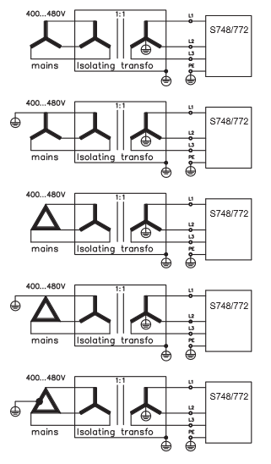

Figure ‑. Application of an isolating transformer [9]

### Power Filtering

Since the ServoStar servo-amplifiers are used in an industrial park and close to small industrial operations, then additional filter measures must be implemented. Moreover, these devices can cause high-frequency interferences in non-industrial environments. This requires measures for interference suppression like additional external EMC filters.

The filtering effect of the mains filters is only assured when the permissible power rating of the mains filters is not exceeded even on peak loading of the servo-amplifiers. The maximum permissible power rating of the mains filter ($P_{Fmax}$) is

|  |  |
| --- | --- |
| $$P_{Fmax}= \sqrt{3}V_{R}.I_{RF},$$ |  |

where $V_{R}$ and $I_{RF}$ are the rated voltage and current of the filter. Maximum power consumption of the servo-amplifier ($P_{Smax}$) is

|  |  |
| --- | --- |
| $$P_{Smax}=g\sqrt{3}V_{R}\sum_{i=1}^{n}{I_{peakSi}},$$ |  |

where $g$ is the coincidence factor($≤1$), $n$ is the number of axes on the filter, and $I_{peakSi}$ is the peak current of each servo-amplifier axis. For proper sizing the mains filters, $P_{Fmax}$ should be bigger than $P_{Smax}$.

Based on the motor manufacturer recommendation, the rated current of the filter $I_{RF}$ should be

|  |  |
| --- | --- |
| $$I_{RF}>2.\sum_{i=1}^{n}{I_{RSi}},$$ |  |

and $I_{RSi}$ is the rated current of the amplifiers on each axis. Assuming $g=1$ and single axis on each filter, $P_{Smax}$ is found to be $66.51 kVA (38.4 kW)$. Schaffner’s 3-phase FN 258 filters have been known as the industry standard EMC solution for power drive systems. The FN 258-100-35 component well satisfies the requirements of the VT Roller Rig. Table ‎3‑3 summarizes the technical data of this filter.

Table ‎3‑3. Technical data of 3-phase Schaffner FN 258-100-35 filters [23]

|  |  |
| --- | --- |
| Maximum continuous operating voltage | $$3×480/277 VAC$$ |
| Operating frequency | $$dc to 60Hz$$ |
| Typical drive power rating | $$55 kW$$ |
| Rated current | $$100 A at 50℃ (110 A at 40℃)$$ |
| Overload capability | $4×$ rated current at switch on, $1.5×$ rated current for 1 minute, once per hour |
| Leakage current | $$25.8 mA$$ |
| Power loss | $$51 W$$ |

Figure ‎3‑6 shows the 3-phase FN 258-100-35 filter and its block diagram. Typical filter attenuation of the FN 258 filters is also given in Figure ‎3‑6.

|  |  |
| --- | --- |
| **Fuses**  **Filters**  **To Amplifiers**  **From Transformer** | Attenuation (dB)  Frequency (Hz) |

Figure ‑. Schaffner FN 258-100-35 filter and its block diagram [23]

### DC Power

Multiple layers of safety and monitoring systems ensure maximum safety for the VT Roller Rig users and machinery. Extensive discussion of these systems is given in Section ‎3.3 of this document. Safe-Torque-Off (STO), Ready-to-Operate (RTO), Emergency Stop, Regenerative Dynamic Braking, Holding Brake, and Thermal Monitoring systems are the most critical safety systems that should remain ON regardless of the status of the Rig. Under no circumstances should the user be allowed to bypass these systems. Special procedures should be followed after killing the mains lines, before touching the servo-amplifiers inside the control cabinet. Simple disconnection of mains switch is not sufficient. This group of safety systems should not be excluded, even if the Logic ON-OFF is deactivated.

An uninterruptible auxiliary power system feeds the circuitry mentioned above at 24VDC. It consists of two parallel DC power systems that each can provide up to 40A rated current ($-25 °C to 70 °C$), and up to 215A peak current for 12ms. An electronic switchover unit switches to battery operation without interruption so that loads continue to be consistently supplied. It also provides information regarding the charging state, remaining runtime, and service life of the rechargeable battery module at all times and thereby increases system availability. One power supply feeds the RTO, Regenerative Dynamic Braking, Holding Brake, and the logic circuitry of servo-amplifiers. The negative pole of this power supply is grounded, since the voltage should be 24VDC non-floating. The other system feeds the STO, Hardware Enable, Logic ON-OFF, emergency stop, and Motor-Short Dynamic Braking circuits.

Each DC power system consists of a Quint-PS 3Phase-480VAC to 24VVDC power supply, a Quint-UPS 24VDC to 24VDC electronic switchover unit, and a 38Ah 24VDC battery (all from Phoenix Contact, Blomberg, Germany). The DC power system has a separate mains switch that is only manually switchable. It is isolated from the circuit breaker with shunt trip capability that feeds the servo-amplifiers. Shielded AWG10 power lines of the DC power supplies are protected with 16A circuit breakers against surges. Figure ‎3‑7 shows the DC Power system of the VT Roller Rig.

|  |
| --- |
| C:\Users\MHP\Google Drive\Dissertation\Material\pictures\DC Power.JPG |
| **Batteries**  **Power Supply**  **Switchover Unit**  **To Safety Systems** |

Figure ‑. Uninterruptible auxiliary DC power system of the VT Roller Rig

These two power systems run in parallel, but independently. In case higher operational safety is required, the systems could be interconnected in parallel for redundancy. If a fault occurs in one of the electronic switchover units, the second system automatically takes over the entire supply without interruption. With this configuration, each electronic switchover unit should be sized properly so that it can handle the total current requirements (80A). Figure ‎3‑8 is a schematic of the parallel connection of the two DC power systems for redundancy.

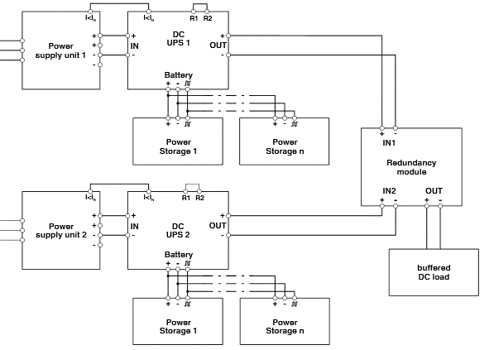

L1

L2

L3

PE

L1

L2

PE

L3

Figure ‑. Parallel connection of DC power systems for redundancy [24]

### DC-Bus

The regenerated power (due to braking or motor-generator operation mode) is divided between the two ServoStar servo-amplifiers by connecting them through a common DC–Bus link circuit. Each ServoStar servo-amplifier has a $900 μF$ capacitor. The rated voltage of the AKM84T motors are at least as high as the DC bus link voltage divided by $\sqrt{2}$ produced by the servo-amplifier ($U_{n×Motor}≥ U_{DC}/ \sqrt{2}$).

If one of the devices fails due to an internal short circuit, other devices can become damaged. Therefore, intermediate circuit fuses are required on the DC-Bus Link. If an internal short circuit occurs in one of the devices, only the intermediate fuses will be tripped, and the rest of the system continues uninterrupted. The sum of the rated currents for all of the servo-amplifiers connected in parallel to a ServoStar must not exceed 96 A. Figure ‎3‑9 shows the DC-Bus link topology between the two ServoStar servo-amplifiers.

If the under-voltage threshold is undershot in the DC bus link, the servo-amplifier generates a fault, and it will not be ready to operate (not RTO see Section ‎3.3.3). Contacts of the servo-amplifier may still be live, even after disconnecting the servo-amplifier from the main supply. The manufacturer recommends waiting for at least eight minutes after disconnecting the servo-amplifiers from the mains supply before touching potentially live sections of the equipment or removing any connections. The DC bus link voltages should always be measured and components not handled until the voltage is below 40V.

|  |  |
| --- | --- |
| C:\Users\MHP\Google Drive\Dissertation\Material\pictures\DC Bus2.jpg |  |

Figure ‑. DC-Bus link topology. The actual DC-Bus link is marked in red

## Grounding

### Star Ground Topology

All chassis ground, signal ground, or common points need to be tied together at a star connection internal to the equipment. A star connection is a single point ground. This star connection is then tied with a single conductor to an earth ground point [25]. The single conductor used in this technique is sized per the International Electrical Code (IEC) and should be low in inductance. Practicing this grounding technique will prevent ground loops and ensure properly grounded equipment against shock hazards. System grounding is essential for proper performance of the drive system. Figure ‎3‑10 compares the correct and incorrect grounding topologies.

In addition to the safety grounding, a high-frequency ground must be provided that connects the back panel to the enclosure and, ultimately, to earth ground. The objective is to provide a highly low impedance path between the filters, drives, power supplies, and earth ground. This high-frequency ground is accomplished with the use of a flat braid or copper bus bar. It is important not to rely on a standard wire for the high-frequency ground. In general, a cable has an inductance of 8 nH-per-inch, regardless of diameter. At higher frequencies, this unwanted inductance between grounds equates to limited filter performance.

|  |  |
| --- | --- |
|  |  |

Figure ‑. Correct star ground connection (left) versus incorrect daisy chain ground (right) [25]

Two new $5/8''$ (D) by $8'$ (L) copper-clad steel rods were installed at the CVeSS facility for the Roller Rig. The procedure for installing the ground rods included:

1. A 3-inch diameter hole was augured to a depth of X, 6 inches shorter than the length of the ground rod
2. The ground rod was placed into the augured hole and driven 1 foot (if possible) into bottom of the hole
3. Connections to ground rod using were made using ERICO CADWELD Exothermic connections (Pentair, Manchester, UK)
4. Ground Enhancement Material (GEM) was premixed into a slurry form
5. The appropriate amount of GEM was poured around the ground rod
6. The area around the ground rod was tamped with a pole to ensure the GEM material completely fills the hole
7. After 1 hour, the hole was filled with soil backfill
8. The ground resistance was measured to ensure the ground rod had impedance less than 20Ω

For measuring the ground resistance, an EXTECH Digital Earth Resistance Tester (FLIR Systems, Inc., MA, USA) was used. The test with one ground rod showed a 32.7Ω resistance. Therefore, a second ground rod was added at least one ground rod length away from the first rod. Stranded green THHN wire was used to connect the two ground rods. The second test showed 19.5Ω resistance for the two rods, which is less than the design goal for the VT Roller Rig.

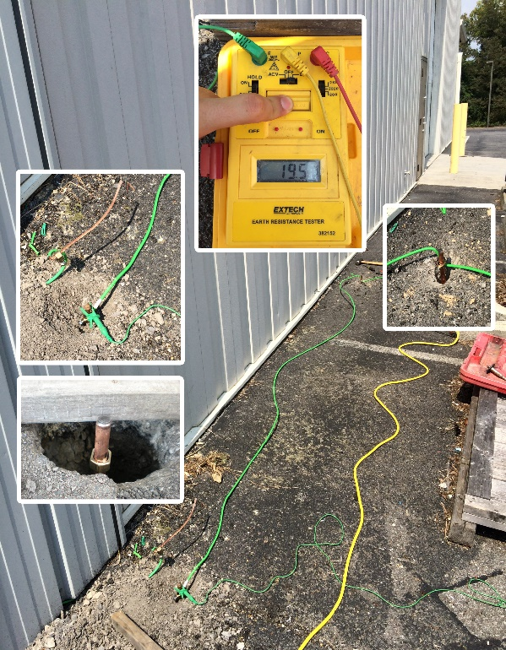

**First Ground Rod**

**Second Ground Rod**

Figure ‑. Earth resistance testing

### Shield Grounding

The rules for grounding the cable shield differ significantly from one system to another [26]. While some engineers believe in grounding the shield at one end to prevent ground loops [27], motor and power supply manufacturers have had repeated experiences were undesired noise was only eliminated through grounding both ends [28,29]. Some application notes specifically instruct the user not to terminate both ends of the shield to ground [30]. Meanwhile, others claim that if a cable’s shield is grounded at one end only the opposing end of the shield is under-grounded, and it can represent a fire and shock hazard if the cable’s shield becomes energized due to AC power system ground faults [31]. There is even a debate among those who agree with one end grounding on whether termination should be on the signal’s source side or the receiver side.

The myth originates from the fact that low-frequency crosstalk is the sum of inductive and capacitive coupling contributions [32]. If the shield is grounded at one end, the shield voltage becomes zero, and the capacitive coupling will be ideally eliminated. Consequently, shielding a wire and grounding the shield at only one end will reduce the crosstalk only for high-impedance loads where capacitive coupling dominates inductive coupling before the addition of the shield. If inductive coupling dominates capacitive coupling before the addition of the shield, grounding the shield at only one end will not reduce the total crosstalk, and the shield will be ineffectual. In the case of low-impedance loads, a shield will reduce the total crosstalk by reducing the dominant inductive coupling component only if it is grounded at both ends. This allows a current to flow back along the shield which provides a magnetic flux that cancels the magnetic flux from the generator circuit current.

From numerous discussions with experts in the field, and comparing textbooks with product instruction manuals, the final answer is that no single approach can fit all. The final approach for each system is a combination of source-side grounding, receiver-side grounding, and both-side grounding. To understand this statement, one should look at the frequency response and sensitivity. Tube receivers from 1960’s had a combination of grounds at both ends. Audio sections of the same devices were grounded at one end. For the tuner section, the unwanted noise was the high frequency (above $108.1MHz$ in the US). In order to use both magnetic and capacitive coupling shields, grounds at both ends with no break in the shields were used. The audio section, however, was susceptible to 60 Hz, which is a low frequency. It was also sensitive to ground differentials, therefore it had grounds at one end, the source side.

In today’s circuitry, differential inputs are used to resolve the low-frequency noise caused by ground differentials. In cases where a single-ended signal with high gain is shielded, one may have to use an isolated ground. Primary shields may be used with internal shields grounded at one end, and secondary shields referenced at both ends for rejecting the high frequency. A good example of such signal in the VT Roller Rig is the force measurements from the dynamometer charge amplifiers. All measurements are single ended with a common ground. Provisions for grounding the shields at both ends assures maximum noise attenuation. The ultimate grounding solution remains to be verified through testing.

A common direct coupled noise source is when the ground that is being used for return or reference is not referenced to earth as expected. This is especially prevalent in a sensitive high-gain circuit like the VT Roller Rig. An important criterion in proper ground referencing in this system is separating the earth ground and neutral line in the power system. As shown in Figure ‎3‑12, the earth ground and the neutral are at the same potential only at the main transformer in a power distribution network. Connecting the power return of the line to the ground instead of neutral would work, but it would likely put unintended noise on the ground line, negatively affecting all of the devices connected to it. The difference between the neutral line and earth ground is that neutral is a current carrying conductor while earth ground is a non-current carrying conductor by definition.

Transformer

Phase I

Phase II

Phase III

Neutral

Ground

Copper Rod

Ground and Neutral at the same potential at the main transformer

Figure ‑. Coupled noise source due to connection between ground earth and neutral line

### Additional Measures

To reduce the noise coupling possibilities, control and signal cables must be separated from power and motor wires. A distance of 20cm (8 in.) is sufficient in most cases. These cables should also be shielded to reduce the effects of radiated interference. Where control cables cross power or motor wires, they should have an angle of 90 degrees to reduce the electromagnetic coupling effect.

The motor should be grounded close to the servo-amplifier to obtain the lowest impedance to the current source. This reduces the noises in the machine grounds. The expense of this technique is an excessive amount of cable that complies with local electric codes. These cables are often expensive. Any unused wires should be terminated to ground to reduce the noise risks.

The eight servo-drives is shown in Figure ‎3‑13 drive eight permanent magnet AC servomotors of Figure ‎1‑1. These devices are manufactured according to certain EMC standards (i.e. IEC61000). Nevertheless, customary shielding is essential for preventing interference. VT engineers were warned by the motor and drive manufacturer that the digital servo-drives will radiate high amplitude electromagnetic noise that sweeps the whole range of low frequency to 5MHz. Other sensitive motion control electronics, as well as all the sensory systems nearby, could be affected by this noise. Therefore, VT engineers paid particular attention to the task of designing a proper shielding for the PWM power electronics. The approach taken at the RTL to design a proper shield (Faraday Cage) for a slew of PWM controlled power electronics running the VT Roller Rig testing facility is reported in [ELECTROMAGNETIC SHIELDING PAPER]. Figure ‎3‑13 shows the custom fabricated Faraday Cage for the VT Roller Rig. The Faraday Cage, cable shields, and motor housings are connected the isolated ground rod. Inside the Faraday Cage, all panels are bonded together using braided cables at paintless spots.

|  |  |
| --- | --- |
| C:\Users\MHP\Google Drive\CVeSS\Roller Rig\Pics\Cabinet\Final\IMG_0086.JPG | C:\Users\MHP\Google Drive\CVeSS\Roller Rig\Pics\Cabinet\Final\IMG_0077.JPG |

Figure ‑. The enclosure for the control tower of the VT Roller Rig

## Safety and Monitoring

The Stop function is used to shut down the machine in normal operation. The Stop functions are defined by IEC 60204. The Stop Category must be determined by a risk evaluation of the machinery.

**Category 0:** Shut-down by immediate switching-off of the energy supply to the drive machinery (i.e. an uncontrolled shut-down). Such functionality can be implemented with Safe-Torque-Off (STO) circuit (Section ‎3.3.1).

A wiring example for stop Category 0 is given in Figure ‎3‑14. The switching sequence is precisely determined by this circuit to avoid undesirable fault messages and servo-amplifier failures. It is not possible to achieve a Category 0 shut-down with the servo-amplifier alone since hard-wired electromechanical components are compulsory for this type of disconnection. To meet Category 0, a brake that is built into the motor must have an additional electromechanical control circuit, as well as the control by the servo-amplifier,

Usually, a brake in a servo-motor only functions as a holding brake (Section ‎3.3.5), not means for deceleration. To ensure an emergency stop function, the braking torque that is required for decelerating the entire mechanical system is calculated. Using the holding brakes for deceleration leads to significantly increased wear in the motors.

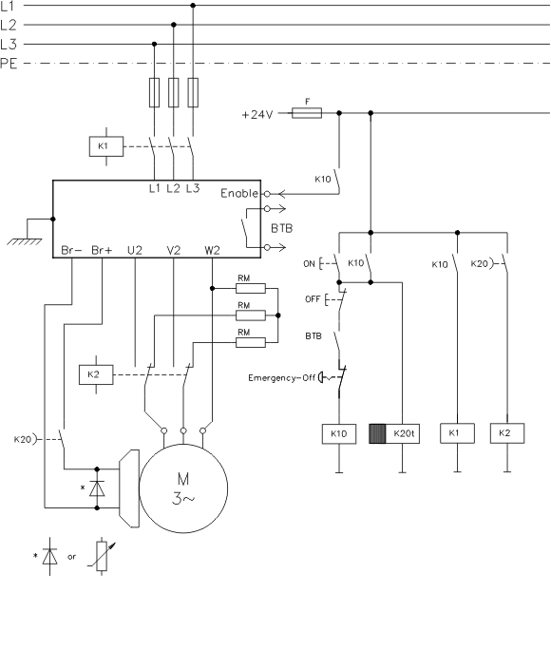

Figure ‑. Wiring example for stop Category 0 [9]

**Category 1:** A controlled shut-down, whereby the energy supply to the drive machinery is maintained to perform the shut-down, and the energy supply is only interrupted when the shutdown has been completed. This function can be implemented with a Hardware Enable circuit (Section ‎3.3.2)

A wiring example for stop Category 1 is given in Figure ‎3‑15.. The logic power (often 24 V) supply for the servo-amplifier must remain on for Category 1 stop. The drive is braked in a controlled manner during the stopping (disabling) procedure. If the speed drops below a certain threshold, the holding brake will be applied, and the output stage will be disabled.

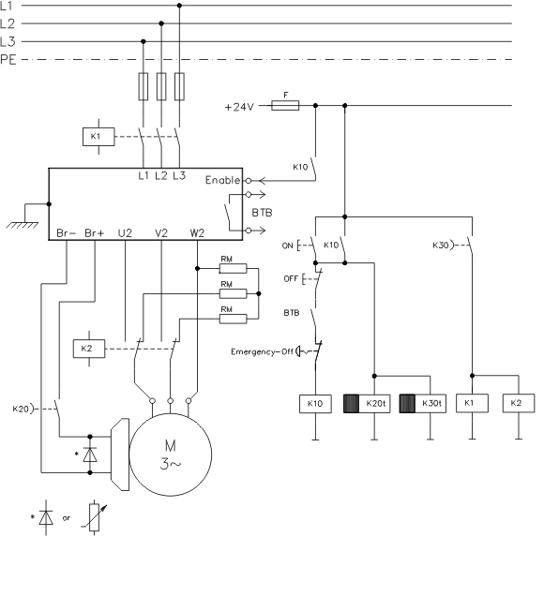

Figure ‑. Wiring example for stop Category 1 [9]

**Category 2:** A controlled shut-down, whereby the energy supply to the drive machinery is maintained. This functionality is often implemented in motion controlling software. A wiring example for stop Category 2 is given in Figure ‎3‑16. The drive is braked in a controlled manner during the stopping (disabling) procedure. If the speed drops below a threshold, the holding brake is applied, and the output stage remains enabled. In this case, there is no interruption of the electrical supply.

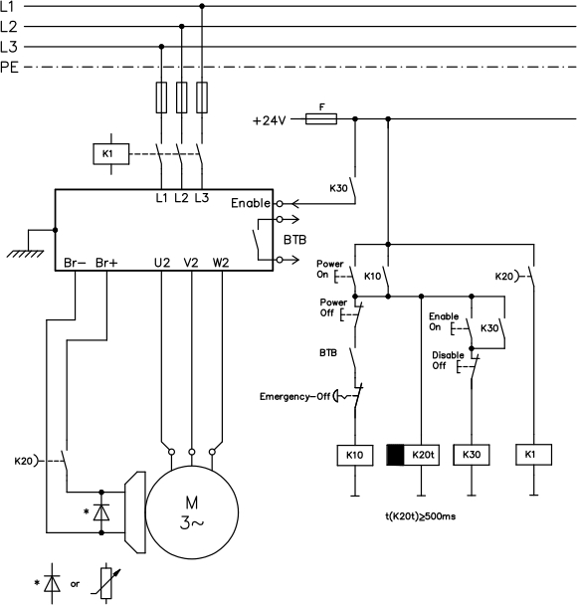

Figure ‑. Wiring example for stop Category 2 [9]

The Stop Category must be determined by a risk evaluation of the machine. Also, suitable means must be provided to guarantee a reliable shut-down. Category 0 and Category 1 Stops must be operable independently of the operating mode, whereby a Category 0 Stop must have priority. Stop functions must be implemented by **disconnection** of the appropriate circuitry, and take precedence over assigned start functions. Figure ‎3‑17 compares the controlled and uncontrolled stops. In Category 1 and 2 stops, the brake will get engaged after velocity drops below a certain threshold or when a speed threshold timeout saturates. In Category 0 stop, the brake will be engaged after the disable timeout saturates.

Velocity

Time

Controlled Stop

Deceleration Ramp

Uncontrolled Stop

Disable Timeout

Power Stage Disabled and Holding Brake Active

Power Stage Disabled and Holding Brake Active

Velocity Threshold

Velocity Threshold Timeout

Figure ‑. Comparison between stop categories

If necessary, provision must be made for the connection of protective devices and lock-outs. If applicable, the Stop function must signal its status to the control logic. A reset of the Stop function must not create a hazardous situation.

Table ‎3‑4. Function of safety circuits in the VT Roller Rig

|  |  |
| --- | --- |
| **Safety Circuit** | **Function** |
| Safe Torque Off | Monitoring the safety gate and unintentional restart prevention |
| Hardware Enable | Activating the output stage of servo-amplifiers |
| Ready-to-Operate | Monitoring internal faults of servo-amplifiers |
| Logic On-Off | Turning the drive logics ON and OFF |
| Emergency Stop | Implementing emergency stop |
| Dynamic Braking | Activating the dynamic brake resistors for electrodynamic braking |
| Holding Brake | Controlling the holding (static) brake |
| Temperature Monitoring | Monitoring the temperature of other electronic components and notify the user if over-temperature occurs |

### Safe-Torque-OFF (STO) Safety Circuit

A frequently required application task is the safe torque off and the protection of personnel against unintentional restarting of drives. With the functional, safe restart lock STO, the drive can be secured on standstill using its internal electronics so that even when power is being supplied, the drive shaft is protected against unintentional restart. The 772 servo-amplifier offers a two-channel Safe-Torque-Off (STO) function. The function blocks the trigger pulses of the power transistors (pulse inhibitor). The STO safety function corresponds to stop category 0 (uncontrolled stopping) according to EN60204-1. When STO is engaged during operation, drives generates a fault, and the motor runs down out of control, and there is no possibility of stopping the drive controllably.

The STO function is exclusively intended to provide functional safety, by preventing the restart of a system. To achieve this functional safety, the wiring of the safety circuits must meet the safety requirements of IEC 60204, ISO 12100, IEC 62061 respectively ISO 13849-1. The STO function must not be used if the drive is to be made inactive for the following reasons:

1. Cleaning, maintenance and repair operations, long inoperative periods: In such cases, the entire system should be disconnected from the supply by the personnel, and secured (Section ‎3.3.4).

2. Emergency-stop situations: In an emergency-off situation, switched off the main contactor (Section ‎3.3.5).

The safety function STO can be operated from external safety relays, from a safe external control (semiconductor output or driven contact) or the built-in safety card. It can be implemented with single-channel or dual-channel control with simple safety switching devices (corresponding to SIL CL2 in EN62061 and PLd Cat3 in EN13849-1).

**Advantages of the safety function STO:**

* The DC bus link remains charged up since the mains supply line remains active
* Only low voltages are switched, so there is no contact wear
* Simple wiring is required
* Single or dual channel control possible

In the case of single channel usage of STO, erroneous engaging will not be recognized. Therefore, the output of the control unit must be supervised for possible malfunction. With the dual-channel monitoring of the STO safety function, the switch-off paths are switched separately by two outputs of a safety switching device (e.g. safety relay). To reduce the risk of relay malfunction, a control circuit with dual-channel SIL CL2/PLd Cat3 is designed for all eight axes (2 AKM84T and 6 EC4). Figure ‎3‑18. shows the circuit diagram for both wheel and roller axes.

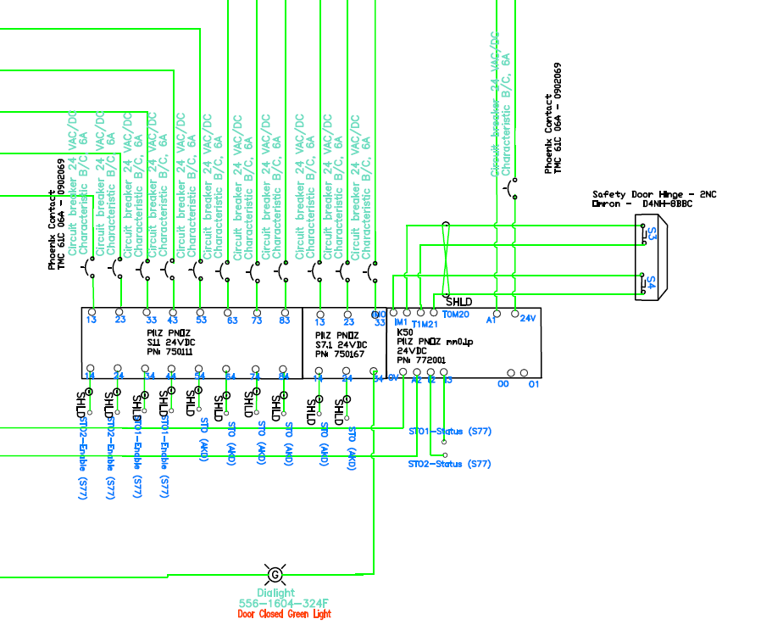

Safety Gate

Solid State Relay with Two Expansion Modules

Figure ‑. Dual-channel SIL CL2/PLd Cat3 STO control circuit for eight axes

The STO of the drives is switched by a dual channel normally-closed safety door hinge. The hinge is mounted on the door of a protective screen that encloses the Rig. The safety switch gears used in this circuit include a programmable solid-state safety relay with two input channels, an extension solid-state relay with three normally-open contacts, and another extension solid-state relay with eight normally-open contacts. Shielded AWG16 load lines are protected with twelve 6-Amp circuit breakers. A green indicator light visually represents the status of STO signals.

### Hardware Enable Safety Circuit

Two enable commands are required for activating the output stage of the drive:

* Enable signal for the servo-amplifier, Hardware-Enable with 24V signal
* Software-Enable command by setup Software, Fieldbus or permanently set

Both are required for enabling the amplifier. Software enable means that motion program in properly uploaded on the drive and motion control is ready. However, this can also be permanently enabled and monitor the output stage of the drive through Hardware Enable safety circuit. Enable is possible only if both inputs of STO have a 24V signal. Table ‎3‑5 clarifies the possible status that may happen between STO and Hardware Enable.

Table ‎3‑5. Possible servo-amplifier status between STO and HW-Enable

|  |  |  |  |
| --- | --- | --- | --- |
| **STO1 and STO2** | **Hardware Enable** | **Motor Torque** | **Drive Status** |
| 0 V | 0 V | No | Error |
| 0 V | +24 V | No | Error |
| +24 V | 0 V | No | Normal |
| +24 V | +24 V | Yes | Normal |

Voltages between -3 and 5V are considered low, and 15 to 30V are considered high. When Hardware Enable has low voltage (like an emergency stop), drive generates a fault, and speed-controlled braking with an emergency ramp (Category 1 stop) will bring the motor to stop. When the speed drops below a certain threshold, the output stage will be disabled, and the amplifier will not be ready to operate (not RTO, Section ‎3.3.3). Standard operation is possible when the error has been quit (Emergency Stop released). Figure ‎3‑19. shows the Hardware Enable circuit for the VT Roller Rig. The circuit constitutes of a dual input solid-state relay with two normally-open contacts, a solid-state extension relay with eight normally-open contacts, an illuminated momentarily pushbutton (reset), Eight 6-Amp circuit breakers, a green indicator light, and AWG 16 shielded wires. The circuit implements Hardware Enable for eight axes. Inputs of these relays are taken from the emergency stop circuit.

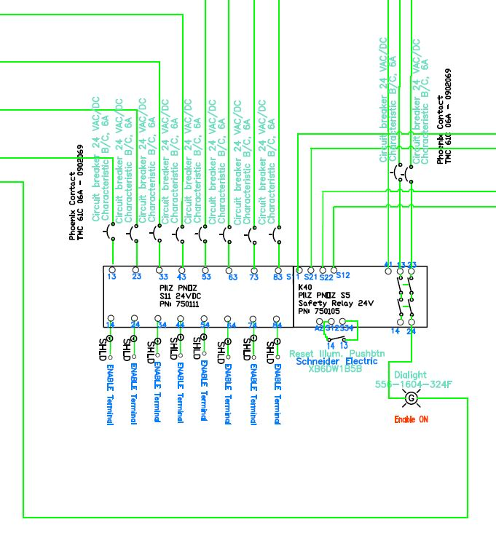

Double-Contact Controlled Stop Switch

Solid State Relay

Figure ‑. Hardware Enable control circuit for eight axes

### Ready-to-Operate (RTO) Safety Function

Ready-to-Operate (RTO) function is an internal contact of the ServoStar servo-amplifier that is signaled by a floatingrelay. The contact is closedwhen the servo-amplifier is ready for operation, and the signal is notinfluenced by the Hardware Enable signal, or the brake threshold (Sections ‎3.3.1 and ‎3.3.5.1). Unlike STO and Hardware Enable that monitor external events, RTO is dedicated to internal faults. RTO is implemented by the manufacturer with high sensitivity to the possible abnormal conditions. All faults cause the RTO contact to open and the output stage to be switched off. Table ‎3‑6 provides a list of most significant internal faults that will cause the RTO contact to open. The third column of the table gives reference to the section of this document where more information about that fault can be found. If the RTO contact is open, the output stage of the drive is disabled and has not power output to the motor.

While the servo-amplifiers would open the RTO contacts in case of the above faults, an intermittent circuit is required to integrate the VT Roller Rig emergency stop circuit and the two RTO contacts of the servo-amplifiers. The output of this circuit would be turned off if any fault occurs, either internally or externally. This signal is a summarized representation of all safety and monitoring systems of the Rig. For the initial tests with the VT Roller Rig, this signal is fed into the shunt tripping circuit of the I-Line panel (mains 3-phase circuit breakers). Figure ‎3‑20. shows this circuitry.

Table ‎3‑6. Internal faults that cause the RTO contact to open

|  |  |
| --- | --- |
| **Fault** | **Reason** |
| Overvoltage | Overvoltage in DC bus link. Limit depends on the electrical supply voltage |
| Undervoltage | Undervoltage in DC bus link (default: 100 V) |
| Internal Voltages | Internal supply voltages not ok |
| Heat Sink Temperature | Heat sink temperature too high (default: 80 °C) |
| Motor Temperature | Motor temperature too high or temperature sensor is defective |
| Ambient Temperature | Ambient temperature too high |
| Overspeed | Motor speed is too high |
| Motor Phase | One or more motor phases are missing (e.g. cable break) |
| Output Stage | Fault in the power output stage, also with wrong motor cable or insufficient cable shielding |
| STO | Operational error with STO |
| Emergency Stop | Emergency stop circuit is activated, or Emergency stop timeout has reached |
| Brake Circuit | Brake circuit faulty or incorrect setting |
| Feedback | Cable break, short-circuit, short to ground |
| System Software | System software not responding correctly |

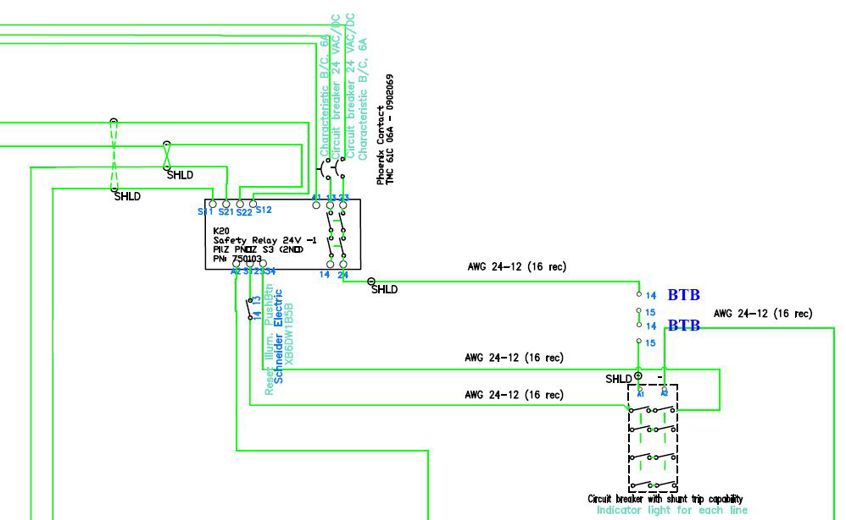

Switches inside ServoStar Drives

3Ph I-Line Panel with Shunt-Trip Capability

Double-Contact Emergency Stop Switch

Solid State Relay

Figure ‑. RTO intermittent circuit

### Logic ON-OFF

This section describes the circuit that controls the logic power of the ServoStar and AKD drives. It is important to note that motors may be in stand-still position, or the output stage of the drives may be deactivated while the logic power is still ON. If the Logic ON-OFF is switched OFF, the following circuits will lose control over the system or switched OFF: Hardware Enable, Emergency Stop, and Motor-Short Dynamic Braking. However, the following will remain ON: STO, RTO, Regenerative Dynamic Braking, Holding Brake, and Thermal Monitoring. The second group should never be switched OFF, even if the Logic ON-OFF is deactivated. As described in Section ‎3.1.3, the power to these circuits is backed up by interruptive power supplies. The only way to kill these systems is via the mains service switch, and manually removing both back up UPSs.

This circuit constitutes of a normally-open illuminated momentarily pushbutton (ON), a normally-closed illuminated momentarily pushbutton (OFF), a 4-pole-double throw mechanical relay, a protective lock for the OFF button, a red indicator light, a green indicator light, and AWG16 shielded cables. When the ON button is pressed, the 4PDT relay is energized, and the emergency stop relay is activated. One of the contacts of the emergency stop relay is fed back to the 4PDT relay after the ON switch. This means that, as the ON switch is released, the 4PDT relay remains energized. The OFF switch sits between the emergency stop relay and the 4PDT relay. If it is pressed, the feedback line opens and the 4PDT relay halts. Figure ‎3‑21. shows the Logic ON-OFF circuit for the VT Roller Rig.

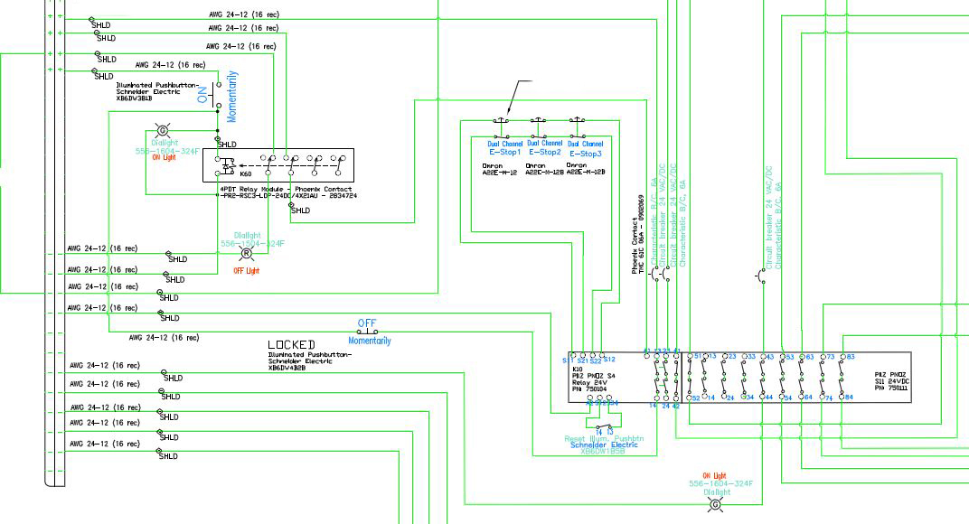

Latching E-Stop Switches

4PDT Relay

Solid State Relay with Expansion Module

Figure ‑. Logic ON-OFF and Emergency Stop circuits for the VT Roller Rig

### Dynamic Braking

Dynamic braking is a general term that denotes application of various electrical or mechanical systems for bringing the AKM84T motors to stop from a non-zero speed. For the VT Roller Rig, different mechanical and electrical systems were considered for dynamic braking. Integration of mechanical disk brakes into the powertrain adds significantly to the complexity of the driveline. On the other hand, engaging mechanical brakes while the output stages of the drives are active can lead to over-voltage in the motor or DC-bus. Applying mechanical brake should also be synchronized between both wheel and roller drivelines. Otherwise, excessive torque will be enforced to one brake mechanism. Considering the rotational speed of the drivelines, any possible breakage in the brakes can lead to serious safety hazards. Moreover, synchronizing the two mechanical brakes will require additional control and monitoring gears. After numerous discussions with application engineers of the motors and gearheads suppliers, two alternative approaches were selected for dynamically braking the Rig.

#### Regenerative Dynamic Braking

In this method, mechanical energy is converted into electrical energy using the motor regeneration and is fed back into the servo-amplifier. A part of this braking energy is stored in the DC link bus capacitors of the servo-amplifier. If these capacitors are filled, the brake energy is led to the regenerative resistors to be dissipated as heat. The regenerative resistors are switched in by the brake circuit. The setup software can be used to adapt the brake circuit (thresholds) according to the electrical supply voltage.

Electric power stored in the DC Link capacitors ($E_{s}$), depends on the mains supply voltage. $E_{c}$ is the amount of additional energy that can be stored in the bus capacitors during motor regeneration before the shunting resistor circuit is closed. This is the difference between the peak energy (Joules) in the bus capacitors and the nominal energy stored. Specifically: $\frac{1}{2}CV^{2}$, (where C is the capacitance in farads and V, is the peak bus voltage when the shunting transistor turns on, minus the minimal energy value $\frac{1}{2}CV^{2}$ based on the nominal bus voltage. ServoStar servo-amplifier have $900 μF$ capacitors. The rated voltage of the motors must be at least as high as the DC bus link voltage divided by $\sqrt{2}$ produced by the servo-amplifier ($U_{n×Motor}≥ UDC/ \sqrt{2}$). Based on motor manufacturer data at 3Ph 480V, $E_{c}$ is $110J$. From that the reduced speed due to the power storage in DC capacitors can be found with [33]:

|  |  |
| --- | --- |
| $$n_{2}= \sqrt{n_{1}^{2}-E_{c}×\frac{219}{J+J_{ext}}}$$ |  |

where $n_{1}$ is the maximum speed of the motor, $J$ is the inertia of the motor in $\frac{kg}{m^{2}}$, $J_{ext}$ is the inertia of the load, and $n_{2}$ is the reduced speed of the motor. The rest of mechanical energy is dissipated in regenerative resistors ($E_{Brems}$). It can be calculated as:

|  |  |
| --- | --- |
| $$E_{Brems}=\frac{\left(J+J_{ext}\right)×n_{2}^{2}}{228}$$ |  |

From this energy, the number of turns until the motor stops ($N$), and time to stop ($t$), one can calculate the required brake power for regenerative resistors as:

|  |  |
| --- | --- |
| $$P_{Brems}=\frac{N×E_{Brems}}{t}$$ |  |

Considering the large inertia of the roller driveline $495(kg.cm^{2})$, regenerative resistor should be sized properly. On the other hand stop time greater than $1s$ and less than $5s$ is desirable. Small stop time not only increases the required resistor size, but puts the driveline under excessive braking torque. Considering the recommendations of the resistor manufacturer for allowable range of power, 6 kW rated power per regenerative resistor is used for selecting the proper part. The regenerative dynamic braking circuit is shown in Figure ‎3‑22. The circuit constitutes of two ServoStar servo-amplifiers, two regenerative resistors, DC-Bus link, four 125-Amp fuses, and shielded twisted pair AWG2 cables.

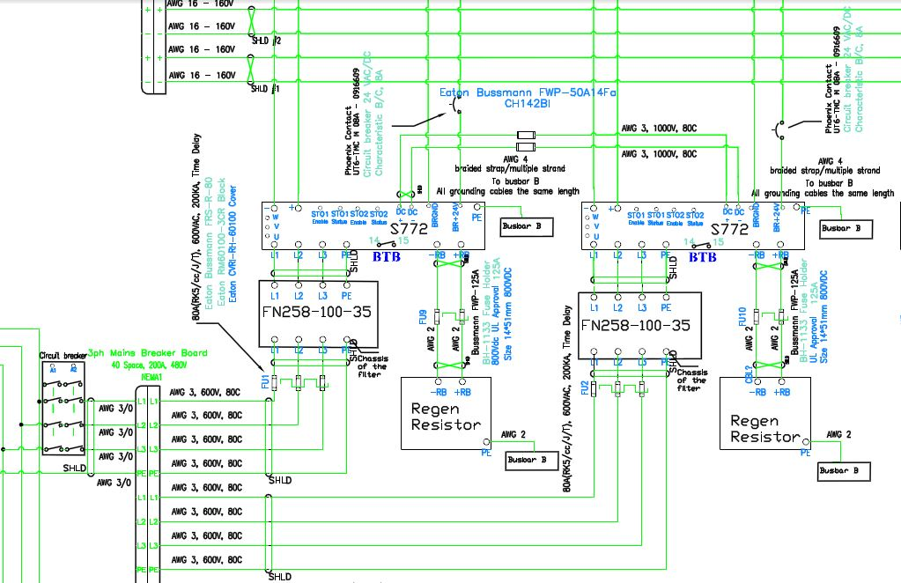

Figure ‑. Regenerative Dynamic Braking circuit

#### Motor-Short Dynamic Braking

In this approach, motor leads are disconnected from servo-amplifiers and external dynamic brakes short the U, V and W leads of the motor to dissipate the mechanical energy as heat. Unlike regenerative braking, no energy will be stored in DC bus link, and servo-amplifier will have no control over the motor after external dynamic brakes are switched on. This method assures minimum stop time but does not allow for Category 1 or 2 stops. Therefore, this approach is only recommended for emergency stop or safety hazards.

The equations for calculating the stopping time with the motor-short dynamic braking of a 3Ph permanent magnet (PM) brushless motor are adapted from a Kollmorgen application note originally derived for a PM DC motor [34]. A typical connection for 3 phase PM motor for dynamic braking is shown in the figure below.

3 Phase Amplifier

Dynamic Motor-Short Resistors

Motor-Short Contactor

3 Phase Motor

Figure ‑. Typical connection for 3 phase PM motor for dynamic braking

Assuming a motor-short dynamic brake resistance of $R_{DB}$, the current in each phase resistor ($I$) can be calculate as:

|  |  |
| --- | --- |
| $$I=\frac{ωK_{B}}{R_{o}}$$ |  |

where $ω$ is the motor speed in $\frac{rpm}{sec}$ or $\frac{rpm}{9.55}$. $K_{B}$ is the motor BEMF constant in $\frac{V×sec}{rad}$ or $\frac{V×104.7}{kRPM}$. $R_{o}$ is the resistance per phase of the motor plus $R_{DB}$ in ohms. The total inertia ($J_{o}$) can be defined as:

|  |  |
| --- | --- |
| $$J_{o}=J_{M}+J_{RL}$$ |  |

where $J_{M}$ is the motor inertia in $lb×ft×s^{2}$, and $J_{RL}$ is the reflected load inertia on the motor in the same unit. $J_{RL}$ is found as:

|  |  |
| --- | --- |
| $$J_{RL}=\frac{J_{L}}{g^{2}}+J_{GI}$$ |  |

where $g$ is the gearhead ratio, and $J_{GI}$ is the inertia of the gearhead at the input.

From that, parameters $P$ and $Q$ will be defined as:

|  |  |
| --- | --- |
| $$P=\frac{{(K}_{B}-L×PP)K_{T}}{J_{o}R_{o}}$$ and $$Q= -\frac{T_{F}}{J_{o}}$$ |  |

where L is the phase inductance in $L-L Henrys$, $PP$ is the number of motor pole pairs, $K_{T}$ is the motor torque constant in $\frac{lb×ft}{\frac{amp}{phase}}$, and $T_{F}$ is the static friction in $lb×ft$.

Finally, motor stop time with motor-short dynamic braking can be calculated as:

|  |  |
| --- | --- |
| $$t=(\frac{1}{P})ln⁡(\frac{ω_{1}-\frac{Q}{P}}{ω_{2}-\frac{Q}{P}})$$ |  |

where $ω_{1}$ is the beginning speed in $\frac{RPM}{9.55}$ and $ω_{2}$ is the ending speed in the same unit. If $ω_{2}=0$, then equation 34 can be simplified to the following:

|  |  |
| --- | --- |
| $$t=(\frac{1}{P})ln⁡(1-\left(\frac{P}{Q}\right)ω_{1})$$ |  |

If friction is neglected, equation 35 leads to:

|  |  |
| --- | --- |
| $$t=(\frac{1}{P})ln⁡(\frac{ω_{1}}{ω_{2}})$$ |  |

From equation 36, one can assume a motor-short dynamic brake resistance and find the equivalent stop time in the worst case scenario. With iterative calculations, the proper resistance size can be found. For the purpose of the VT Roller Rig, stop time less than $2s$ is desirable. After numerous discussions with Kollmorgen application engineers, peak braking torque was limited to $50\%$ of the nominal motor torque ($0.5×680=340 Nm$). Table ‎3‑7 shows some of the calculations towards finding the proper size resistance. For these calculations $ω_{1}= 2000 RPM, ω_{2}=0, T_{F}=0$. From the gearbox manufacture data sheet, gearbox efficiency is set $94\%$.

Table ‎3‑7. Iterative calculations for sizing motor-short dynamic braking resistors

|  |  |  |  |
| --- | --- | --- | --- |
| $$R_{DB} (Ω)$$ | **Estimated Stop Time (s)** | **Peak Watts/Phase (W)** | **Braking Torque (Nm)** |
| 1.6 | 0.53 | 25261 | 340 |
| 3.3 | 0.90 | 12630 | 170 |
| 6.6 | 1.49 | 6315 | 85 |
| 8.2 | 1.73 | 5052 | 68 |
| 17.0 | 2.76 | 2452 | 33 |
| 82.6 | 6.07 | 505 | 6.8 |

Not every desirable size dynamic resistor is available off the shelf. From the above calculations, the $8.2Ω$ resistor will stop the motor in $1.73s$ and imposes $10\%$ of motor nominal torque to the motor during braking. The motor-short dynamic braking circuit is constituted of two AKM84T motors, 8 T-connectors, two 3Ph contactors, a dual-channel time-delayed solid-state relay with two normally-open contacts, six $8.2Ω$ dynamic resistors, two 6-Amp circuit breakers, a green indicator light, a red indicator light, shielded AWG4 motor cables, shielded AWG16 cables, and shielded twisted pair AWG16 cables. Inputs of the solid-state relay are taken from the emergency stop circuit.

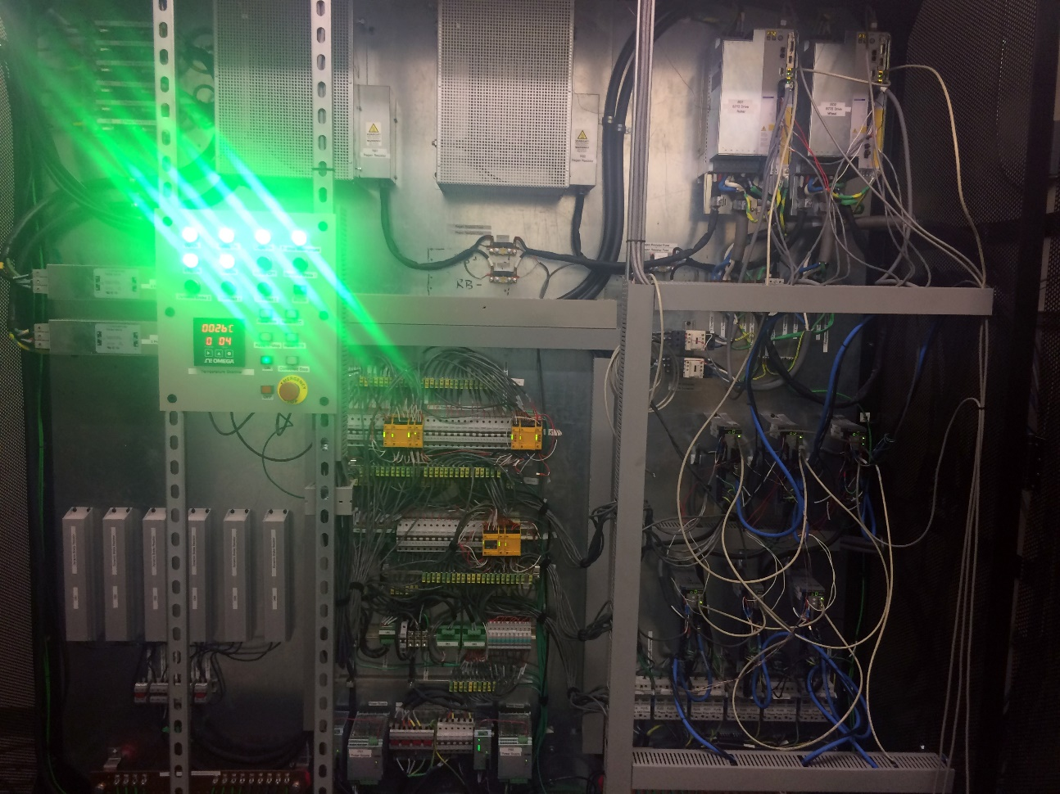

**Motor-Short Dynamic Resistors**

**Regenerative Dynamic Resistors**

**Motor-Short Contactors**

**Safety Systems**

Figure ‑. Motor-Short Dynamic Braking circuit

### Holding Brake

All AKM84T and EC4 motors are equipped with an internal holding brake mechanism that is intended to be used in “static/stationary” conditions. The application of this brake in “dynamic/moving” condition will result in dramatic wear of the brake mechanism. This brake is only intended for holding the motor in stalled condition. The holding brake is not field-replaceable, and two possible scenarios can damage it:

* Using the holding brake for reducing speed of the motor
* Applying power to the motor while the holding brake is engaged

The holding brake can be controlled directly with the servo-amplifier with 24 V voltage level. The following scenario describes the function of holding brake in an emergency stop condition (Hardware Enable off). The same procedure can be followed for normal circumstances when the motor is stopped manually and holding brake is being engaged.

When the Hardware Enable signal drop, after a delay time of 100ms, the speed setpoint of the servo-amplifier is internally driven down with an adjustable ramp to 0 RPM. The output for the holding brake is switched on when the speed has reached 5 RPM, at the latest after 5s Hardware Enable signal drops. The release delay time (tbrH) and the engage delay time (tbrL) of the holding brake are built into the motor for preventing instantaneous engagement of the holding brake. Figure ‎3‑25. shows the proper sequence for switching off the output stage of the servo-amplifier with the Holding Brake signal.

The holding brake is not intended to be used as a single stage functional safety during maintenance. An additional mechanical brake is required to hold falling loads. Turning the logic or power systems off will disengage the holding brake.

t

t

t

t

**Brake Release Delay**

n

U

U

U

t

t

t

t

**DECDIC**

Emergency Stop Ramp

**Ramp**

Velocity Threshold

5

Emergency Timeout

$$max 0.5s$$

U

Delay

Delay

Brake

Timeout

U

F

U

**Analog-Inputs**

**Enable**

**Signal**

**Internal Speed Setpoint**

**Speed**

**Internal**

**Enable**

**Brake Signal**

**Braking Force**

**STO-Enable Signal**

Figure ‑. Special sequence for switching off the output stage of the servo-amplifier with the Holding Brake signal [9]

### Emergency Stop

The stop categories described at the beginning of this chapter, classify the general STOP functions, and may be used for normal stopping as well as e-stop. Stop categories and control reliability categories are not the same, and there are significant differences between them. Control reliability categories are defined and described in ISO 13849-1, and they are used to describe system architectures for safety-related control systems. Each architecture includes a range of reliability performance that can be related to the degree of risk reduction in the system. The following control circuits could fall within the scope of these architectures: STO, Hardware-Enable, RTO, Logic On-OFF, Dynamic Braking, and Holding Brake.

Three standards define the requirements for emergency stop categories, and they are relatively consistent.

* ISO 13850, Safety of machinery: Emergency stop function
* IEC 60204-1, Safety of machinery: Electrical equipment of machines(aka EN 60204-1)
* NFPA 79, Electrical Standard for Industrial Machinery

The three stop category definitions match well with the regulations given in these three standards. All standards require all machines to have at least a Category 0 stop. This is identical to physically killing the power source through a master-control relay, or through and emergency stop. However, this does not require all machines to have an emergency stop. The VT Roller Rig can perform Category 0 stop with each one of STO, RTO, Hardware-Enable, Logic ON-OFF, and Motor-Short Dynamic Braking control circuits without having a dedicated emergency stop circuit. Therefore, it well satisfies the requirement. However, stopping the system with Category 0 stop can impose certain risks to the personnel and machinery. First, all moving objects coast to stop out of control. Considering the high kinematic energy stored in the wheel and roller drivelines, broken components should be treated as serious safety risks. In addition to that, increasing the number of turns before the machine stops, can lead to more damage to the machinery. Categories 1 and 2 are favorable for three reasons:

1. The machinery has a significant amount of inertia, meaning that it will not coast to stop in a short time
2. The machinery can be stopped more quickly under control than when the power is simply removed
3. The machinery needs to be stopped on a regular basis during operation. This means that there are devices that require power to keep them in a safe state. In this case, certain precautions should be taken into account as leaving high power on the machinery exposes user to electrical shock hazards

Category 2 stop is not allowed for emergency stopping, although it may be used for normal stop functions. ISO 13850, IEC 60204-1, and NFPA 79 explicitly limit emergency stop functions to Categories 0 and 1. For the VT Roller Rig, emergency stop circuit is intended to serve two purposes:

1. Give the highest priority to Category 0 stop
2. Allow for Categories 1, and 2 stop using the same system architectures

The emergency stop circuit is not a safeguard by itself, but can be considered as a complementary prioritizing measure. Understanding the hazards that need to be controlled by the user, provides specific direction on the stop category required and the degree of control reliability necessary to deliver the expected risk reduction.

The emergency stop circuit is fed by the Logic ON-OFF circuit, and feeds the Hardware Enable, and Motor-Short Dynamic Braking circuits. Emergency stop circuit provides a bypass for the momentarily ON pushbutton of the Logic ON-OFF circuit. This allows the Logic ON-OFF circuit to feed the safety systems without relying on a single pushbutton. The Emergency Stop circuit further feeds the inputs of the Hardware Enable through two normally-open contacts and Motor-Short Dynamic Braking circuit through two normally-closed contacts. This means that if one of the emergency stop switches are pressed, it will kill the Hardware Enable signals while it activates the Motor-Short Dynamic Brakes. As the Hardware Enable signals drop, the output stage of the servo-amplifiers will get deactivated, and the Motor-Short Dynamic Brakes stop the motors is the shortest possible time. This gives the highest priority to Category 0 stop.

The Motor-Short Dynamic Braking circuit is equipped with a time delayed relay. This allows for performing Category 1 stop even when the emergency stop switch is depressed. This is possible by giving the servo-amplifiers enough time to stop the motors controlled before the Motor-Short Dynamic Brakes kick in. The default setting for the time delay relay is 0ms for providing the highest degree of safety. This setting should only be changed if the user is fully aware of the risks and understands the operational parameters of the servo-amplifiers.

Categories 1 and 2 stops are possible if all emergency stop switches are released, or within the time delay of Motor-Short Dynamic Braking. In either case, Regenerative Dynamic Braking and Holding Brakes are responsible for stopping and holding the system, respectively. The emergency stop circuit is constituted of a dual-input solid-state relay with two normally-open contacts and a normally closed contact. This relay is extended with another solid-state relay with eight normally-open contacts and one normally-closed contact. The inputs of the circuit are taken from three dual-channel emergency stops. Dual-channels provide redundant safety on the switch contacts in case of contacts fusion or shortcut. One of the normally-open contacts bypasses the momentarily ON pushbutton of the Logic ON-OFF circuit while four other ones feed the inputs of Hardware Enable and Motor-Short Dynamic Braking circuits. Two other normally-open contacts input a dual-channel solid-state relay that is in series with the RTO contacts of the ServoStar servo-amplifiers. The purpose of this relay is tripping the shunt of the 3Ph circuit breaker that feeds all servo-amplifiers. This relay is energized, it kills the 3Ph power to all servo-amplifiers, allowing the Motor-Short Dynamic Brakes to dissipate the stored energy in the motors while the output servo-amplifier dead. Three 6-Amp circuit breakers protect the incoming power of this circuit through shielded AWG16 cables. Figure ‎3‑21. shows the Logic ON-OFF circuit for the VT Roller Rig.

## Noise Attenuation

Energy transfer could happen through different coupling mechanisms between a noise source and a receptor (victim). The source and the victim can both be electronic hardware devices, and coupling mechanism can take one or a combination of the following forms: conductive, capacitive, magnetic (or inductive), and electromagnetic (or radiative). Electromagnetic coupling usually occurs when devices are separated from each other by a distance equal or greater than the wavelength of the emitted wave. Both source and victim act like an antenna that can transmit energy regardless of the intermittent material. In the real world, a system or subsystem can be simultaneously an emitter and a receptor.

Electromagnetic interference (EMI) can disrupt the operation of electronic devices in the vicinity of electromagnetic fields. Electromagnetic compatibility (EMC) studies the undesired generation, propagation, and reception of energy through electromagnetic interference or radio frequency interference (RFI). It is achieved by reducing the emissivity of the source or susceptibility of the victim. This compatibility is accomplished using electronic filtering for the sources, and equipment shielding for the victims. References on the general principles of EMI are available [35–37], as well as methodologies for calculating radiated emissions [38].

Grounding and shielding are the two primary techniques for reducing the emission or diverting the electromagnetic noise away by providing an alternative low-impedance path [39]. Grounding is implemented in a star scheme to prevent any ground loop formation between the protected components. In practice, ground rods are tested to make sure that they provide the least impedance path for the noise. Shielding of cables is often implemented by surrounding them with an outer conductive layer that is grounded at one or both ends. A specially shaped conducting material can be used to form a shield against EMI by partially or entirely surrounding an EMI emitter, such as an electronic circuit. Typical materials used for electromagnetic shielding include sheet metal, metal screen, and metal foam [40].

This study, reports the approach taken at the Railway Technologies Laboratory of Virginia Tech to design a proper shield for a slew of PWM controlled power electronics running the VT Roller Rig testing facility [3]. The eight servodrives shown in Figure ‎3‑26 drive eight permanent magnet AC servo motors. These devices are manufactured according to certain EMC standards (i.e. IEC61000). Nevertheless, customary shielding is essential for preventing interference. VT engineers were warned by the motor and drive manufacturer that the digital servodrives will radiate high amplitude electromagnetic noise that sweeps the whole range of low frequency to 5MHz. Other sensitive motion control electronics, as well as all the sensory systems nearby, could be affected by this noise. Therefore, VT engineers paid particular attention to the task of designing a proper shielding for the PWM power electronics. Table ‎3‑8 summarizes the electrical specifications of S772 and AKD digital servodrives (Kollmorgen, Radford, VA) that are utilized in the VT Roller Rig.

The radiated noise is primarily contributed by the Pulse Width Modulation in the drives [41]. A detailed discussion of the frequency noise characteristics at the PWM output of modern drives is available in [42]. In summary, a series of pulses are controlled by a PWM with peak pulse voltage equal to the DC bus voltage. The pulse width and dwell time at zero are PWM controlled to achieve a fundamental sine wave output voltage at a desired variable output frequency. Higher drive AC line voltages lead to higher DC bus voltages (Table ‎3‑8 line 5). The higher output switching frequencies, increase the peak radiated noise (Table ‎3‑8 line 7). Assembling large quantities of drives in a concentrated area increases the potential to cause EMI with adjacent sensitive equipment such as encoder feedback, control interfaces, data acquisition units, piezoelectric load cells, and photoelectric sensors.

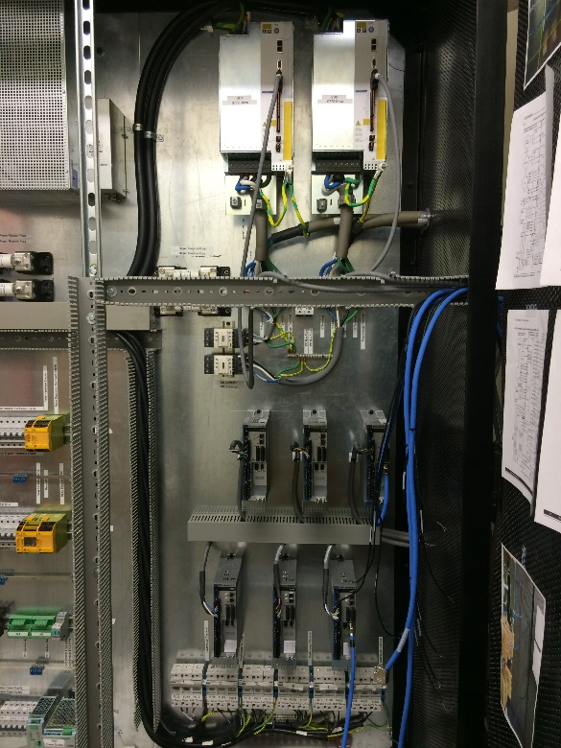

Figure ‑. Eight digital servo drives run the VT Roller Rig testing facility. The drives are part of the control tower that is responsible for motion control and safety of the system.

The simulation environment allows for changing the design parameters to get the required shielding effectiveness while satisfying other constraints in the overall system. Various local and international codes of practice deal with the issue of electromagnetic radiation, particularly in residential environments (e.g. IEC 61000, UL 1283, ISO 11451, CISPR 16) [1–4]. An engineer can change many factors in his design to comply with the system requirements and the EMC standards. The result, however, may or may not provide enough protection for the sensitive victims. Some of the objectives that the designer often has to deal with include the significance of the radiated noise, susceptibility of the nearby electronics, and the estimated shielding effectiveness of the shield. The first two parameters are often approximated from the data provided by manufacturers. The latter, however, requires calculation or simulation.

Table ‎3‑8. Electrical specifications of S772 and AKD digital servodrives [9,43]

|  |  |  |
| --- | --- | --- |
| **Electrical Data** | **S772** | **AKD** |
| Rated supply voltage  (L1, L2, L3) | $$3×480V, 50/60Hz$$ | $$3×480V, 50/60Hz$$ |
| Rated input power for  continuous operation | $$50kVA$$ | $$4.49kVA$$ |
| Rated output current  (rms value, $±3\%$) | $$72Arms$$ | $$6Arms$$ |
| Peak output current  (for approx. $0.5s, ±3\%$) | $$140Arms$$ | $$18Arms$$ |
| Rated DC bus link voltage | $$290-675V$$ | $$340-680V$$ |
| Switching frequency  of the output stage | $$8 or 16kHz$$ | $$8kHz$$ |
| Voltage rise speed dU/dt | $$4.8\frac{kV}{μs}$$ | $$7.2\frac{kV}{μs}$$ |
| Bandwidth of  current controller | $$>1.2 kHz$$ | $$2.5 to 4 kHz$$ |

Different materials provide different shielding properties if used as an enclosure to shield the source of radiation or the receptor. Enclosures often have openings or apertures for wiring and ventilation purposes. When thermal management is a big issue, the enclosure may be fully perforated. The skin effect changes with the frequency of radiation; therefore, the thickness of the shield is also a determining factor in the shielding effectiveness of the enclosure. On the other hand, when numerous devices are installed in the cage, mobility, and structural rigidity can be very limiting. The effects of material, apertures, and thickness are evaluated using finite element analysis on a simplified two-dimensional (2D) model. The shielding effectiveness is assessed as the proportion of electric or magnetic field intensity at the place of an observer in the presence and absence of the enclosure. Results show that magnetic permeability and electrical conductivity are the most critical properties in choosing the proper shielding material. They not only affect the capability of the material in forming the flux lines to divert the electromagnetic field from the victim, but also change the sensitivity of the overall shield to openings and apertures. This paper also shows how skin effect can drastically reduce the performance of the same enclosure at lower frequencies.

Experimental tests were performed using a conventional loop antenna to measure the actual shielding effectiveness of the implemented cage. The results demonstrate that it is possible to get the desired protection using conventional materials if the shield is properly designed.

### Material Selection

In some cases, EMI/RFI shielding is in the form of a spray. The spray is acrylic based and is applied to plastic electronic housings. Highly pure metals such as nickel, silver, and copper in the spray help to reduce or eliminate EMI and RFI [44]. EMI/RFI shielding agents are also available as paints and brush on coatings. RF shielding enclosures filter a range of frequencies for specific conditions. Copper is used for radio frequency (RF) shielding because it absorbs radio and magnetic waves. Properly designed and constructed copper RF shielding enclosures satisfy most RF shielding needs, from the computer and electrical switching rooms to hospital CAT-scan and MRI facilities. Aluminum, steel, and iron have also been used for shielding purposes whenever there is a cost or material limitation [45]. PVC is widely used in electrical conduits. EMI shielding effectiveness of PVC is also of interest. Table ‎3‑9 shows the material properties of these materials that are pertinent to electromagnetic considerations.

In evaluating the performance of different materials for EMI shielding purposes, three material properties are the most important factors: electrical conductivity, relative permittivity, and relative electromagnetic permeability. Electrical conductivity measures the ability of material to conduct the electric field. It is often denoted by $σ$ that is defined as the inverse of resistivity $ρ$. The permittivity of a material relates the electric flux density to the electric field. It is denoted by the symbol $ϵ$ and represents the resistance that is encountered when forming electric fields inside a medium. In an isotropic material, relative permittivity ($ϵ_{r}$) is usually given as a division of permittivity of the medium to that of free space $ϵ_{0}= 8.85×{10}^{-12} F/m$. Relative permittivity is always greater than or equal to 1, which means that electric field is always reduced relative to what it would be in free space.

Table ‎3‑9: Material properties of aluminum (Al), copper (Cu), Iron (Fe), carbon steel, and PVC

|  |  |  |  |  |  |  |  |  |
| --- | --- | --- | --- | --- | --- | --- | --- | --- |
| Property | Name | Unit | Property Group | Al | Cu | Fe | Carbon Steel | PVC |
| Relative Permeability | $$μ_{r}$$ | 1 | Magnetic | $$1.000022$$ | $$0.999994$$ | $5000$\* | $$100$$ | $$1$$ |
| Electrical Conductivity | $$σ$$ | $$\frac{S}{m}$$ | Electrical | $$3.774e^{7}$$ | $$5.998e^{7}$$ | $$1.12e^{7}$$ | $$4.032e^{6}$$ | $$1e^{-16}$$ |
| Relative Permittivity | $$ϵ_{r}$$ | 1 | Electrical | 1 | 1 | 1 | 1 | $$3.18$$ |
| Density | $$ρ$$ | $$\frac{kg}{m^{3}}$$ | Mechanical | $$2700$$ | $$8700$$ | $$7870$$ | $$7850$$ | $$1375$$ |
| Young’s Modulus | E | $$Pa$$ | Mechanical | $$70e^{9}$$ | $$110e^{9}$$ | $$200e^{9}$$ | $$200e^{9}$$ | $$3.38e^{9}$$ |

\* Maximum Value

Electromagnetic permeability ($μ$) is a measure of how easily a magnetic field can pass through a material. It represents the orientation of bound magnetic particles within a material and relates the magnetic flux density ($H$) to the magnetic field ($B$) through $B=μH$. The permeability of vacuum is denoted by $μ_{0}$ and is equal to $μ_{o}=4π×{10}^{-7}H/m$. The electromagnetic permeability of a medium is often denoted by its relative permeability $μ_{r}$ that is a measure of the permeability of a medium relative to that of vacuum. Paramagnetic and ferromagnetic materials have $μ_{r}$ greater than 1, while $μ_{r}$ is less than 1 for diamagnetic materials. When a paramagnetic or ferromagnetic material is inserted into a magnetic field, like inside a coil, it causes the lines of magnetic flux to concentrate. This increases the inductance of the coil compared with the same coil with an air core.

### Models



Field radiated from an electromagnetic source is represented by transversal waves (TE) that are described by the following Maxwell’s equation in 2D [46]:

|  |  |
| --- | --- |
| $$∇×μ_{r}^{-1}\left(∇×E\right)-k_{0}^{2}\left(ϵ_{r}-\frac{jσ}{ωϵ_{0}}\right)E=0,$$ |  |

where E is the electric field intensity vector, $ω$ is the frequency, and $k_{0}=ω\sqrt{ϵ_{0}μ_{0}}$. The terms inside the second parentheses denote the complex permittivity of the environment.

Depending on the material, an enclosure between the source and emitter can diminish the strength of coupling between them. The effectiveness of this electromagnetic shield is expressed as the ratio of two values of the electromagnetic field at a particular location in presence and absence on the shield. Electric shielding effectiveness $SE_{dB}$ and magnetic shielding effectiveness $SM_{dB}$ can be defined as [47]:

|  |  |
| --- | --- |
| $${SE}_{dB}=20×\log{(\frac{E_{1}}{E_{2}})},$$ |  |

or

|  |  |
| --- | --- |
| $${SM}_{dB}=20×\log{(\frac{H_{1} }{H_{2}})},$$ |  |

where E is the electric field and H is the magnetic field at a particular location. For an infinite conducting shield, $SE_{dB}$ and $SM_{dB}$ are equal and only depend on the frequency of the wave, conductivity, permeability, and thickness of the shield. For finite enclosures, $SE_{dB}$ and $SM_{dB}$ are different and depend on the location within the enclosure [47]. These two equations can be used as the tools for measuring the performance of a specific shield or compare the effectiveness of two shields in the same field. In this study, Equation 3 is used for plotting the results and discussions.

For simulation purposes, the radiation source can be modeled as a magnetic boundary source $H\left(x,y,z\right)$ with the frequency given by parameter $ω$. The parametric solver of the finite element package accounts for the frequency by switching the direction of the magnetic field coordinates harmonically. Changing the magnetic field generates the moving electrical field that radiates throughout the physical domain. Due to symmetry in generation and propagation of the electromagnetic field in the above configuration, the domain can be reduced to 2D. Figure ‎3‑27 shows the simplified 2D model used in finite element analysis. A cross section of the shield with apertures is shown in this figure. Openings are assumed to have the same dimensions and the longest dimension of the apertures to be in the plane of cross section shown in Figure 2.

`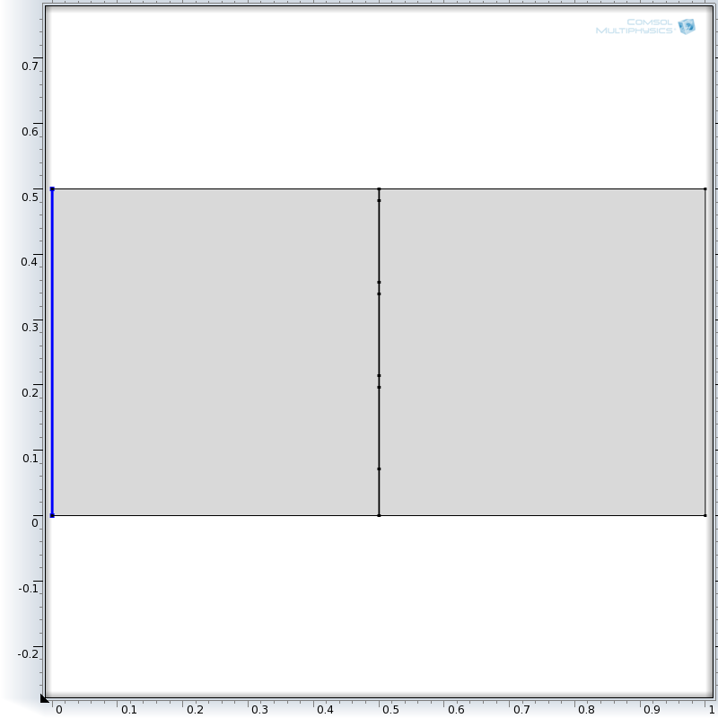

Boundary Magnetic Source

Perforated Shield

H

Plane wave

E

2D Domain

Figure ‑: The Simplified 2D model of the electromagnetic source and perforated shield

### Simulations

COMSOL Multiphysics has a set of solvers for PDE-based problems in the frequency domain. The geometry and configuration of Figure ‎3‑27 are defined in COMSOL with 2D axisymmetric structure. Material properties of air are assigned to the 2D domain, as given in Table ‎3‑10. The boundary magnetic source is assumed to have one component in y direction ${ H}_{y}=10\frac{A}{m}$. This forces the longest side of the apertures to be normal to the E-field, which is the worst case for shielding [47]. Since the ratio of electric or magnetic fields at the same location determines the shielding effectiveness, the intensity of the field at the boundary source will not affect the results. The 2D domain is $0.5m \left(H\right)×1m (w)$, and thickness of the shield is $1mm$ in the first set of simulations. The effect of thickness will be further evaluated in the second part of the paper.

Three apertures are shown in Figure ‎3‑27 to create a grid shield. Each opening is $0.125m(H)$, which is identical to removing $75\%$ of the full shield. The size of openings in the sheet plate is enforced by the minimum ventilation required for keeping the high power electronics below maximum allowable temperature. Smaller openings cause less air intake, thus higher temperature within the enclosure.

Table ‎3‑10: Material properties of air

|  |  |  |  |  |
| --- | --- | --- | --- | --- |
| Property | Name | Value | Unit | Property Group |
| Relative Permeability | $$μ_{r}$$ | $$1$$ | 1 | Magnetic |
| Electrical Conductivity | $$σ$$ | $$0$$ | $$\frac{S}{m}$$ | Electrical |
| Relative Permittivity | $$ϵ_{r}$$ | $$1$$ | 1 | Electrical |
| Density | $$ρ$$ | $$1.275$$ | $$\frac{kg}{m^{3}}$$ | Mechanical |

Figure ‎3‑28 shows the mesh quality of the proposed 2D model. The minimum mesh quality is 0.8372 with a total number of 32892 triangular elements. To have enough degrees of freedom in evaluating the skin effect, fine mesh with a minimum quality of 0.8659 is used for the shield.

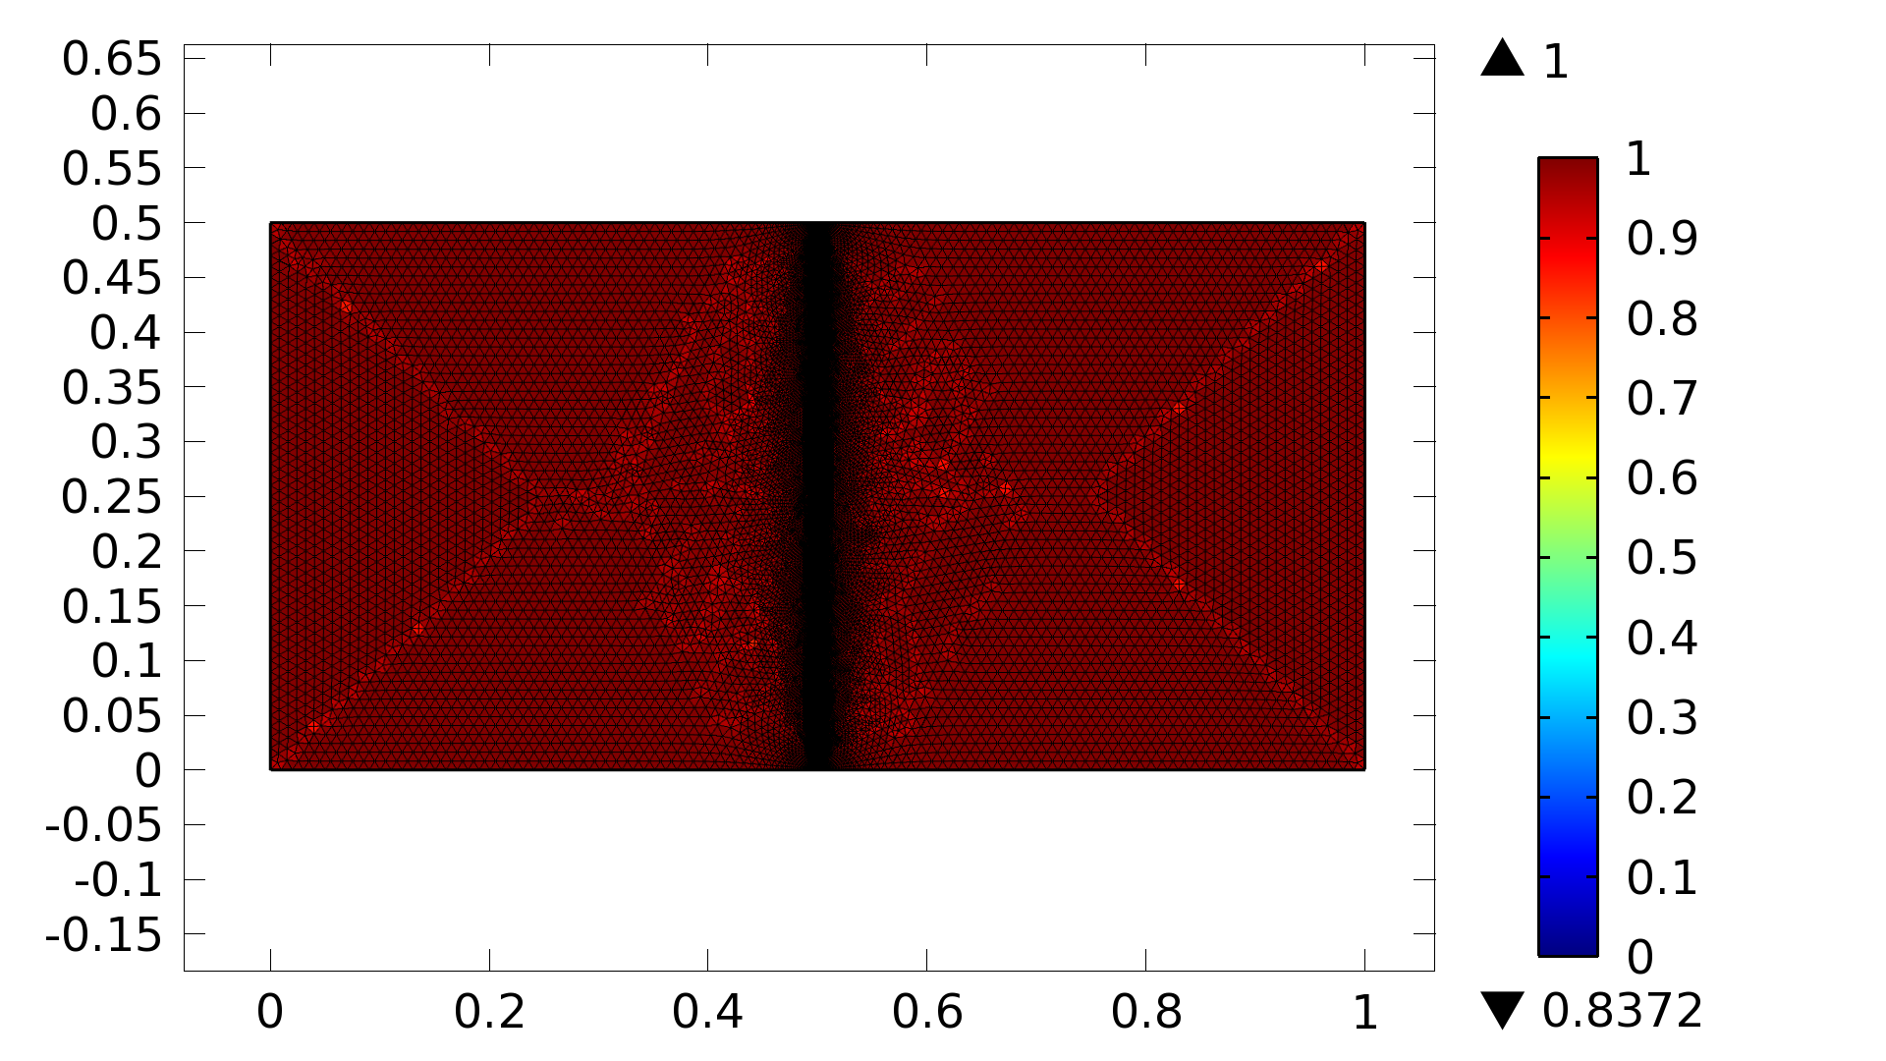

Figure ‑: Mesh quality of the physical model in COMSOL Multiphysics

COMSOL provides three different solvers for electromagnetic problems: MUMPS, PARDISO, and SPOOLES. For fast simulations, it is suggested to use MUMPS and PARADISO. MUMPS is usually required for cluster computation while PARADISO is multi-core capable. Results given in this paper are found with MUMPS direct solver.

#### $SM_{dB}$ of different materials

Figure ‎3‑29 shows the electric displacement field norm (D) and magnetic field density norm (B) at $ω=100 kHz$ without any shield. Figure ‎3‑30 shows D, when full and grid aluminum shields are added to the model. As mentioned above, full shield means that there is no perforation or opening in the shield. Grid shield means that three $0.125m$ openings are cut out of the shield for ventilation purposes.

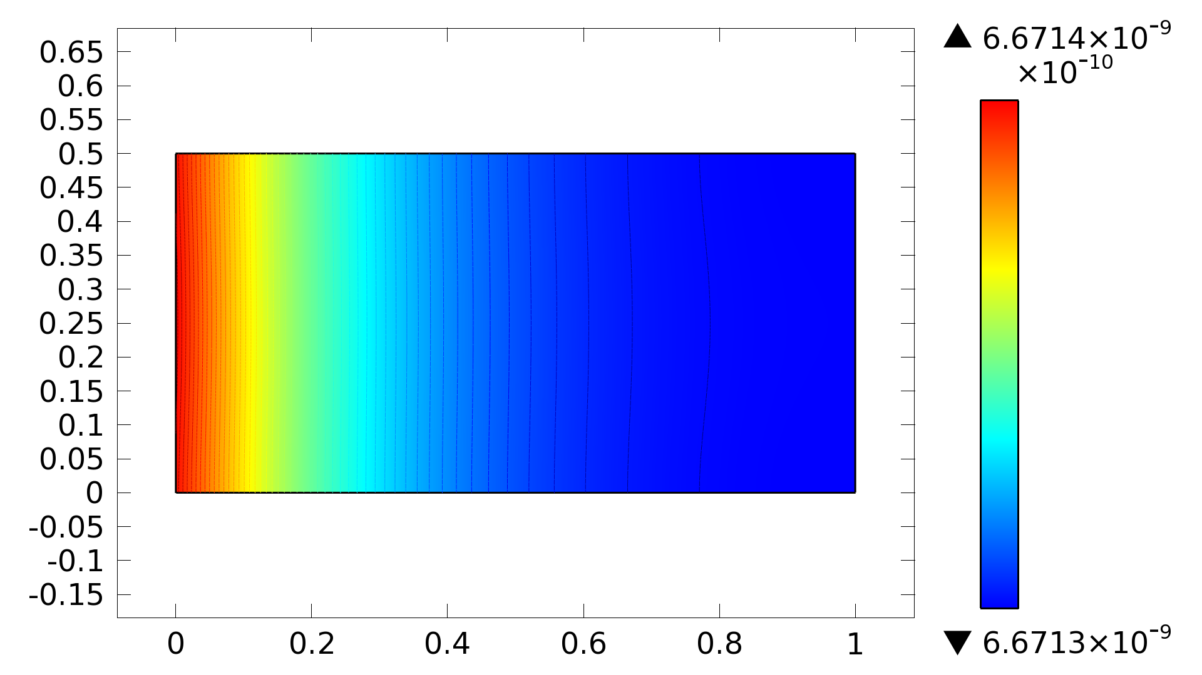

a

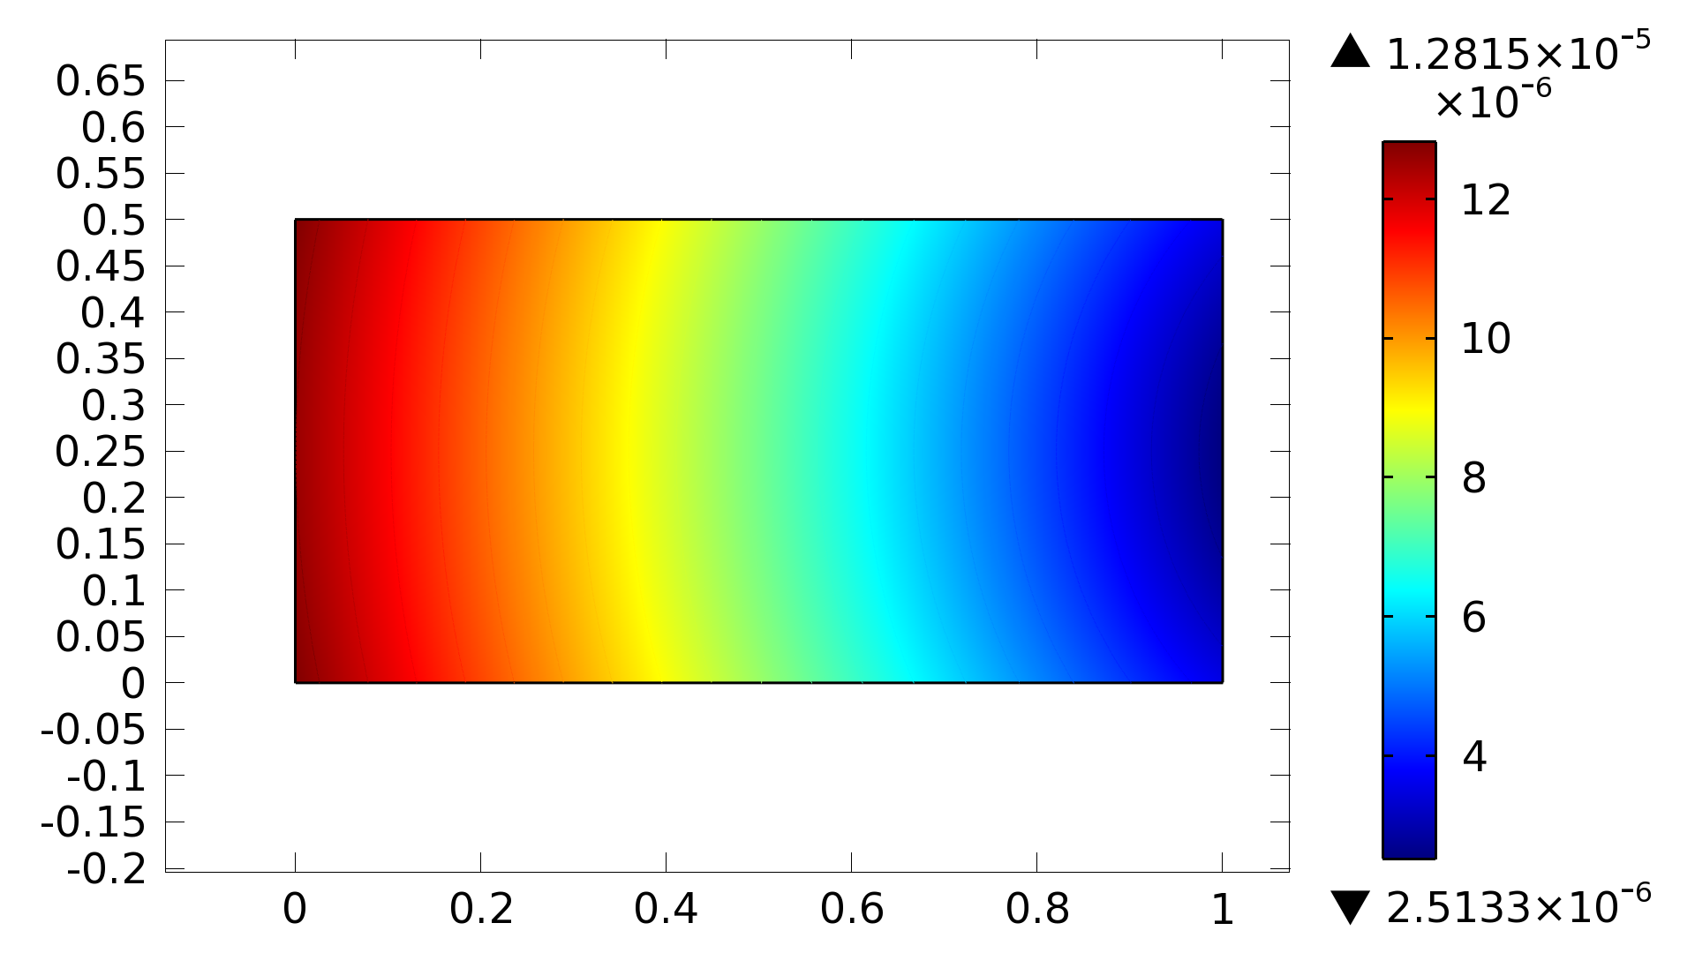

b

Figure ‑: a) Electric displacement field norm (D), and b) magnetic field density norm (B) at 100kHz without any EMI shielding

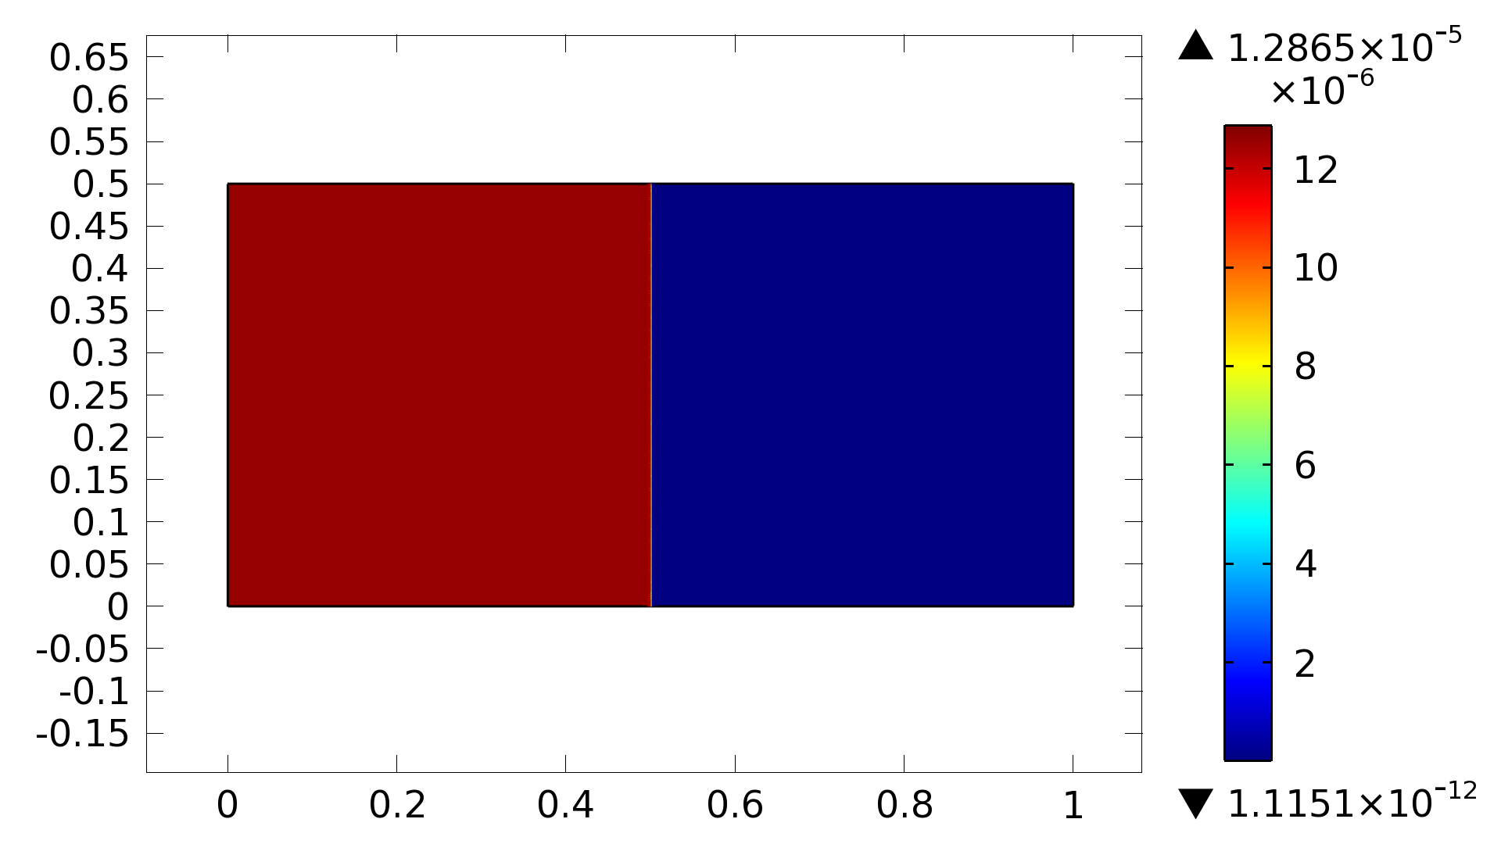

a

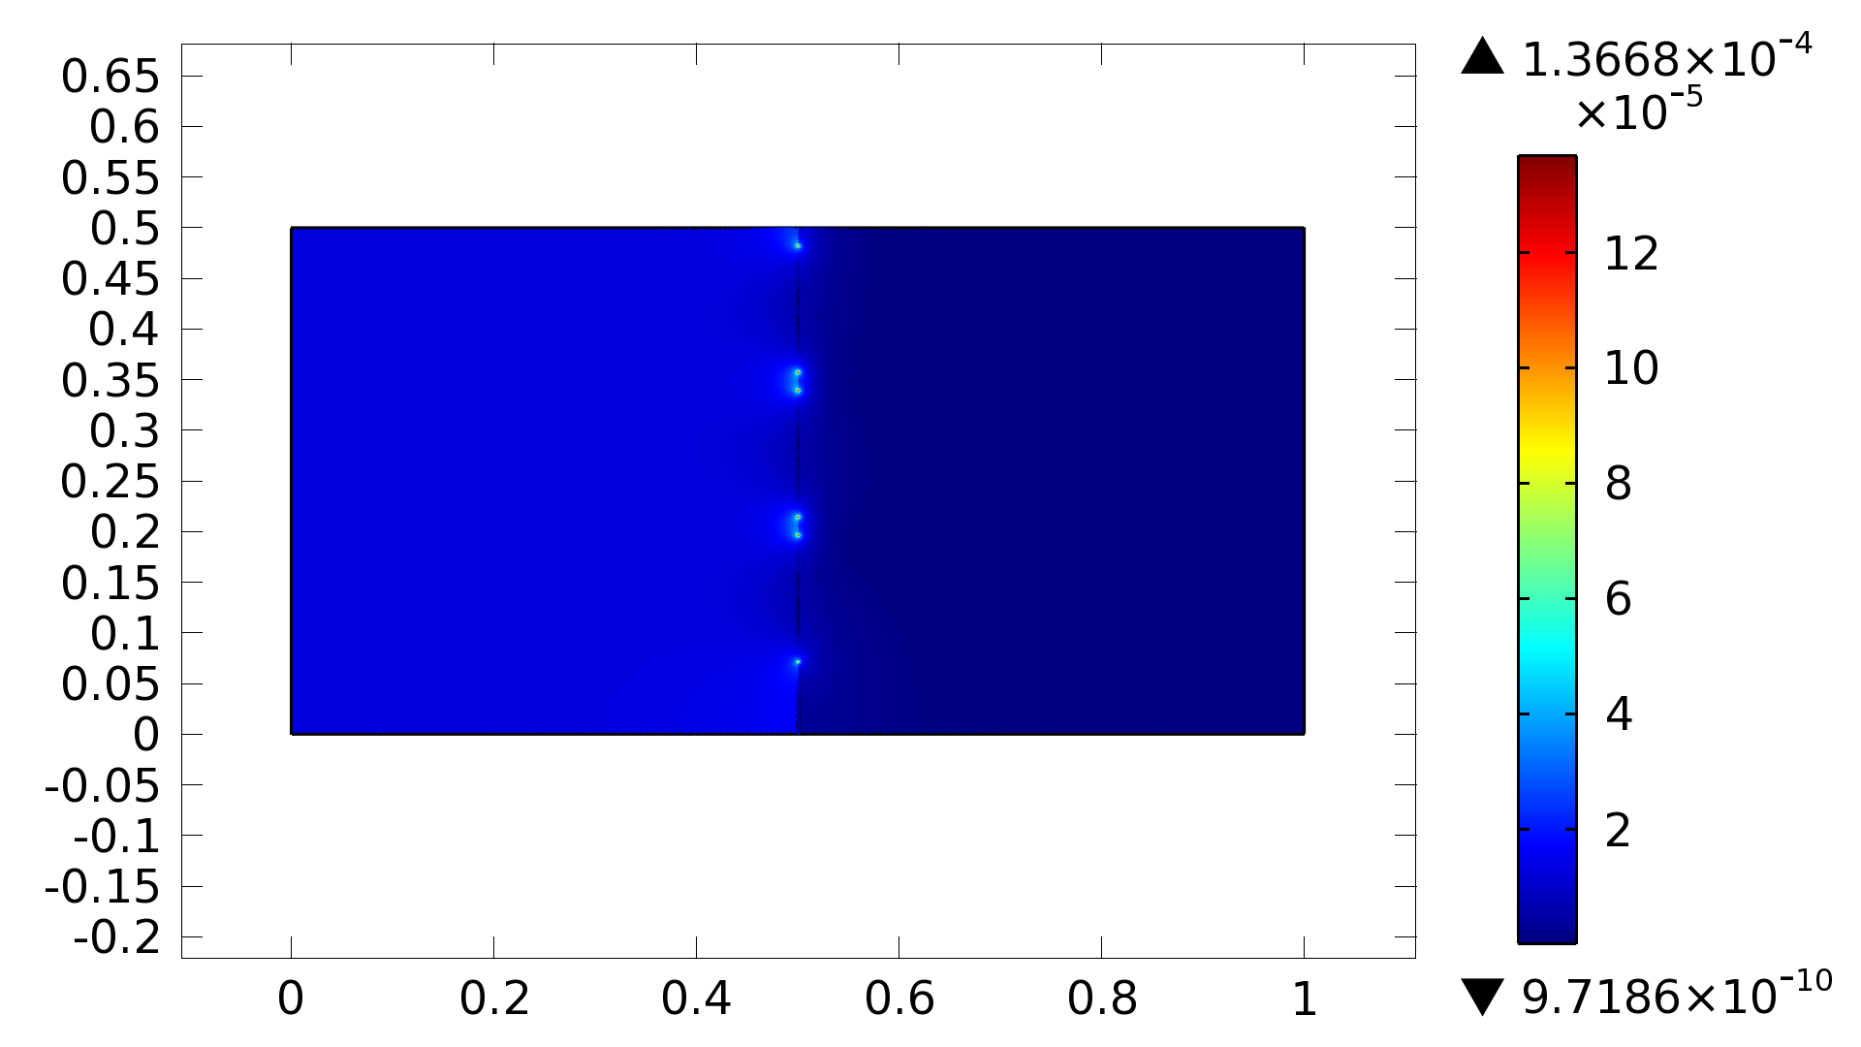

b

Figure ‑: Magnetic field density norm (B) at 100kHz with a) full Aluminum shield, and b) Aluminum grid shield

The first major difference between Figure ‎3‑29-b, Figure ‎3‑30-a, and Figure ‎3‑30-b is the significant decrease in the maximum field norm. In Figure ‎3‑30-b, the value of magnetic field density norm at the shield is much higher than the rest of the domain, which causes the left-hand boundary values turn out blue. To better show the effect of shields, results are plotted along a horizontal line in the middle of the 2D domain. Figure ‎3‑31 shows the electric displacement field norm plotted at $=[0, 60, 100, 1000, 10e^{3}, 100e^{3},1e^{6}, 5e^{6}]$ with full (Figure ‎3‑31-a) and grid (Figure ‎3‑31-b) aluminum shields.

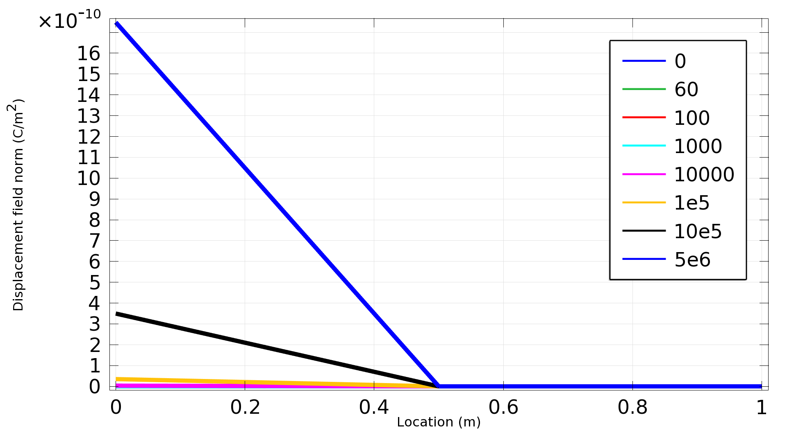

a

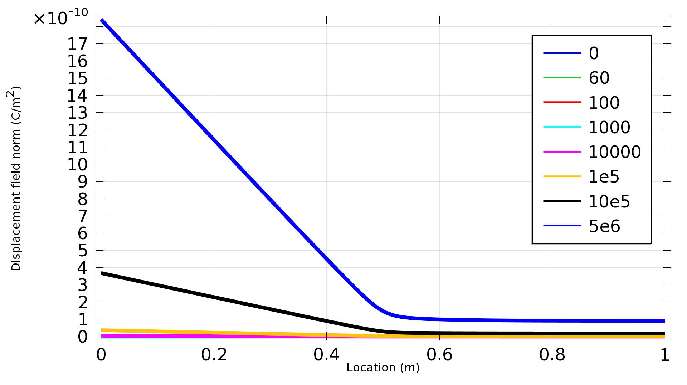

b

Figure ‑. Electric displacement field norm (D) with full Aluminum shield at different frequencies along a line in the middle of the 2D domain. a) full shield and b) grid shield

Results of simulations for full and grid shields made of copper, aluminum, iron, and carbon steel are summarized in Figure ‎3‑32 to better elaborate $SM_{dB}$ of different materials at different frequencies. Using Equation 2, $SM_{dB}$ is found for $ω=[0, 60, 100, 1000, 10e^{3}, 100e^{3},1e^{6}, 5e^{6}]$ Hz at a point $1m$ away from the boundary source. Shield is grid for all these cases with $0.125m$ openings. This size of the opening is smaller than the wavelength of all evaluated frequencies.

, the field intensity is higher out of the enclosure when the shield is a grid. An important factor in choosing the proper material for shielding purposes is the sensitivity of the shielding effectiveness to the size of openings and apertures. To study the sensitivity of different materials to openings, Equation 2 is modified as below:

|  |  |
| --- | --- |
| $${ΔSM}_{dB}=20×\log{(\frac{M_{f}}{M_{g}})} ,$$ |  |

where $M_{f}$ and $M_{g}$ denote the full shield and grid shield field intensities at a particular location. $ΔSM_{dB}$ represents the difference between the two cases:

|  |  |
| --- | --- |
| $${ΔSM}_{dB}=SM_{dB}^{full}-SM_{dB }^{grid}= 20×[log\left(\frac{M_{f}}{M_{no shield}}\right)-\log\left(\frac{M_{g}}{M_{no shield}}\right)]= 20×log⁡(\frac{M_{f}}{M_{g}}).$$ |  |

Figure ‎3‑33 shows the $ΔSM_{dB}$ for the respective cases of Figure ‎3‑32 . The smaller the $ΔSM_{dB}$, the less sensitive enclosure performance is to the aperture size. It is found that the shielding effectiveness is practically determined by the penetration of energy through the apertures in the enclosure rather than through the walls. Figure ‎3‑33 provides a means for comparing the contribution of walls and apertures to the escaping field.

Figure ‎3‑32 shows the dependency of the shielding effectiveness on the frequency of the electromagnetic wave. At frequencies equal to or greater than 100kHz these four materials provide almost the same attenuation. At low frequencies, however, copper and aluminum behave much better than steel or iron. At 60Hz, copper attenuates the electromagnetic field $20.99\%$ better than steel, while the difference is about $9.64\%$ at 5MHz.

As shown in Figure ‎3‑33, steel has the least sensitivity to grid shielding, especially at frequencies above $10kHz$. This means that upon changing the size of openings, $SM_{db}$ for steel would change less compared with other materials. Iron shows a different reaction to the gird shield; at low frequencies there is a small difference that tends to get bigger as the frequency increases. This could be attributed to the larger relative permeability (5000 times larger than copper) and smaller conductivity ( $70.3\%$ less than copper) of iron. At low frequencies the electromagnetic shielding is more possible through attenuating magnetic field, therefore permeability plays a more important role in the performance of the material. At high frequencies however, electric field attenuation dominates the shieling effectiveness of the material. The overall behavior of the material depends on conductivity, permeability, and frequency.

D:\VT Drive\Control Panel Analyses\Control Panel Electromagnetic Analysis\2D with Boundary Electric Field - Copy\Original Model\New folder\B_norm attenuation.tif

Figure ‑: *SMdB* of different materials at different frequencies. Shields are grid in all cases

D:\VT Drive\Control Panel Analyses\Control Panel Electromagnetic Analysis\2D with Boundary Electric Field - Copy\Original Model\New folder\Effect of grid on B_norm.tif

Figure ‑: *ΔSMdB* of different materials at different frequencies. Grid shields are the same in all cases

A time varying magnetic field is accompanied by a time-varying electric field that induces time-varying currents in the shield and a secondary time-varying magnetic field. From the Lenz’s law, the induced currents produce a magnetic field that opposes the external magnetic flux, so that the total flux reduces. The larger the conductivity, the larger the induced currents. Also, the larger the permeability, the more significant the flux reduction.

To provide a measurement of the shielding effectiveness of PVC in comparison with metals, $SM_{dB}$ of steel, copper, and PVC are plotted in Figure ‎3‑34. The effectiveness of PVC is not zero but, it is much smaller than the other two materials considered in this comparative study. The maximum achievable attenuation with PVC with this configuration is less than $1dB$ at 5MHz. This low performance was expectable due to low permeability and conductivity of this material. The only major difference between electrical properties of PVC and air is relative permittivity (3.18 for PVC versus 1 for air), which does not show a significant effect on the results.

D:\VT Drive\Control Panel Analyses\Control Panel Electromagnetic Analysis\2D with Boundary Electric Field - Copy\Original Model\New folder\B_norm attenuation_PVC.tif

Figure ‑: *SMdB* of copper, steel, and PVC at different frequencies. Shields are grid in all cases

#### Effect of thickness on $SM_{dB}$ of steel

The skin effect is the tendency of a time-varying current to concentrate near the surface of a conductor. At high frequency, the current is restricted to a very thin layer near the conductor surface. Therefore, the shield could be coated with highly pure metals to increase the shielding effectiveness. The skin effect is much higher in ferromagnetic materials compared with diamagnetic materials [48]. Skin depth for some common materials is given in Table ‎3‑11. To better understand the effect of thickness on the shielding effectiveness of material at different frequencies, the geometry of Figure ‎3‑27 is regenerated for shield thicknesses of $0.5mm$ to $3mm$ at every $0.5mm$ step. Results of those simulations are summarized in Figure ‎3‑35.

Table ‎3‑11: Skin depth for some common materials [49]

|  |  |  |  |  |
| --- | --- | --- | --- | --- |
| Material | 60Hz | 1kHz | 10kHz | 1MHz |
| Copper | $$8.61mm$$ | $$2.1mm$$ | $$0.652mm$$ | $$67μm$$ |
| Iron | $$0.275mm$$ | $$67.2 μm$$ | $$21.27μm$$ | $$2.127 μm$$ |
| Carbon Steel | $$3.24mm$$ | $$0.793mm$$ | $$0.250mm$$ | $$25μm$$ |
| Aluminum |  |  |  |  |

D:\VT Drive\Control Panel Analyses\Control Panel Electromagnetic Analysis\2D with Boundary Electric Field - Copy\Original Model\New folder\steel_B_norm_thickness.tif

Figure ‑: Effect of thickness on *SMdB*of steel at different frequencies. All shields are grid.

As the frequency increases, the skin effect decreases. Proper shielding is possible if the thickness of the shield is greater than the skin effect. In other words, the same material and thickness may perform well for high frequencies, but it will saturate at low frequencies. Results of 1000Hz in Figure ‎3‑35 show $23.4\%$ difference between $0.5mm$ and $3mm$, while the difference is about $3.5\%$ at 5MHz.

### Implementation and Experimental Results

#### The Electromagnetic Shield for the VT Roller Rig Control Tower

Based on the findings in section ‎3.4.3.1, steel was selected for fabricating the enclosure. Although, steel provides the least effectiveness compared with copper, aluminum, and iron, the difference does not support the cost difference. Copper provides only $20\%$ more attenuation at $60Hz$ and such difference drops below $10\%$ at $5MHz$. As mentioned earlier, steel shows the least amount of attenuation reduction caused by material removal. In other words, there will be less change in the behavior of steel due to further apertures for running cables or installing the user interface. For the same gauge sheet plate, the cost difference between the four aforementioned materials is significant. Surveying the market reveals that the availability of copper, aluminum, and iron perforated sheet metals at the desired thickness and grid size is quite restricted.

Considering the results in section ‎3.4.3.2, 16GA sheet was selected for fabricating the enclosure ($1.5 mm$). This thickness is readily available in the market, and is in the middle of the spectrum shown in Figure ‎3‑35. The closest conventional grid structure that was available in the market was $1/4''$ circular holes staggered at $3/8''$. This is equivalent to $80\%$ material removed, which is a little more than $75\%$ material removal used in the simulations.

The electronics inside the cabinet weight more than 200lb without the cables. The back plate of the enclosure should bear the weight of all components without buckling. On the other hand, it should be bare conductive metal for grounding purposes. After structural FEA analysis galvanized 14GA sheet plate reinforced with $2×1$ C-beams on the back was used as the back plate of the enclosure.

Particular attention was paid to the assembly of the cabinet such that the biggest gap between mating components remains smaller than $1/4''$. The enclosure was assembled using bolts and nuts. Figure 11 shows the final enclosure with the electronic equipment and cables installed. For securing the cabinet from tipping over, it was anchored to the ground with four Grade 5 steel stud anchor for concrete, $1/2"$ diameter.

|  |  |
| --- | --- |
| C:\Users\MHP\Google Drive\CVeSS\Roller Rig\Pics\Cabinet\Final\IMG_0086.JPG | C:\Users\MHP\Google Drive\CVeSS\Roller Rig\Pics\Cabinet\Final\IMG_0077.JPG |

Figure ‑. The final enclosure for the control tower of the VT Roller Rig

#### Test Setup

To be added by Mehdi:

* Loop antenna
* Matching circuit
* Scope
* External trigger
* Probe

#### Results

Measurements were taken at three spots all along the same line and the same height, with different distances from the enclosure:

1. Inside the cabinet with the doors open
2. Outside the enclosure adjacent to the doors with the doors shut
3. Outside the enclosure, $1m$ away from the doors with the doors shut

Measurements at the second and third spots, when the doors are open, show a negligible difference compared to spot number one. The minimal difference could be related to distance, but also, the stochastic nature of the signal. For the sake of future comparisons, the measurement at spot one is assumed to be valid for spots number two and three with the doors open.

As mentioned above the signal shows stochastic behavior, meaning that is slightly different between consecutive measurements. The data reported below are intended to represent the worst case scenario for the shield, i.e. minimum noise inside the cabinet, maximum noise outside the cabinet.

The first set of data given in Figure ‎3‑37, shows the time and frequency of the signal inside the cabinet. As expected, the maximum power is transferred with low to $5MHz$ frequency, which agrees with the information provided by the manufacturer. The peak on the FFT plot occurs at around $2MHz$ with $35dB$ amplitude. Repeating the measurements reveal that the peak can go as high as .

|  |  |
| --- | --- |
| C:\Users\MHP\Google Drive\Rig Workstation\Loop Antenna Tests\April 19- 2016\RR\0ft\ALL0005\F0005TEK.TIF | C:\Users\MHP\Google Drive\Rig Workstation\Loop Antenna Tests\April 19- 2016\RR\0ft\ALL0004\F0004TEK.TIF |

Figure ‑. Measurements inside the cabinet. Left figure is the time signal, and right figure is the FFT using Hanning window

Discussion on the shape of time signal and how it is related to pulse (PWM) to be added by Mehdi. The time signal represents a sinc behavior, which describes the dU/dt voltage change by the PWM controller.

The second set of data given in Figure 13, shows the measurements right after the enclosure when the doors are shut. The FFT plot shows about 15dB attenuation compared with the doors open. Consecutive measurements show less than a 5dB drop in the amplitude of the peak at 2MHz.

|  |  |
| --- | --- |
| C:\Users\MHP\Google Drive\Rig Workstation\Loop Antenna Tests\April 19- 2016\RR\2ft\ALL0011\F0011TEK.TIF | C:\Users\MHP\Google Drive\Rig Workstation\Loop Antenna Tests\April 19- 2016\RR\2ft\ALL0010\F0010TEK.TIF |

Figure ‑. Measurements at a location adjacent to cabinet when the door is closed. Left figure is the time signal, and right figure is the FFT using Hanning window

Finally, Figure ‎3‑39 shows the measurements at $1m$ distance from the enclosure. Comparing it with Figure ‎3‑37 reveals that the enclosure is successfully attenuating the whole DC to $25MHz$. The amplitude at $2MHz$ drops to $10dB$, which is equivalent to $25dB$ shielding effectiveness or 315 times less power. The peak in the FFT plot is difficult to capture and is often between 0 to .

|  |  |
| --- | --- |
| C:\Users\MHP\Google Drive\Rig Workstation\Loop Antenna Tests\April 19- 2016\RR\4ft\ALL0016\F0016TEK.TIF | C:\Users\MHP\Google Drive\Rig Workstation\Loop Antenna Tests\April 19- 2016\RR\4ft\ALL0015\F0015TEK.TIF |

Figure ‑. Measurements at a location at 4ft away from the cabinet when the door is closed. Left figure is the time signal, and right figure is the FFT using Hanning window

# Commissioned Capabilities of the Virginia Tech Roller Rig

## Novel Motion Control and Data Acquisition Architecture: Fast, Low-Noise, High-Performance, and Plug-n-Play

The Virginia Tech Roller Rig’s motion control and data acquisition are based on SynqNet Technology, provided by Kollmorgen (Radford, VA). The communication protocol between components of the Roller Rig was selected based on the following criteria:

1. Unified between servodrives, motion controller computer, and data acquisition units
2. Maximum performance with minimum wiring
3. Minimum skew and jitter
4. Does not require additional diagnostic tools. Simply serviceable
5. Easily expandable without modifying the existing network

SynqNet is a digital communication protocol for multi-axis motion control applications. It is globally renowned for high-performance, low-noise, and synchronous command and feedback. SynqNet replaces the noise-prone analog communication protocols (±10V + Encoder) with a real-time digital network. The digital communication provides additional diagnostic, performance and reliability benefits to the Roller Rig.

A unique feature of SynqNet is adaptability to servodrives, motion controllers, and data acquisition units. This eliminates the need for any data conversion between these units, thus maximizing the network bandwidth to 48kHz for torque updates (4axes). For the Virginia Tech Roller Rig, SynqNet was successfully implemented on S772 and AKD servodrives, QMP motion controller, SQIO-SQID data acquisition boards (all from Kollmorgen).

The centralized QMP motion controller transmits regular synchronization data to every component around the Roller Rig network. Each receiving component uses advanced digital time-correction techniques to minimize both skew and jitter to less than 1 $μs$, and cycle time latency to $\sim 25 μs$. These values are constantly reported to the user.

Altogether, Roller Rig includes more than 3200ft of cable in various gauges. Adding more cables not only makes the cable management more difficult but increases the risk of cross-talk between adjacent cables. An important criterion in selecting the motion communication protocol for the Roller Rig was maximum performance with minimum required wiring. The physical layer of SynqNet is based on IEEE 802.3 standards for 100Base-TX, the physical layer of Ethernet [50]. The 100BASE-TX protocol is based on specifications published in the ANSI TP-PMD physical media standard. The 100Base-TX system operates over two pairs of wires, one pair for ‘receiving’ data signals and the other pair for ‘transmitting’ data signals. Each link is full duplex, i.e. capable of transmitting and receiving simultaneously [51]. 100Base-TX Ethernet cables are inexpensive and can transfer more data than traditional serial cables.

SynqNet has built-in query mode that allows for querying components regarding a variety of information without additional diagnostic tools. For the S772 and AKD drives, a user can simply acquire drive information via the motion communication protocol and the Roller Rig motion programming interface (Section ‎4.2).

Each component on the SynqNet network, regardless of physical role, is called a ‘node.' The nodes are enumerated sequentially according to the wiring order of the network. Roller Rig does not require a DIP ID switch or EEPROM to hold the node numbers. The Roller Rig nodes are:

1. Wheel S772 digital servodrive
2. Roller S772 digital servodrive
3. Lateral AKD digital servodrive
4. AoA AKD digital servodrive
5. Vertical 1 digital servodrive
6. Vertical 2 digital servodrive
7. Cant 1 digital servodrive
8. Cant 2 digital servodrive
9. SQIO-SQIO data acquisition board 1
10. SQIO-SQIO data acquisition board 2
11. SQIO-SQIO data acquisition board 3
12. SQIO-SQIO data acquisition board 4

The signaling scheme between the nodes is strictly point-to-point, meaning that one transmitter is connected to one receiver. A schematic of node-to-node signaling is given in Figure ‎4‑1. SynqNet is compatible with two standard connectors: RJ-45 and Micro-D. The RJ-45 connector is standard for commercial 100Base-TX applications and conforms to CAT-5. Micro-D is used in environments where additional tolerance of vibration is required. All sensitive electronics of the VT Roller Rig are secured in the control tower, isolated from vibration. Therefore, RJ-45 connectors are used for implementing the network.

Rx

Tx

Tx

Rx

PHY

PHY

Figure ‑. Node-to-node signaling in the Virginia Tech Roller Rig is full duplex

Frequently, motion designers think of each axis regarding a single motor; however, the Roller Rig motion controller platform allows the user to expand this model. For example, the X-Y cradle on a three-axis machine can be simply controlled by two motors, each of which represents a single, independent axis. However, it may be advantageous to “map” a second motor to each axis, to obtain independent, rapid-coarse motion and slow-fine motion. Currently, the motion axes of the Roller Rig are:

1. Wheel rotation
2. Roller rotation
3. Lateral linear motion
4. AoA linear motion
5. Vertical 1 linear motion (tied to Axis 6)
6. Vertical 2 linear motion (tied to Axis 5)
7. Cant 1 linear motion (tied to Axis 8)
8. Cant 3 linear motion (tied to Axis 7)

Motor 4 Y Fine

Motor 3

Y Coarse

Motor 1

X Coarse

Motor 2

X Fine

Y (Axis 2)

X (Axis 1)

$Motion Supervisor 1 \left\{\begin{aligned}Axis 1 \left\{\begin{aligned}Motor 1 \\ Motor 2\end{aligned}\right. \\ Axis 2 \left\{\begin{aligned}Motor 3 \\ Motor 4\end{aligned}\right.\end{aligned}\right.$

Figure ‑. An illustration of motor-axis mapping concept

A concept similar to mapping multiple motors to the one axis is Gantry. The term “Gantry” defines a system with two motors controlling a single linear axis. The vertical and cant axes in the VT Roller Rig are examples of Gantry (Figure ‎4‑3). Each motor/bearing system is separated a finite distance orthogonal to the direction of the axis. Small rotational motion about the center of the gantry due to differential motion of the two motors is usually undesirable and will lead to mechanical binding if the rotational motion is excessive [52].

|  |  |
| --- | --- |
| C:\Users\MHP\Desktop\IMG_0243.JPG | C:\Users\MHP\Desktop\IMG_0239.JPG  **C:\Users\MHP\Desktop\IMG_0240.JPG** |

Figure ‑. Gantry axes of the VT Roller Rig (left: vertical, right: cant)

A goal of the gantry system is to move both separate motor systems together so that negligible “crabbing” occurs, wherein one motor leads or lags the other. Since each side of the gantry receives the same linear command position (with zero yaw command), a lagging motor/encoder provides a greater error signal to that respective control loop [52]. Due to the mechanical coupling of the Gantry beam, motion from one motor can appear as a disturbance on the other motor, particularly within the same bandwidth, since they have identical or similar control elements. This coupling of disturbances can reduce system performance. In a Gantry control scheme, separate controllers directly control each motor. The standard gantry configuration results in a control loop that controls each motor the same as if they were separate (non-gantry) motors. It provides the convenience of commanding the linear motion, thereby simplifying programming and lab testing. Figure ‎4‑4 illustrates the Gantry motion control concept. The Gantry axes in the VT Roller Rig are 5&6 for vertical motion and 7&8 for cant. In the Roller Rig, six motion supervisors are responsible for commanding the four independent axes and the two Gantry ones. These supervisors are:

1. Wheel
2. Roller
3. Lateral
4. AoA
5. Vertical
6. Cant

Nodes 1 and 2 each incorporates an S772 digital servodrive connected to an AKM84T servomotor and a single-turn EnDat 2.2 absolute sine encoder. Nodes 3 through 8 each have an AKD servodrive that commands an EC4 linear actuator and receives feedback from its multi-turn EnDat 2.2 absolute sine encoder. Nodes 9 through 11 each have an SQIO-SQID data acquisition board connected to an SQIO-MIXEDMODULE. SynqNet supports up to 64 motion axes, 64 nodes, and 32 bits of configurable I/O per axis. Figure ‎4‑6 shows the VT Roller Rig SynqNet network. The blue arrows represent the digital communication network.

The VT Roller Rig’s control and data acquisition architecture are Plug-n-Play. Expanding the network includes connecting two RJ45 cables to its adjacent components and refreshing the Roller Rig MPI. Nodes are all updated and queried at the same time, while the data is processed in the order reported to the motion controller.

**0.5**

**+**

**+**

**0.5**

**-**

**+**

Command

Motion

**Roller Rig Gantry Axis 1**

Command

Motion

Position Error In

**Torque Out**

PID or PIV

Gain

$$k_{da}$$

Volts

Motor Current

Servo Drive 1

Encoder Equivalent Output

EEO

Volts

Motor Current

Servo Drive 2

Encoder Equivalent Output

EEO

**Roller Rig Gantry Axis 2**

Actual Position 1

Actual Position 2

$$P_{cmd}$$

Feedback

Feedback

Error

Counts

Volts

Figure ‑. Gantry motion control scheme using two encoders

Common motion control architectures are String without termination, Dual String without termination, String with termination, Dual String with termination, and Ring. Figure ‎4‑5 compares these topologies with each other. In some non-standard applications, Ring-of-Rings and Tree topologies have also been used. The String topology is the most basic network configuration [51]. Packets are sent downstream from the motion controller to the nodes, and upstream from the nodes to the controller. Each node repeats the downstream and upstream data to the next node. If a cable breaks, the nodes downstream from the break will be lost. A String topology has nodes connected to either IN or OUT ports. If nodes are connected to both ports, the topology is called Dual String. If the end of String or Dual String topologies are left unterminated, a timeout period is required to detect the end of the string. To reduce this discovery time, a loopback connector can be added to String and Dual String topologies. The loopback allows the motion controller to deterministically find the last node on the network.

The VT Roller Rig control architecture is set up in a Ring topology (closed-loop). The Ring topology is similar to String topology, except with an idle link that is added between the last node and the motion controller. In a Ring topology, if any one of the cables fails, the network will redirect packet data around the break, and the motion controller will notify the user in the Roller Rig MPI with an event. The location of the break can be determined by the motion controller [53]. Furthermore, if one or more nodes fail, the network will continue to operate and communicate with the good nodes, while the motion controller notifies the user of bad nodes.

|  |  |
| --- | --- |
| String Topology (IN Port) | C0  IN  OUT  OUT  IN  **N1**  **N0**  OUT  IN  OUT  IN  **N2** |
| Dual String Topology | C0  IN  OUT  OUT  IN  **N3**  OUT  IN  **N2**  OUT  IN  **N1**  OUT  IN  **N0** |
| String Topology  (IN Port, Terminated) | C0  IN  OUT  OUT  IN  **N1**  **N0**  OUT  IN  OUT  IN  **N2**  **Loop-Back**  **Connector** |
| Dual String Topology  (Terminated) | C0  IN  OUT  OUT  IN  **N3**  OUT  IN  **N2**  OUT  IN  **N1**  OUT  IN  **N0**  **Loop-Back**  **Connector** |
| Ring Topology | C0  IN  OUT  OUT  IN  **N2**  OUT  IN  **N1**  OUT  IN  **N0**  **Idle** |

Figure ‑. Common motion control network topologies

The Roller Rig network topology can be saved to the motion controller's flash memory. After a reset, the controller will automatically initialize the Roller Rig and verify that the number and type of discovered nodes match the expected topology. Figure ‎4‑6 shows the Virginia Tech Roller Rig control and data acquisition architecture. The green arrow indicate the data acquisition channels, while the brown arrow indicate incoming power. The command and feedback loop between each drive and motor is represented by red and purple arrows, respectively. For more information on the yellow and gray arrows (regen and dynamic brake resistors), see Section ‎3.3.5.

CAT5

Feedback

Feedback

Feedback

CAT5

CAT5

CAT5

CAT5

CAT5

S

T

AoA EC4

Cant EC4

Cant EC4

Lateral EC4

Vertical EC4

Vertical EC4

AKD Drive

AKD Drive

AKD Drive

AKD Drive

AKD Drive

AKD Drive

Host Computer

Simulink/MATLAB

MechaWare Library

MPI Developer Software

LabVIEW

MPI Libraries

MPI Runtime

QMP-SynqNet-GB-PCIe

Bode Tool

C/C++

Motor AKM84T

Motor AKM84T

S700 Drive

SynqNet Expansion Card

S700 Drive

SynqNet Expansion Card

SQIO-MIXEDMODUL 1

F

Load Cells Charge Amplifier

AoA Laser Sensors

4550A Torque Meter

SQIO-SQID 1

480VAC 3-Phase 60 Hz

480VAC 3-Phase 60 Hz

Command

Feedback

Feedback

Feedback

4550A Torque Meter

Power

Power

Power

Power

L

Contact Patch Laser Profiler

F

Load Cells Charge Amplifier

SQIO-MIXEDMODUL 2

SQIO-SQID 2

SQIO-MIXEDMODUL 3

SQIO-SQID 3

SQIO-MIXEDMODUL 4

SQIO-SQID 4

CAT5

CAT5

CAT5

CAT5

CAT5

CAT5

CAT5

T

S

Command

Command

Command

Command

Command

Feedback

Command

Feedback

Command

Regen Resistors

Motor-Short Resistors

Motor Dynamometer

Wheel Dynamometer

Wheel Torque System

Wheel Torque System

Figure ‑: The Virginia Tech Roller Rig’s control, power, and data acquisition architecture

### Motion Controller

The motion controller is responsible for the real-time trajectory calculations, closed-loop control, handling the dedicated I/O, updating status, event messages, data recording, SynqNet network data processing, plus many other features. The controller's processor load is based on the number nodes, axes, supervisors, and enabled features [54,55]. The ultra-high-performance QMP-SynqNet card (Figure ‎4‑7) incorporates a 64-bit Freescale QorIQ P2010 1200MHz PowerPC for optimum flexibility and speed. The controller offers servo update rates up to 48kHz and can support up to 64 axes, 64 nodes, and 32 bits of configurable I/O per axis [56].

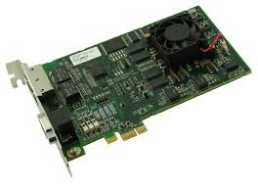

Figure ‑. QMP-SynqNet-GB-PCIe-RJ motion controller

The central motion processor performs matrix computations based upon multiple inputs generating multiple outputs. MIMO (Multiple-In-Multiple-Out) control systems use demand and feedback inputs, such as the actual torque and velocity, to compute new target data for output components such as drives and motors.

The QMP motion controller splits the operations into two tasks: foreground and background [54]. The foreground task is the main task and is triggered by an internal interrupt that fires when the sample period timer expires. After the foreground task completes, then the background task executes. If the background task does not complete within one sample period, it is interrupted to begin the foreground task in the next sample. Each time the foreground cycle completes, it begins the background task from the point it was adjourned in the last reporting period.

All sample period critical functions are performed in the foreground: trajectory calculations, closed-loop servo calculations [54], SynqNet data processing, data recording, linking, camming, position compensation tables, capture, compare, program sequencers, etc. Less critical functions are performed in the background cycle: status update, dedicated I/O processing, motor limits, actions, event messages, etc.

The motion controller maintains the previous sample's actual position and calculates the actual velocity. If the feedback packet is corrupted, the controller will interpolate the expected actual position [53]. This feature prevents motor jumps due to network data integrity problems.

EMI shielding for the motion controller follows standard 100BT NIC design conventions: the RJ-45 connector shell is tied to the bracket or front panel, and not directly connected to the controller's local digital ground. The host computer chassis is responsible for grounding the chassis [57]. It is tied to the Roller Rig isolated ground rod at a central point along with the digital ground. The cable shield is also related to an isolated plane section on the motion controller PCB to minimize EMI. To prevent ground loop formation in the control Ring, the RJ-45 connector is isolated from local node chassis, as well as from ground and power signals. Instead, the connectors are AC coupled via internal capacitors (one for each port) to a nearby earth point on the node. Figure ‎4‑8 illustrates this technique [57].

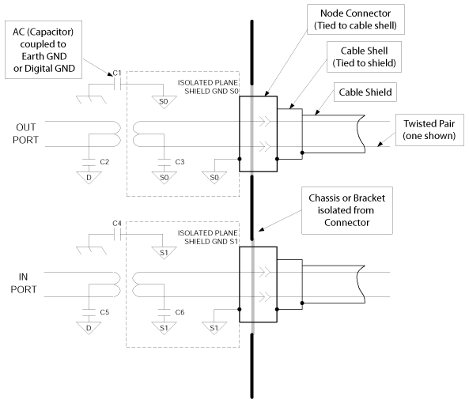

Figure ‑. Cable shield grounding at local nodes to prevent ground loop in the VT Roller Rig control loop [57]

### Data Acquisition Units

Roller Rig data acquisition units have a modular architecture based on SQIO Technology developed by Motion Engineering (now part of Kollmorgen). SQIO is a modular system, in which each data acquisition unit is considered a node in the SynqNet network. Each node is comprised of the following:

* An SQID, which serves as the SynqNet network interface and power source for all connected I/O boards
* One or more board modules that can be cascaded to provide as much I/O as is required . Available modules are DIN32DOUT32, ADC4DAC4, and MIXEDMODULE. DIN32DOUT32 provides 32 isolated digital inputs and 32 isolated digital outputs. ADC4DAC4 provides 4 ADC and 4 DAC channels. The most versatile of the three, MIXEDMODULE, features 64 isolated digital inputs, 64 isolated digital outputs, 16 ADC channels, and 8 DAC channels [57].

Communication between the board modules and the SQID is implemented through four SPI-type[[1]](#footnote-1) serial busses [58]. Each SPI bus either passes through the logic circuitry of a board module or is merely tracked-through. Figure ‎4‑9 illustrates the SQIO communication through the SPI busses. The SPI rates on the digital input SPI, digital output SPI, analog input SPI and analog output SPI are completely independent.

For adding more modules to and existing SQID board, the following two criteria should be satisfied:

* A 2A fuse limits SQID's incoming current
$$\left(d×0.02\right)+\left(a×0.10\right)+\left(m×0.20\right)+0.06<2$$

* SQID’s 5W DC-DC converter can provide maximum 800mA spare capacity

$$(d×0.05)+(a×0.12)+(m×0.65)<0.8,$$

where d is the number of DIN32DOUT32 modules, a is the number of ADC4DAC4 modules, and m is the number of MIXEDMODULE1 modules. For adding more modules to and existing SQID board, the following two criteria should be satisfied:

1. SQID’s incoming current is limited by a 2A fuse
2. SQID’s 5W DC-DC converter can provide maximum 800mA spare capacity

where *d* is the number of DIN32DOUT32 modules, *a* is the number of ADC4DAC4 modules, and *m* is the number of MIXEDMODULE1 modules.

Table ‎4‑1 summarizes the SPI rates. Connecting ADC4DAC4 to and existing assembly of SQID+DIN32DOUT32 will not affect the SPI rate of either. However, when a unit with a MIXEDMODULE is connected to a DIN32DOUT32, the lesser clock rate will prevail on the affected SPIs.

SQID

Logic

DIN32DOUT32

Logic / Interface

ADC4DAC4

ADCs/DACs

SynqNet

SPI 3

SPI 2

SPI 1

SPI 0

P4

P5

P1

P2

P2

P3

SPI 3

SPI 2

SPI 1

SPI 0

Figure ‑. SQIO communication through SPI serial busses. A digital module (DIN32DOUT32) and an analog module (ADC4DAC4) are cascaded to the SQID

For adding more modules to and existing SQID board, the following two criteria should be satisfied:

1. SQID’s incoming current is limited by a 2A fuse
2. SQID’s 5W DC-DC converter can provide maximum 800mA spare capacity

where *d* is the number of DIN32DOUT32 modules, *a* is the number of ADC4DAC4 modules, and *m* is the number of MIXEDMODULE1 modules.

Table ‎4‑1. SPI rate of different data acquisition modules

|  |  |
| --- | --- |
| **Module** | **SPI Rate** |
| DIN32DOUT32 | 6.25MHz |
| ADC4DAC4 | 6.25MHz |
| MixedModule1 | 12.5MHz |

To SynqNet, the board modules appear as a “chain of bits.” i.e. a knowledge of the SPI busses is all that is required to design a custom data acquisition unit. Neither special controller software nor special SQID FPGA logic is required [58]. As mentioned earlier, motion control and data acquisition units are similarly interpreted as nodes in the SynqNet network. This allows for expanding or modifying the network with minimum adjustments. Adding an entirely new node only requires connecting two RJ45 cables to its adjacent components and refreshing the Roller Rig MPI.

Each SPI bus on each SQID node can support up to 256 bits. In a standard scheme, therefore, there can be up to 256 digital inputs, up to 256 digital outputs, 16 sixteen-bit ADC channels, and 16 sixteen-bit DAC channels attached to each SQID node. Up to eight board modules can be connected [59]. This is a constraint of the I2C2 EEPROM[[2]](#footnote-2) addressing scheme on the SQID. The Roller Rig MPI will check the setup at initialization to verify compatibility and report an error if it is not valid. Currently, the VT Roller Rig has four SQID boards, each slotted with a MIXEDMODULE. The SPI rate of this configuration, shown in Figure ‎4‑10, is 12.5MHz.

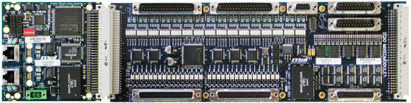

J2: Digital Outputs

J3: Digital Outputs

P4: Digital Inputs

P5: Digital Inputs

P2 and P3:

Analog Inputs

J4: Analog Outputs

P1: R/C Connector

J1: R/C Connector

SynqNet

24V

Power

Figure ‑. Current configuration of each data acquisition node on the VT Roller Rig SynqNet network

#### Latency

The load on each SPI affects the delay between consequent updates. The SPI delay is defined as:

$$SPI delay=(\frac{Number of bits on the SPI}{SPI Clock Rate} )+2µs$$

For the configuration shown in Figure ‎4‑10, the SPI delay is tabulated in Table ‎4‑2.

Table ‎4‑2. SPI delays for the VT Roller Rig data acquisition units depending on the SPI load

|  |  |  |  |  |
| --- | --- | --- | --- | --- |
| **SPI Clock Rate**  (MHz) | **Number of Bits on the SPI** | | | |
| **32** | **64** | **128** | **256** |
| **6.25** | 7.12 | 12.24 | 22.48 | 42.96 |
| **12.5** | 4.56 | 7.12 | 12.24 | 22.48 |

The overall latency between the acquired bits depends on:

* SPI delay
* Network update rate (Section ‎4.1.3)
* Opto-isolator delay

The SynqNet network latency for each update rate is given in Table ‎4‑4. Optoisolators are components that transfer digital signals between two isolated circuits in the SQIO module using light. For a standard optoisolator, the delay is 1µs when the input is energized and 500µs when the input is de-energized. For digital outputs, the delay is 5µs when the output is turned ON and 80µs when the output is turned OFF. Below is the equation for the worst-case latency between a digital input changing and the value appearing at the Roller Rig MPI:

$$Worst Case Latency=Opto Isolator Delay+SPI Delay+Network Delay$$

Assuming full load on an SPI (256bit), with an SPI clock rate of 12.5MHz, and network update rate of 4kHz, the worst case ON latency is:

$$Worst Case ON Latency:1+22.48+250= 273.48 μs$$

moreover, the worst case OFF latency under the same condition is:

$$Worst Case OFF Latency:500+22.48+250= 772.48 μs$$

For analog inputs, the optoisolator delay is substituted with ADC conversion delay. To include the number of analog channels, worst case analog latency is defined as:

$$Worst Case Latency =\left[\left(ADC Conv. Time×Num. of Channels\right)+SPI Delay\right]+ Network Delay$$

To use Table ‎4‑2, the resolution of ADC should be known. All Roller Rig data acquisition units, report analog inputs with 16bit resolution. The standard ADC conversion delay for the ADC4DAC4 and MIXEDMODULE is $8μs$. So, the worst case latency for a full load (16 channel) ADC input node with an SPI clock of 12.5MHz and a network update rate of 4kHz is:

$$Worst Case Latency: \left(8×16\right)+22.48+250=400.48μs$$

For analog outputs, the DAC delay is represented by slew rate. The slew-rate delay varies with the change of voltage, but for most purposes a lumped figure of 10µs can be used.

### Network Update Rate

The network update rate determines the update frequency for the motion controller and the SynqNet network. Every sample, the motion controller must read the cyclically sampled data from the network hardware (sense), process the data (think), and write the transmit data to the network (act). The maximum controller/sample rate and servo control latency of the Roller Rig depend on the various factors:

#### Network Load

At higher update rates, the servo performance improves. However, more nodes require more data packets and more features within a node will require larger data packets. The limitation to the servo update rate is the network loading. The bandwidth usage must be kept below 100% at all time. Based on the initial tests on the Roller Rig, the servo update rate is limited by the motion controller's processing power and not by the network bandwidth. For example, at 4kHz, the Roller Rig only uses 16% of the motion control network bandwidth. In the future, with more features within each node, the user should pay attention to the maximum sample rate and data packet load. Data packets can be optimized to remove unused features in case of sample rate limitations due to network bandwidth.

#### Digital Servodrive Update Rate

S772 and AKD digital servodrives update torque, velocity, and/or position loop at specific frequencies. To make sure the motion controller's closed-loop control loop is synchronized with the drives’ loops, the motion controller update period must be a multiple of the drive’s update period. Currently, the S772 and AKD drive update rates are set to those given in Table ‎4‑3.

Table ‎4‑3. Update rate of digital servodrives used in the Virginia Tech Roller Rig

|  |  |  |
| --- | --- | --- |
| **Drive** | **Drive’s Control Loop Update Rate** | **Drive’s Control Loop Update Period** |
| **S772** | 16kHz | 62.5µs |
| **AKD** | 4kHz | 250µs |

Such restriction guarantees that the drive phase-locked loop (PLL) can lock to an even sample period of the motion controller. Since the drives on the Roller Rig network have different update rates, then the motion controller sample period must be a common multiple of all drives on the network. With current settings, valid network update rates are 1kHz, 2kHz, and 4kHz. The SynqNet network latency for each sampling frequency is given in Table ‎4‑4.

Table ‎4‑4. Network latency for each update rate

|  |  |
| --- | --- |
| **Network Update Rate  (kHz)** | **Latency (µs)** |
| 1 | 1000 |
| 2 | 500 |
| 4 | 250 |
| 8 | 125 |
| 16 | 62.5 |

#### Cyclic Data Transmit ($T_{x}$) Time

The transmit time ($T_{x}$) determines when the cyclic data is sent within the motion controller’s sample period. The $T_{x}$ time is expressed as a percentage from 0% to 100%. Smaller $T_{x}$ time values will cause the cyclic data to be transmitted earlier in the sample period.

Smaller $T_{x}$ time values will reduce the latency between the feedback data from the node and the servo demand value sent from the motion controller to the node. Decreasing the latency will improve the servo closed-loop performance. The ( $T_{x}$ time × controller period) must be larger than the controller's foreground calculation time.

$$T_{x}×Controller Period>Controller Foreground Calculation Time$$

Larger $T_{x}$ time values will cause the cyclic data to be transmitted later in the sample period. Larger $T_{x}$ time values will increase the latency between the feedback data and the demand value. Nevertheless, using a larger $T_{x}$ time value may allow the controller to operate at a higher sample rate, thereby increasing the servo bandwidth.

For S772 and AKD servodrives, the latency change is only effective if the magnitude of the $T_{x}$ time change is large enough to cross the boundary of the drive's sample period. For example, suppose the Roller Rig cyclic period is 250µs (4kHz) and the AKD drive period is 62.5µs. Changing the $T_{x}$ time by 2% will cause a 5µs change in the transmit time. To cross the drive period boundary, the $T_{x}$ time would need to be changed by about 26% (or less). Since the transmit data timing may not be exactly lined up with the drive's update time, the actual amount of $T_{x}$ time change to cross the drive period boundary may be significantly less.

The default $T_{x}$ time for the Roller Rig Time is 75%. A reasonable range for $T_{x}$ time values is from 65% to 95%.

**Example:**

$$Sample Rate = 4000 \left(period = 250μs\right) \\ T_{x} time = 75\% \left(187.5μs\right)$$

$$Foreground Time = 238μs \\ Background Time = 11.98μs \\ Delta = 1$$

Foreground 0

Foreground 0

Background 0

B0

B1

Foreground 0

B1

B2

Sample Period

Foreground

Background

TxTime

Texp

Transmit

SynqNet

Buffer

Transmit

SynqNet

Buffer

Transmit

SynqNet

Buffer

Texp

Texp

Figure ‑. The relation between background, foreground, and transmit times

Delta is the maximum number of times a full background task is interrupted by the foreground task. A value of zero means the background task executed to completion without being interrupted by the foreground cycle [53]. Larger deltas can degrade controller performance. Figure ‎4‑12 shows an example of Roller Rig controller timing.

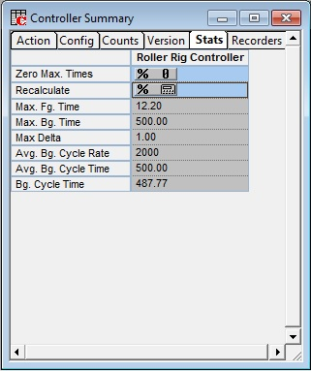

Figure ‑. An example of the Roller Rig controller timing

## Flexible Motion Programming Interface (MPI)

The Virginia Tech Roller Rig’s motion programming interface (MPI) is founded on a set of object-oriented, C-language functions and data types developed by Motion Engineering (now part of Kollmorgen). These libraries are independent of the motion controller hardware used, as well as the platform (operating system and compiler) on which the motion control application is built.

These libraries can be used directly to develop motion control applications. Programs written using these tools range from simple, single-task, single-controller applications to complex multi-task applications that use multiple motion controllers. These libraries provide direct memory access to all motion controller firmware components, delivering much more performance than other systems that use command-based controllers or ASCII interfaces. Motion programming for the VT Roller Rig is made possible using the following objects [60,61]. Figure ‎4‑13 illustrates the relation between these objects:

* **Control object:** A Control object manages the motion controller. One Control object is created for the Roller Rig motion controller. This object can read and write device memory using I/O ports, memory-mapped or device driver methods. All communication with the Roller Rig motion controller firmware is handled by this Control object. The Control object can also provide a memory snapshot of the controller stored in a file.
* **Axis objects:** An Axis object is associated with a single physical axis on the Rig’s motion controller, and corresponds to a geometric axis used for calculation of a path of motion. An Axis may be controlled by one or more Motion objects. The Roller Rig Axis objects were introduced in Section ‎4.1. The concept of an Axis is a "geometric" idea, but the main purpose of an Axis object is to generate the desired path (trajectory calculations, i.e., to generate command positions) on every sample, using the path-planning data provided by a Motion Supervisor. An Axis object is mostly a computational block .
* **Motion objects:** Motion object, aka Motion Supervisor object, corresponds to a coordinate system or collection of axes. The primary function of the Motion Supervisor is to provide data in a synchronized manner to the Axis objects for use in path creation. Roller Rig Motion Supervisors were introduced in Section ‎4.1. A second important function of the Motion Supervisor is to monitor the status of all of the Axes under its control (and all of the Motors, and Filters associated with these Axes), so that motion can be stopped or resumed in a controlled manner, especially in the event of errors. The Motion Supervisor is the primary handle for the Roller Rig MPI on the motion.
* **Motor objects:** The Motor object corresponds to a physical motor used to cause motion. The main function of the Motor object is simply to provide an interface to the S772 and AKD digital servodrives. The data of the Motor object contains the state of motion feedback, limit switches, home sensors, amplifier control and status signals (demand, amplifier enable, fault, warning, step, and direction), and motor related general purpose digital I/O.
* **Filter objects:** The Filter object implements the controller's closed-loop servo control loop, i.e., what should the controlled output be based on the position error. The Filter is primarily a computational block, taking command positions and actual positions and computing errors. The Filter object calculates the demand output (representing a torque or velocity command) that controls a physical motor or motors, using data (command positions) computed by the Axis object. PID, PIV and Biquad filter calculations are all parts of the Filter object.
* **Event objects:** An Event object contains information about an asynchronous event that has occurred. Event messages are generated and stored in the controller’s memory buffer. When an event occurs, an interrupt is generated to the Roller Rig MPI and the control event service retrieves the event messages and distributes them to the application threads waiting for a notification.
* **Notify objects:** A Notify object is used by a thread to wait for event notification. Notify object can be configured to wait and look for specific events and specific event sources.
* **Recorder objects:** The Recorder objects allow for recording any data from the Roller Rig motion controller’s memory. The data is stored in a controller memory buffer and retrieved by the host application. Multiple recorder objects can be enabled and can be started/stopped from the application or by using trigger conditions in the controller memory.
* **Sequence objects:** A motion application can issue individual motion commands, or can create a series of the movement commands (that are executed in sequence by the controller). Sequence object can be used to download commands that are implemented by the motion controller, and not carried out by the host. A typical Sequence might be:
  + Wait for 60ms
  + Change Cant angle
  + Turn on a specific I/O bit
  + Start a motion
  + Wait for motion to finish
  + Wait for another I/O bit
  + Change AOA and Vertical
  + Start a new motion
* **Command objects:** A Command object specifies a single action that is executed by a Sequence, such as motion, conditional branch, computation, time delay, wait for a condition, etc. Any Command object that specifies motion must have a Motion object associated with it.
* **Coordinate systems:** To create a coordinate system for a motion application, the Axis numbers are mapped to the Motion Supervisor in the Roller Rig controller’s memory. The axis count and list of axis numbers define the coordinate system.

Control

Drive Map

Motion

(Motion Supervisor)

Axis

Filter

Motor

SqNode

Capture

Compare

SynqNet

Compensator

Recorder

Map

Notify

Platform

Command

User Limit

Sequence

Owner Relationship

Usage Relationship

Figure ‑. Objects used in the VT Roller Rig Motion Programming Interface

### High-Level Motion Programming Interfaces

For non-programmer users, four high-level interfaces are provided on the VT Roller Rig. These interfaces hide platform-specific and firmware implementation details while providing a rich set of functions for controlling motion at any desired level. These interfaces are all developed by Motion Engineering:

#### MPX .NET API

The MPX is a .NET API (application programming interface) for the Roller Rig MPI Libraries [62]. It is an alternative way of writing code for users who do not want to write C code using the standard tools. It is programmed using the standard libraries, so everything that is possible with the MPX is possible with the MPI libraries. However, the MPI libraries can only be employed by C and C++ compilers while the MPX can be utilized by any language that supports .NET, including .NET scripting languages.

#### MechaWare Matlab/Simulink Plugin

MechaWare is rich Matlab/Simulink control topology designed to provide the ability to design, implement, and load user-defined control algorithms onto the Roller Rig motion controller. MechaWare is built on top of MPI libraries using 64-bit double data types. The user defines and designs a new control algorithm in the user-friendly environment of Matlab/Simulink [63]. This environment provides an easy-to-use graphical interface for defining the control algorithm and also takes advantage of Matlab's data analysis capabilities.

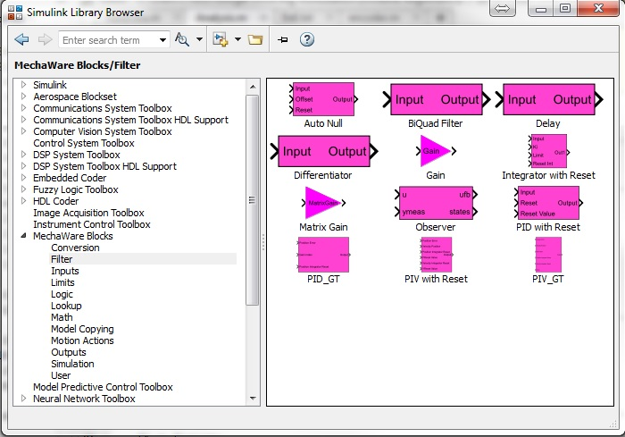

Figure ‑. MechaWare Simulink Plugin

MechaWare simplifies addressing more complex control system problems, particularly the issues of system resonance, vibration control and improved settling time performance. It is made up of time-proven basic building blocks used in PID and PIV algorithms. MechaWare allows the user to graphically define a combination of essential components for a desired algorithm (or control law). The Matlab/Simulink workspace provides the user with a graphical user interface for algorithm definition and access to the full functionality of Matlab [64]. The user is also able to load the control algorithm directly into the Roller Rig controller and gives the non-software engineer the ability to download custom control solutions onto the controller. MechaWare can collect and process feedback from all axes on the controller and issue commands at the same time, which facilitates and simplifies the design of MIMO systems [64].

#### MechaWare C++ API

The MechaWare API is a C++ programming interface that is used with MechaWare [63]. The API provides an interface to the controller for configuring MechaWare blocks after they have been downloaded. All MechaWare objects are available in MechaWare C++ API.

#### Motion Console

Motion Console embodies the object-oriented approach to motion control through its graphical user interface. Each object introduced above is separately represented in the software. Motion Console has been designed as a utility to assist programmers. It does not write custom applications or compile code. Rather, it provides an environment for the testing and monitoring of motion control components. This proves extremely helpful when writing new applications because it allows the user to check the code against a proven interface [61]. For example, if a request fails to move a component, the user can try Motion Console to see whether the problem lies within the hardware or software. Figure ‎4‑15 shows a snap-shot of the Motion Console interface.

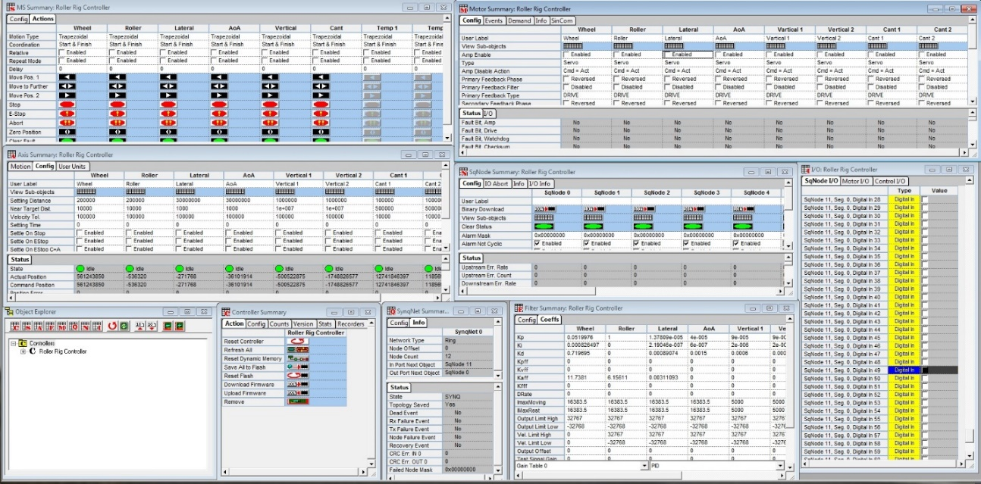

Figure ‑. A snapshot of Roller Rig Motion Console user interface

#### Motion Scope

Motion Scope provides a virtual "oscilloscope" to plot and export the captured data from motors, drives, and contact measurement sensors. Using Motion Scope in conjunction with Motion Console or MechaWare allows the user to command and plot the data in real time. Motion Scope plots, traces, and exports I/O signal data from the motion controller [65]. It also provides a utility for checking and troubleshooting motion control systems. Motion Scope is a purely "passive," read-only utility, with no ability to write data or control motion. Figure ‎4‑16 shows a snapshot of the software.

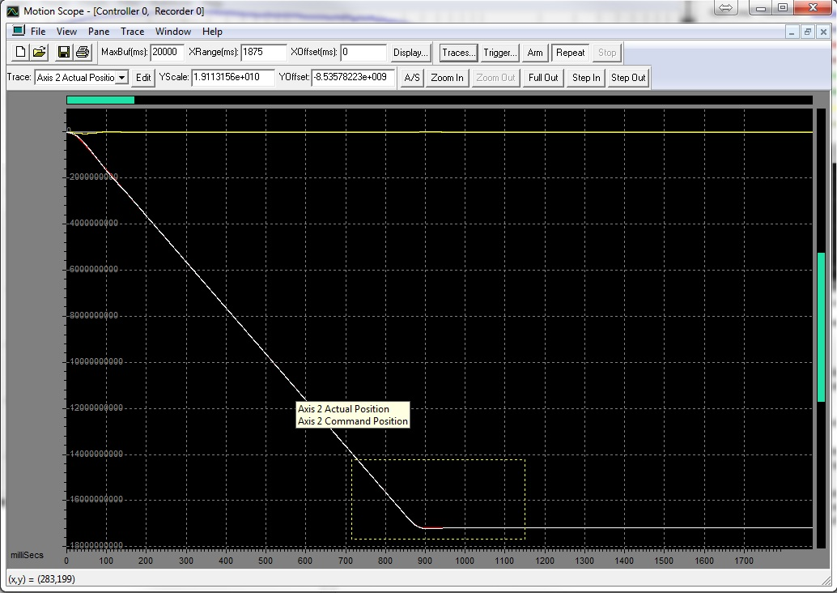

Figure ‑. An overview of the Roller Rig Motion Scope user interface (data for lateral axis)

#### Bode Tool

The Bode Tool is a tool for capturing frequency domain data from the Roller Rig. The Bode Tool is intended to make it easy to get the data a controls engineer needs to set up and tune the control system properly [66]. The Bode Tool can be used for the following measurements:

* **Measurement of Closed-Loop Response**: Provides measurement of the closed-loop frequency response of a single axis using sine sweep and white noise excitation methods.
* **Measurement for Two-Axis Systems**: Provides measurement of a two-axis system simultaneously using the sine sweep method, exciting the two axes in or out of phase. This is useful for systems with cross-coupled axes (gantries, SCARA robots, etc.)
* **Direct Measurement Using White Noise Excitation:** Provides direct measurement of closed, open, plant, and controller frequency response of the Rig using a white noise excitation method. The Bode Tool allows users to specify controller addresses for FFT inputs and output points to create specific dual channel measurements.
* **Control loop Configuration and Simulation**: Allows configuration of control loop parameters for PID, PIV, and Biquad post filters for quick, intuitive experimentation of controller response in simulation or on a live system. Additionally, can simulate changes to the control system without retesting, allowing control loop iteration cycles to be measured in seconds.
* **Plotting of Frequency Response Data:** Allows plotting of frequency response data in Bode, Nyquist, real/imaginary vs. frequency, and amplitude vs. phase formats. The results are also made available as tab-delimited text files for use in external analysis programs.
* **Automatic Stability Measurements**: The Bode Tool automatically makes quantitative stability measurements on both measured and simulated responses.
* **Command Line Operation**: Extensive command line parameter flags allowing automated testing from a batch file which useful for diagnosis and production line testing.
* **Plant Measurement of the Roller Rig:** Allows for plant measurement of the Rig and simulate tuning, which provides the user to go from no tuning to high-performance tuning in one step.
* **Open-Loop Response Simulation:** Provides simulation the open-loop response of the Rig from the closed-loop response. A filter can be simulated, and the filtered open- and closed-loop responses can be simulated.

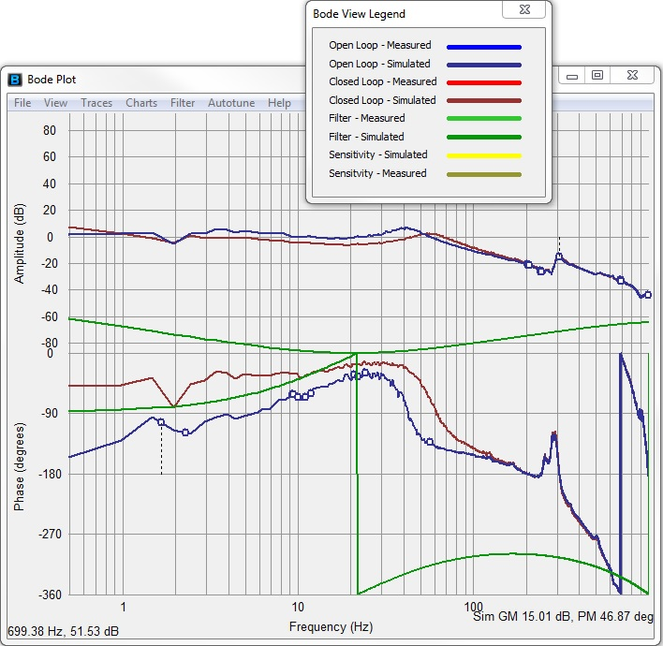

Figure ‑. A snap-shot from the Roller Rig Bode Tool user interface (plant frequency response)

### Packet Timing

A vital task in all layers of the Roller Rig motion programming interface is proper packet timing for on-time control and data capture. The MPI automatically configures the packets during network initialization based on the type of nodes. MPI also estimates the cable length between the nodes and the motion controller. Then, it scales the packet timing based on the node number, order, estimated cable length for on-time delivery.

For estimating the cable lengths, motion MPI sends a packet to each node, waits for the node to repeat the packet back, and measures the elapsed time [67]. In Ring topology, the last cable requires the packet to travel around the network and return to the motion controller. The motion controller reads the clock values for each measurement packet and stores the values. The MPI converts the raw time values into cable length (meters). The MPI also uses the propagation delay values to calculate the packet spacing.

The estimated cable length measured during initialization has an uncertainty factor that can affect control latency. For systems such as Roller Rig, the uncertainty is small $(± 0.160µs$ for an 8 node network) and is completely hidden when latency schedule is rounded up to N×drive period. For the expected sample rates on the Roller Rig, the cable length uncertainty has no effect on control latency. For ultra-high speed tests, however, even a tiny uncertainty can bump the latency by a full drive period. For these tests, the cable lengths cane be set manually (0 uncertainty in this case). Typical CAT-5 cable propagation delays are roughly 0.005µs/m. Actual values are affected by cable construction and will vary, but the variation will be small for any reasonable cable. The propagation delay can be estimated by a cable propagation velocity of 70% the speed of light, using the formula:

$$delay = meters×\frac{1,000,000}{0.7× 299,722,458}$$

The minimum sample rate is 1kHz. The MPI also supports user-configurable packets for customized node types. The MPI allows for time-based position capture. Time-based capture is a special technique useful for high accuracy position capturing when the motion controller reads the interpolated position feedback from the drive (encoder equivalent output or EEO), not the encoder itself. The position interpolation is required for increasing the resolution of the encoder, which is limited by physical constraints.

The MPI calculates the SynqNet control latency for each node. This is the time from when the feedback input is sampled at the node to the time when the demand output available on the node. This duration of time includes internal node delays, packet scheduling, network delays, controller delays, and controller calculation time. It does not include delays for serial encoders, drive feedback delays, or drive demand delays [60].

## Precise Independent Velocity Control

Each axis object executes a servo-loop at a constant rate. The following steps briefly summarize the sequence of operations that are performed each servo-loop period:

1. The servo drive calculates the encoder equivalent output and velocity of the axis using the information captured from the encoder.
2. New command position and velocity are calculated from the trajectory data from a Motion object.
3. The position error is calculated from the difference between the Command and Actual positions.
4. A filter algorithm calculates the demand signal that is applied to the drive.

The Virginia Tech Roller Rig supports Torque and Velocity demand modes. The demand mode determines the size and type of control signal between the controller and the drive. The demand mode is configurable when the amplifier is disabled. On-the-fly switching requires some special techniques to transition smoothly between demand modes.

### Roller Rig Demand Modes

During network initialization, the nodes are discovered, and the demand mode is automatically set to default, based on the particular drive model (S772 or AKD). The number of 16-bit demand fields per motor is configured and connected to the controller’s filter (closed-loop servo algorithm). The default is the recommended mode, but the user can change the demand mode [57].

#### Torque Mode

In **Torque Mode**, the output of the closed-loop servo algorithm is a 16-bit value representing torque. Figure ‎4‑18 shows a schematic of PID servo algorithm in this demand mode. The 16-bit demand value is sent cyclically to the drive in a special packet. Torque motion applies the specified torque to the motor shaft for acceleration or load bearing. The axes will continue to accelerate (with no load) at the specified torque until a new torque is commanded.

Control Velocity

Control Friction

Control Acceleration

Control Position

Actual Position

Velocity

Feedforward

Friction

Feedforward

Acceleration

Feedforward

IRR Filter

PID

Filter Offset

Motor Offset

#32767 Limit

Torque Demand

High/Low Output

Filter Limit

Figure ‑. MechaWare schematic of PID servo algorithm in Torque Mode

PID is a control algorithm based on position error. It is a very common control algorithm in motion control industry. Another servo control algorithm is PIV. It consists of an inner velocity loop and an outer position loop. PIV is a control algorithm based on velocity error for its inner loop and position error for its outer loop. It is similar in concept to a velocity drive that has a position loop around it. Systems that care more about velocity regulation than position error will likely have better velocity regulation with PIV than PID. For any application, it is recommended to try both PID and PIV to get the best performance. Figure ‎4‑19 shows a schematic of PIV servo control algorithm in Torque mode. Position and velocity compensators are further illustrated in Figure ‎4‑20 and Figure ‎4‑21.

Commanded Position

Position Feedback

Velocity Out

Position Compensator

Velocity In

Velocity Feedback

**Torque Out**

Velocity Compensator

Volts

Motor Current

Servo Drive

Command

Motion

**Roller Rig Axis**

Gain

$$k_{da}$$

$$V_{cmd}$$

$$P_{cmd}$$

Encoder Equivalent Output

EEO

$\frac{z-1}{z}$

Differentiator

Figure ‑. MechaWare schematic of PIV servo algorithm in Torque Mode

**+**

**-**

**+**

**+**

**+**

**+**

|u|

Integral Limit Moving

Integral Limit Resting

$$P_{cmd}$$

Position Feedback

1/Z

Unit Digital Delay

Velocity Out

Sign

Figure ‑. MechaWare schematic of the position compensator in PIV servo algorithm

`

Velocity Integral Limit

**+**

**+**

1/Z

Digital Unit Delay

**+**

**+**

**+**

Sign

$$k_{fff}$$

$$k_{aff}$$

$\frac{z-1}{z}$

Differentiator

$$k_{vff}$$

**+**

**-**

**+**

$\frac{z-1}{z}$

Differentiator

$$k_{iv}$$

**+**

**+**

$$k_{pv}$$

**+**

**+**

$\frac{b(z)}{a(z)}$

Digital BiQuad Filter

Velocity Integral Limit

0

Offset

Zero-Order Digital Hold

Velocity Feedback

**Torque Out**

$$V_{cmd}$$

Velocity Out

Figure ‑. MechaWare schematic of the velocity compensator in PIV servo algorithm

#### Velocity Mode

In **Velocity mode**, the output of the closed-loop servo algorithm (PID or PIV) is a 16-bit value representing velocity. The S772 and AKD drives automatically scale the velocity demand input so that the 16-bit range is used effectively. Velocity motion accelerates the axes to a specified velocity. The axes will continue to move at the specified velocity until a new velocity is commanded.

Control Velocity

Control Friction

Control Acceleration

Control Position

Actual Position

Velocity

Feedforward

Friction

Feedforward

Acceleration

Feedforward

IIR Filter

PID

Motor Offset

#32767 Limit

Torque Demand

High/Low Output Velocity

Filter Limit

Filter Offset

Velocity Demand

Figure ‑. MechaWare schematic of PID servo algorithm in Velocity Mode

### Servo Tuning

The object of tuning is to tweak the different gains and motion parameters of a servo machine so that the resulting motion is optimized for production purposes. A machine is considered "tuned" if its servo performance meets the specified requirements. There are some common signs that a servo is tuned:

* Visibly smooth motion
* Little to no audible noise produced during and after a commanded motion
* Acceptable measured overshoot on a step input (e. g. 25%)
* Little to zero position error after the completion of a commanded motion

Furthermore, key points in tuning the Roller Rig servo controllers are:

* For point-to-point moves, total motion time is the main concern, not the rise time. A longer move time with less ringing cycles is a better choice than a shorter move time with longer ringing cycles.
* Larger underdamped peaks should be omitted to prevent long ringing cycles.
* Ringing is caused by moves that are shorter than the closed-loop bandwidth and no acceleration feedforward ($K_{aff}$).
* Sometimes a longer move time is better than a shorter move time because it is more stable (less ringing) and no overshoot.

Various methods are available for tuning a servo system to deliver the above specification.

Table ‎4‑5. Comparison between common servo tuning methods [68]

|  |  |  |  |  |  |  |  |
| --- | --- | --- | --- | --- | --- | --- | --- |
| **Servo Tuning Method** | **Ease of Use** | **Stability** | **Speed of Tuning** | **Ease of  Getting Data** | **Experience Required** | **Servo Algorithm** | **Summary of the Method** |
| Step Overshoot | ✓✓✓✓ | ✓✓ | ✓✓✓ | ✓✓✓ | average | PID | $$K_{d}→K_{p}→K_{i}$$ |
| Step Stability | ✓✓✓✓ | ✓✓ | ✓✓✓✓ | ✓✓✓ | average | PID | $$K_{p}→K_{d}→K_{i}$$ |
| Under/Over damped | ✓✓✓ | ✓✓✓ | ✓✓✓ | ✓✓✓ | average | PID | $$K_{p}\& K_{d}→K_{i}$$ |
| Frequency Response | ✓✓ | ✓✓✓ | ✓✓ | ✓ | expert | PID | - |
| Velocity/ Position Loop | ✓✓✓ | ✓✓✓ | ✓✓✓ | ✓✓ | above average | PIV | Velocity Loop $→$ Position Loop |
| Frequency Shaping | ✓ | ✓✓✓✓ | ✓ | ✓ | expert | PID and PIV | - |

Trial-based iterative methods require some move to be made. The response of the system is observed in the time domain and an adjustment towards the goal is made based on the response of the system. This is iterated until the control goals are satisfied. One of the important features of trial-based iterative methods is that the simplicity of commanding a move and getting the time domain response of the system. The common problem with these methods is that they can easily get unstable for unexperienced user. Roller Rig Motion Console and Motion Scope are two interfaces that can be used for getting time domain response of the system in iterative tuning.

Frequency shaping is a method for tuning a control loop in the frequency domain with more flexibility than time domain methods. It can address problematic elements of a system more directly than simpler methods can provide. Frequency shaping is a tuning method that is largely based on frequency analysis and requires accurate frequency response data of the Rig. It has numerous more adjustments than a standard PID tuning method. It is necessary that the controls engineer has specific knowledge about the problems to be solved to apply correct solutions. Roller Rig Bode Tool is an interface that can be used for performing frequency shaping servo tuning.

PIV and Lead/Lag frequency shaping followed by fine tuning were used for tuning the wheel and roller rotational axes. PID frequency shaping and fine tuning were utilized for the linear axes. Bode Tool provides an excellent Auto-tuning feature for frequency shaping. The Auto-tuner only operates in “Plant” measurement mode with white noise excitation.

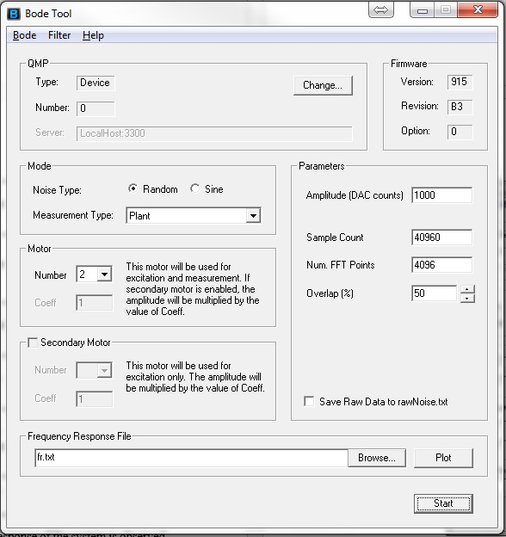

Figure ‑. A snap-shot of Bode Tool ready for FFT measurement

Once the Bode Plot is displayed, the drive should be disabled to prevent unexpected moves during tuning. The Autotuner takes most of the guesswork out of tuning. It does require a reference point for it, as a safety precaution. It is recommended to use the point where the open-loop phase crosses through the -180-degree point (bottom blue trace). The red arrow shows this point for the example below.

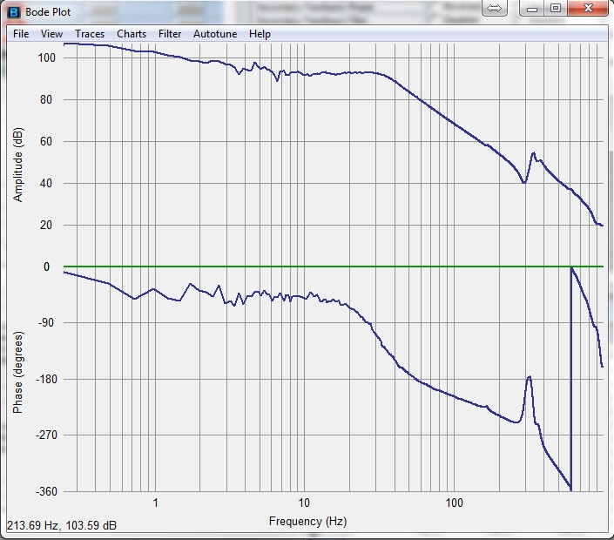

Figure ‑. Selecting the reference point for the Bode Tool Auto-tuner (plant frequency response). The simulated and measured open-loop responses are identical.

There are four auto-tuning methods available:

* Resonator
* PID
* PIV
* Lead/Lag

Each method should be checked for achieving the best performance. Clearing out tuning parameters will set PID and post filter settings to 0.

The Auto-tuner will always return a set of tuning parameters. These parameters should be checked manually to make sure they are stable for Rig. The easiest way to verify this is to turn on the closed-loop simulation and ensure that the frequency response is reasonable. Any peak in the simulated closed-loop response (dark red/brown) of more than +6 dB or so in unacceptable. An example is shown below that show acceptable Auto-tuning with the Lead/Lag method (3% smoothing used to make the results easier to see).

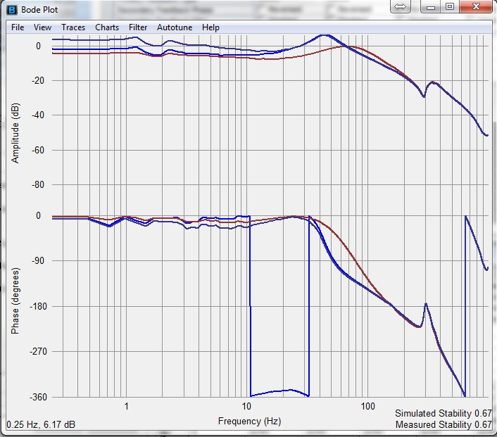

Measured Open Loop Response

Simulated Open Loop Response

Figure ‑. An example of acceptable Auto-tuning results using the Lead/Lag method

#### Stability Measurement

A quantitative stability measurement is made when a bode test is run. The measurement is displayed quantitatively in the bottom right-hand corner of the plotting window [66]. The stability measurement is performed on both the measured open-loop and the simulated open-loop responses. The measured and simulated response are identical if the control tuning has not been changed since taking the measurement. When simulating control-loop response, the user can compare the stability of the measured vs. simulated response.

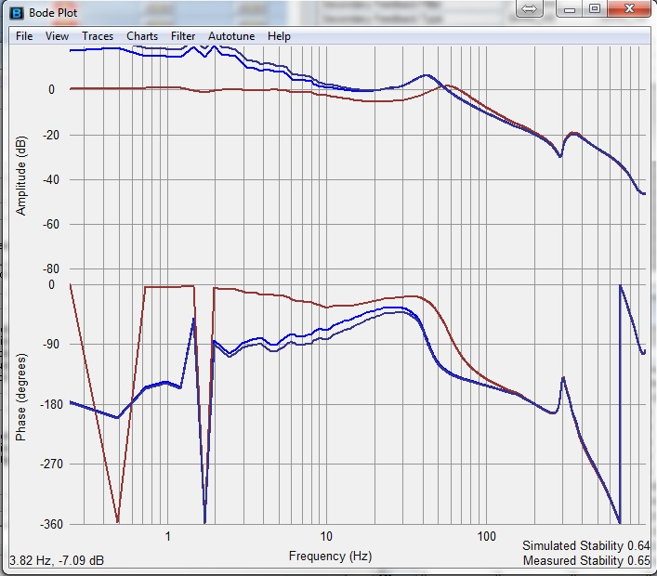

Measured Open Loop Response

Simulated Open Loop Response

Figure ‑. Simulated and measured stabilities using PID (compare with Figure ‎4‑25)

Bode Tool can also provide a visual representation of the stability measurement in Nyquist plot. If different, the measured and simulated responses will be shown separately with arrows. The length of the arrow is equal to the stability measurement value, which is also shown in the plotting window. The stability measurement is the distance between 0dB, -180 degrees and the closest open-loop response point [69]. The 0dB, -180-degree point represents an oscillator. In the figure below, the stability measurement is 0.70.

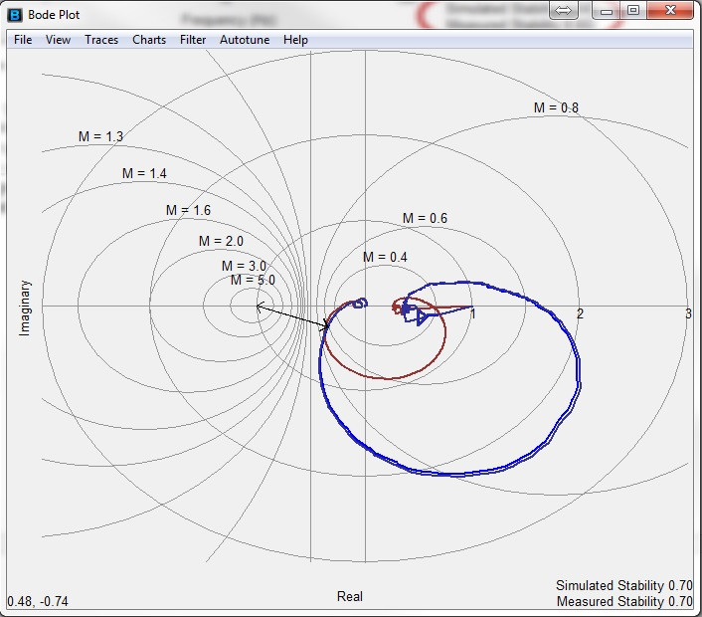

Figure ‑. Simulated and measured stability in Nyquist plot

The stability value ranges from 0 on up (x > 0). However, a realistic upper limit value of 1 would be normal. A stability measurement of 0 would represent an extremely unstable system. A stability measurement of 1 would represent an extremely stable system [69]. It is not uncommon for Roller Rig Axes to end up with a stability figure in the range of 0.3 - 0.5 after all tuning if finalized.

#### Gain and Phase Margin

The gain and phase margins are commonly used in controls to quantitatively determine how stable a system is. The gain and phase margins are separate measures of the stability of a system. Gain and phase margins are only calculated based on the open-loop system response. They are not valid measures of the closed-loop response [70].

Gain and phase margin measurements serve two purposes: 1) They ensure that the system is sufficiently damped and stable to reduce overshoot, ringing effect, and other undesierable behaviors and 2) They ensure the controller is stable enough to deal with any unknowns in the system, such as different motors on the production line having slightly different performance [69]. A normal system would do well with a minimum of 12 dB gain margin and 45 degrees of phase margin.

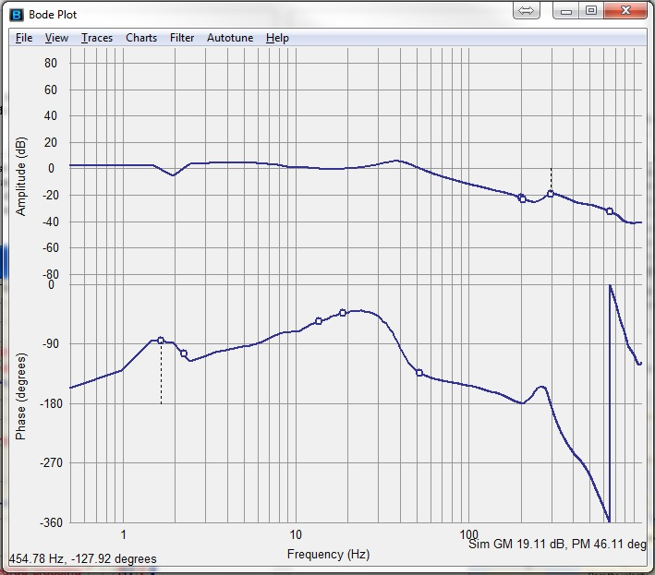

Worst gain margin

Other gain margins

Worst phase margin

Other phase margins

Figure ‑. Multiple gain and phase margin in the bode plot

The gain margin of a system is the amount of amplitude below 0dB at the frequency which the phase crosses -180 degrees. This can occur more than once. A common way to deal with multiple gain margin measurements is to concider the worst one, i.e. the smallest gain margin. The bode tool automatically does this. It shows all gain margin measurements with a dot and show the worst with a dot and dotted line. Gain margin values are shown in the lower left of the screen for both measured and simulated data. These concepts are shown below [66].

The phase margin of a system is the amount that the phase of a system is more than -180 degrees at the frequency where the open-loop amplitude crosses 0 dB. This can happen more than once. The easiest way to deal with multiple phase margin measurements is to concentrate on the worst one (smallest phase margin) [71]. The bode tool does this automatically. It will show all phase margin measurements with a dot and show the worst with a dot and dotted line. Phase margin values are shown in the lower left of the screen for both measured and simulated data. These concepts are shown above.

Both stability measurement and Gain/Phase margin can be used to evaluate the performance of the Rig. The table below provides a comparison of the two methods:

Table ‎4‑6. A comparison between phase and gain margin versus stability measurement

|  |  |  |
| --- | --- | --- |
| Method | Pro | Con |
| Stability Measurement | It is excellent at finding the worst frequency of instability in a system. It is an automated way of looking at the Nyquist plot, which is the most efficient simple way of looking at stability. It will not miss resonances that are not near 0 dB or -180 degrees [69]. | It is much less common than gain and phase margin. |
| Gain and Phase Margin | It is the most common way to specify or measure the stability of a system. | It can miss critical resonances that don't occur near the 0 dB or -180-degree crossover frequencies. |

Table ‎4‑7. Stability of the VT Roller Rig Axes

|  |  |  |  |  |
| --- | --- | --- | --- | --- |
|  | Servo Control Algorithm | Stability | Gain Margin (dB) | Phase Margin (deg) |
| Wheel | PIV with feedforward | 0.61 | 11.45 | 50.56 |
| Roller | PIV with feedforward | 0.93 | 3.21 | 62.95 |
| Lateral | PID with feedforward | 0.65 | 18.02 | 47.70 |
| AoA | PID | 0.41 | 5.00 | 48.76 |
| Vertical | PID | 0.65 | 13.25 | 51.65 |
| Cant | PID | 0.61 | 8.41 | 62.68 |

The diagrams below outlines the main steps of PIV velocity loop tuning [70]:

Command a test motion

Does the motion oscillate or make noise?

Turn up $k_{a1}$

Command a test motion

Does the velocity overshoot or make unacceptable noise?

Turn down $k_{pv}$ until the velocity overshoot stops

Turn down $k_{pv}$ by 2/3

Done! Velocity loop is fine tuned

Turn up $k_{pv}$

Turn up $k_{a1}$

Noisy

Neither

Velocity Overshoot

Turn up $k_{pv}$

No

Yes

Figure ‑. Flowchart of PIV velocity fine tuning

Table ‎4‑8 summarizes the velocity control accuracy of the VT Roller Rig after servo tuning. Figure ‎4‑30 and Figure ‎4‑31 show the raw velocity feedback. As discussed later, this data is subjected to quantization error in encoder equivalent output. In other words, not all of the error shown in these two figures is happening in reality. A major part of it is an artifact caused by the digital interpolation and quantization operations applied by the drive to the encoder output for increasing the performance of positioning servo algorithm. The mathematical modeling and filtering technique for de-noising the velocity data is extensively discussed later in this document. The 90% probability band for the error using the noisy raw data is 0.206rpm for the wheel, and 0.104rpm for the roller. Figure ‎4‑32 and Figure ‎4‑33 show the histogram of the error for both axes and the 90% probability band.

Table ‎4‑8. Velocity control accuracy of the VT Roller Rig after servo tuning

|  |  |  |  |
| --- | --- | --- | --- |
| Axis | after frequency shaping | after fine tuning (improvement) | with 90% probability band |
| Wheel (rpm) | 1.516 | 0.526 (65.30%) | 0.206 |
| Roller (rpm) | 1.282 | 0.221 (82.76%) | 0.104 |

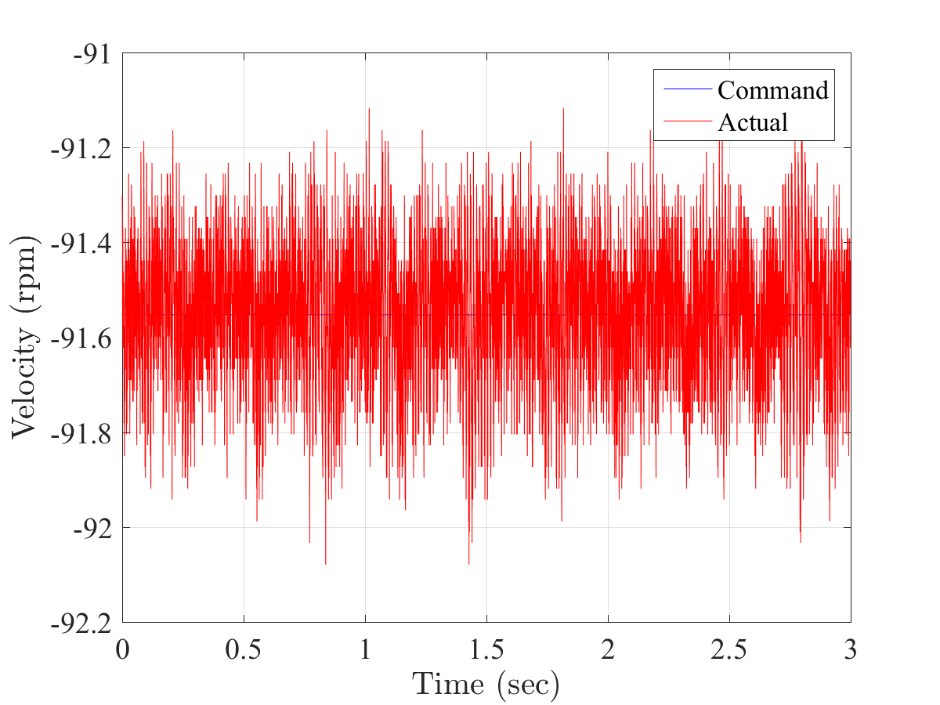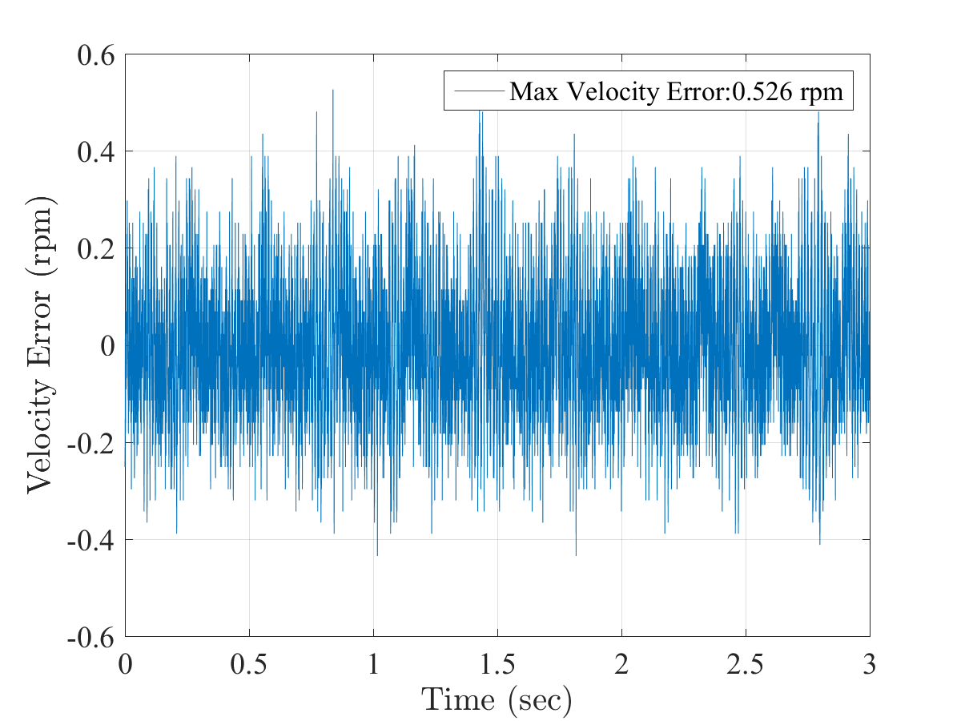

Figure ‑. Instantaneous velocity error of the wheel axis at *91.553rpm*

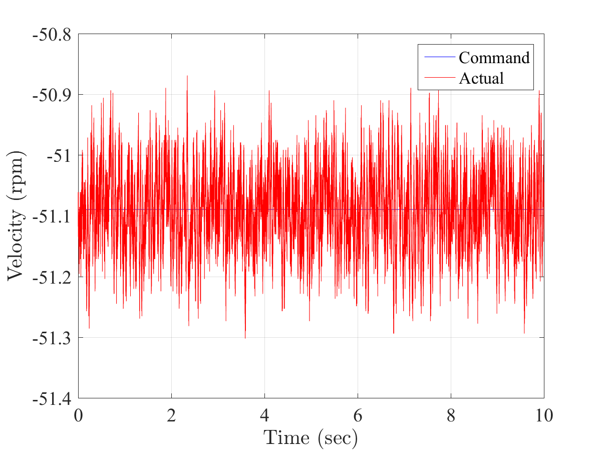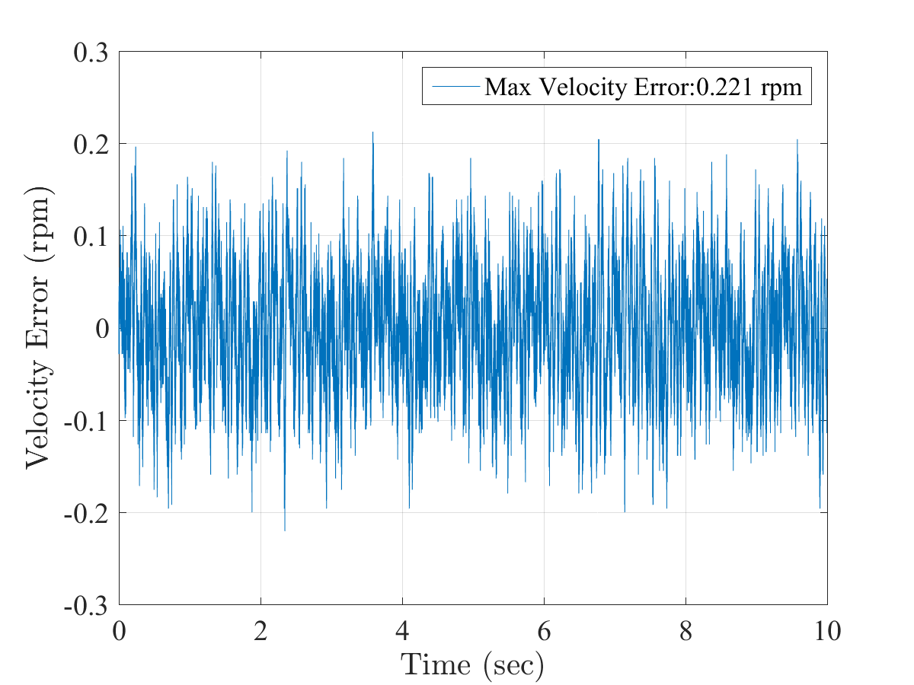

Figure ‑. Instantaneous velocity error of the roller axis at *51.090rpm*

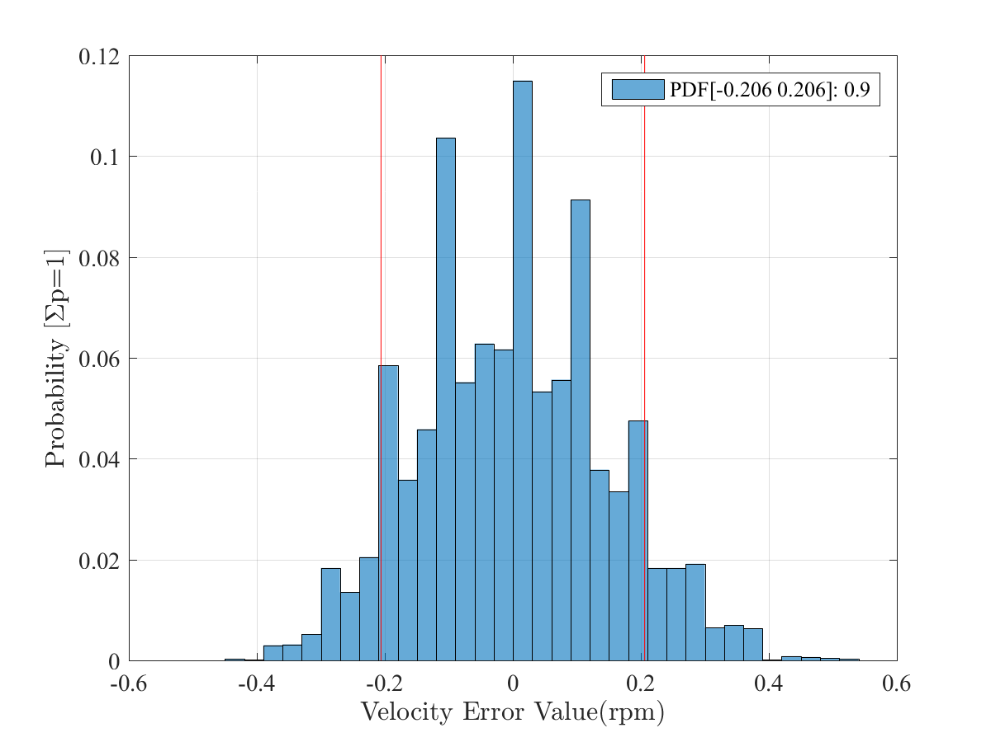

Figure ‑. Velocity control accuracy of the VT Roller Rig for the wheel axis at *91.553rpm* with 90% probability band: *0.206rpm*

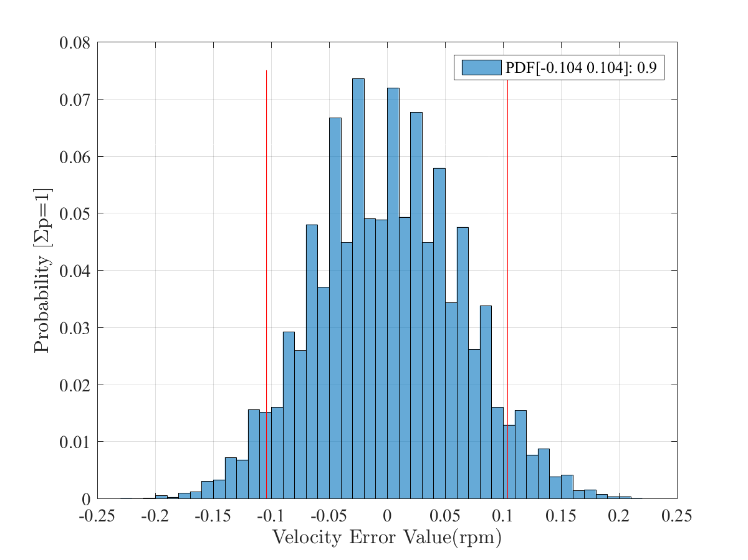

Figure ‑. Velocity control accuracy of the VT Roller Rig for the roller axis at *51.090rpm* with 90% probability band: *0.104rpm*

### D-Rate

D-Rate is a derivative averaging method in PID servo algorithm. When used, the PID derivative term is applied to the velocity that is measured in the last *n* samples where *n = D-Rate +1.* D-Rate is valuable when it is not possible to use filters due to some environmental or design constraint. D-Rate can only be set in integer values with the default value of 0. To conserve computational horsepower and memory, D-Rate is limited to a maximum of 7 [72].

The derivative is applied to the measured velocity over some samples. It is not applied to the average velocity during that period. Therefore, a change in D-Rate influences the effective gain of $K_{d}$. Since the derivative term can be measured over several samples, some aliasing factors can also have an effect. An increase in D-Rate will increase the effective $K_{d}$ at frequencies far below the Nyquist Frequency (1/2 sample rate). The effective increase in $K_{d}$ at low frequencies will be:

$$\left(DRate + 1\right)×K_{d without d-rate}= K_{d effective}$$

D-Rate has the effect of changing the sample rate for the derivative term . This has two effects:

* A comb filtering effect occurs at high sample rates. This consists of two effects: Notches in the amplitude response of the control algorithm that are dependent on the D-Rate value, and distortions in the phase response that correspond to the notches.
* Because of the comb filtering effect, there is an effective cap in $K_{d}$ gain that is relatively the same regardless of D-Rate.

The gain of D-Rate at very high frequencies (near the Nyquist frequency) will be lower than the gain if $K_{d}$ is raised to an equivalent level (equivalent $K_{d}=K_{d}×(DRate + 1)$).

## Precise Wheel-Rail Positioning

Point to point motion will start a move on all the axes mapped to the Motion object from the current command position to a new position. There are two main point-to-point motions, each taking a different set of arguments and generating different velocity profiles as the axis/axes are moving:

* **Trapezoidal:** This type of the movement has a trapezoidal shape for the velocity with constant acceleration and deceleration phases.
* **S-Curve:** This kind of move has an "S" shape to the acceleration and deceleration phases. It uses a “Jerk Percent” argument to decide how much of the acceleration and deceleration phases are curved. A Jerk Percent of zero produces a trapezoidal profile.

These motion profiles are illustrated in Figure ‎4‑34 and Figure ‎4‑35.

Acceleration

Velocity

Position

Figure ‑. Trapezoidal motion profile

Jerk

Acceleration

Velocity

Position

Figure ‑. S-Curve motion profile

The following table summarizes the arguments that each of the motions needs. The Position argument is always required, but all the other arguments are optional.

Table ‎4‑9. Comparison between Trapezoidal and S-Curve motion parameters

|  |  |  |  |  |  |  |
| --- | --- | --- | --- | --- | --- | --- |
|  | **Position** | **Speed** | **Acceleration** | **Deceleration** | **Jerk Percent** | **Attributes** |
| **Trapezoidal** | Mandatory | Yes | Yes | Yes | No | Yes |
| **S-Curve** | Mandatory | Yes | Yes | Yes | Yes | Yes |

If an optional argument is omitted, then the value used is taken from the corresponding properties starting with default in either the Axis or Motion objects. The Attributes argument modifies the default behavior of each of these motions enabling a large number of variations of the basic motion to be generated. The Attributes argument does not have a corresponding default property and must be specified for each motion.

Frequency shaping followed by PID tuning with step behavior were used for tuning the wheel-rail positioning axes. Where needed, feedforwards were added to correct small remaining errors and achieve faster settling time.

PID tuning with step behavior is accomplished by turning up a gain parameter until unwanted behavior (oscillation or noise) is reached and then turn down the gain parameter until the desired behavior is achieved and the stage is stable. This method primarily focuses on tuning the position overshoot parameter. The diagram below shows the natural progression of steps for this tuning method. To create a disturbance on the stage, a small commanded step is made. To create a step, a highly large acceleration, deceleration, and velocity is used ( $1e^{10} counts/\sec^{2}$ should be enough for all axes). Figure ‎4‑36 summarizes the steps involved in tuning a PID servo loop with step behavior [70].

Command a test motion

Does the motion oscillate or make noise?

Turn down $k_{d}$ by 2/3

Command a test motion

Is the overshoot more than half of overshoot specifications?

Command a test motion

Is the overshoot more than the specifications

Done! Velocity loop is fine tuned

Turn up $k_{p}$

No

Yes

Turn up $k_{d}$

Yes

Turn up $k_{i}$

No

No

Figure ‑. PID servo tuning with step behavior

Feedforwards result in a virtually instantaneous response of the system. Feedback control loops (PID, PIV, or similar) take a finite amount of time before reacting. Feedforwards rely on an imperfect model of the system. This means that the feedforwards need help from the feedback control loop to get accurate motion. Feedforwards make the bulk of the move very quickly, while the feedback control loops correct the small errors that remain. As a result, a faster settling time is achieved than if feedforwards were not used.

On the other hand, feedforwards are open-loop, so they cannot suffer from closed-loop instability. Feedforwards are typically less sensitive to being misadjusted than closed-loop parameters. Feedback control systems can be excited into instability by grossly misadjusted feedforwards. However, the amount of maladjustment in feedforwards that is necessary to cause such instability is very rare.

Table ‎4‑10 summarizes the positioning accuracy of the VT Roller Rig after servo tuning. Figure ‎4‑37 through Figure ‎4‑40 show the actual errors in motion and at steady state. All motion profiles are trapezoidal. The maximum positioning error of the VT Roller Rig in motion is 66.35µm, and 16nm while holding a constant position.

Table ‎4‑10. Positioning accuracy of the VT Roller Rig after servo tuning

|  |  |  |  |  |
| --- | --- | --- | --- | --- |
| Axis | In motion | | Steady | |
|  | after frequency shaping | after fine tuning (improvement) | after frequency shaping | after fine tuning (improvement) |
| Lateral (mm) | 0.1058 | 0.06635 (37.29%) | 8.516e-6 | 5.398e-6 (36.61%) |
| Vertical (mm) | 0.0515 | 0.00358 (93.05%) | 0.00323 | 8.567e-6 (99.74%) |
| Cant (mm) | 0.04832 | 0.01779 (63.18%) | 0.00668 | 1.607e-5 (99.76%) |
| AoA (mm) | 0.04304 | 0.02114 (50.88%) | 1.365e-5 | 1.017e-5 (25.50%) |

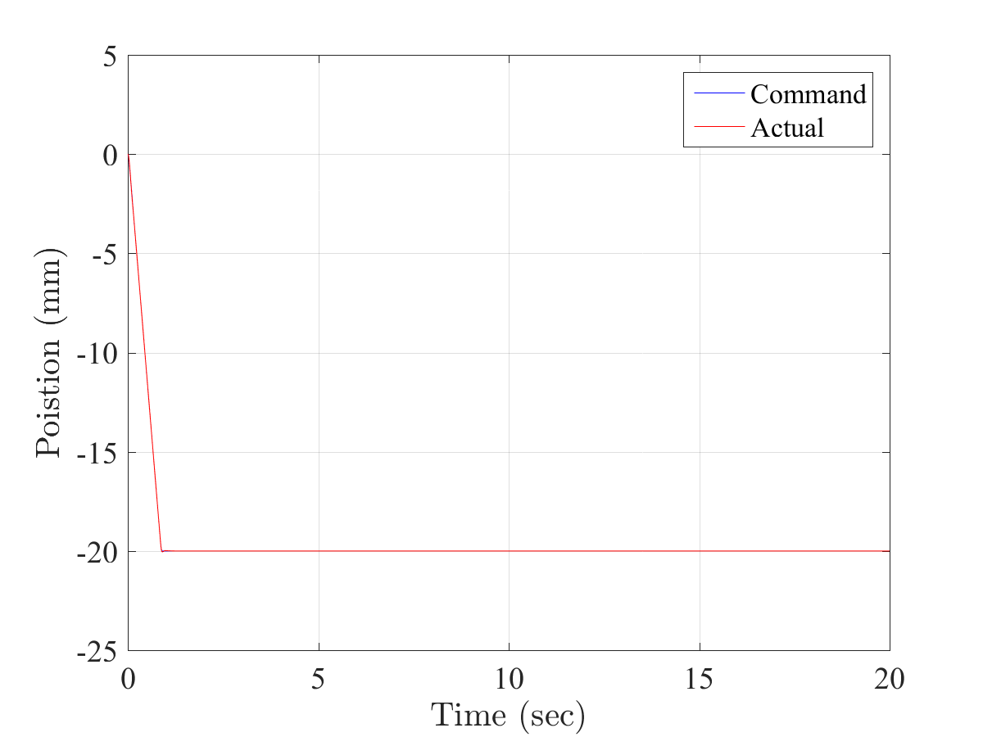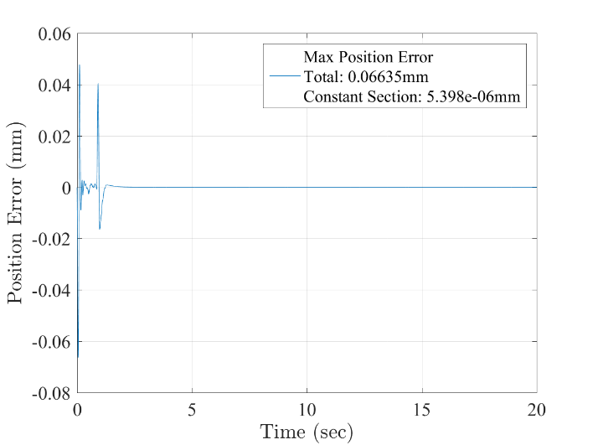

Figure ‑. Positioning accuracy of the VT Roller Rig in a *20mm* lateral motion at *22.52mm/s*: *66.350µm* error in motion, *5.398nm* error at steady state

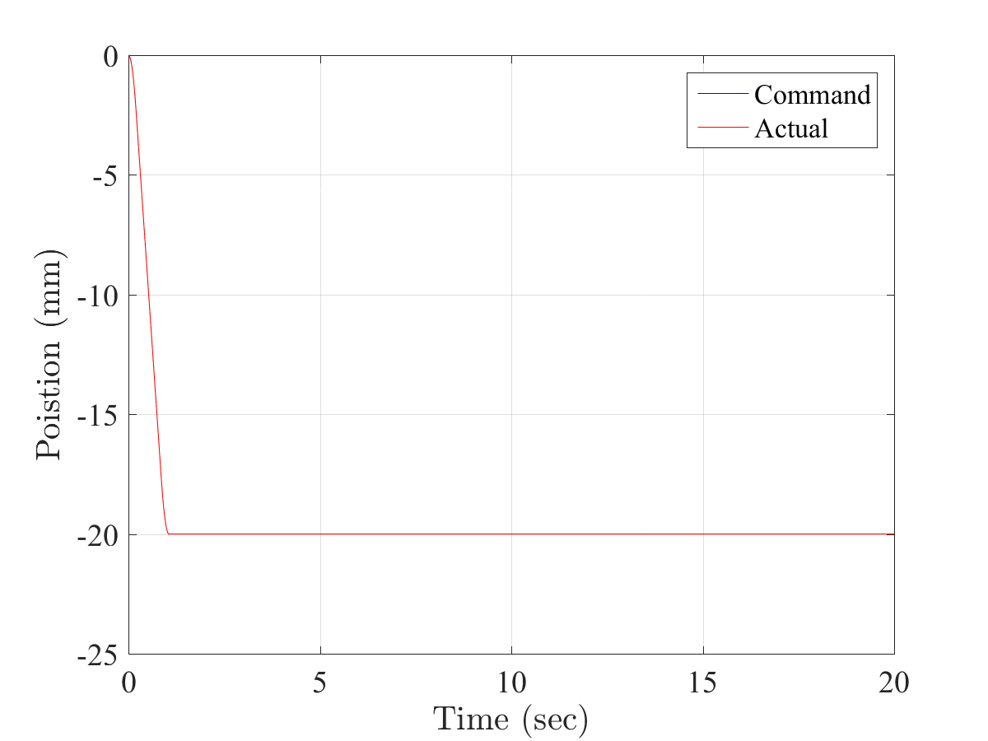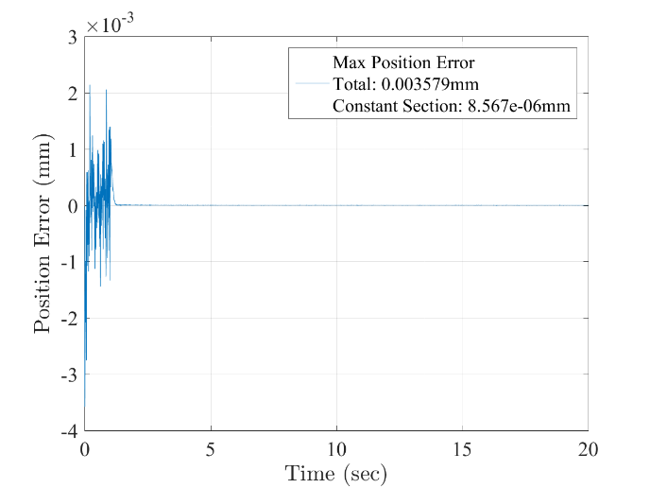

Figure ‑. Positioning accuracy of the VT Roller Rig in a *20mm* vertical motion at *19.3mm/s*: *3.579µm* error in motion, *8.567nm* error at steady state

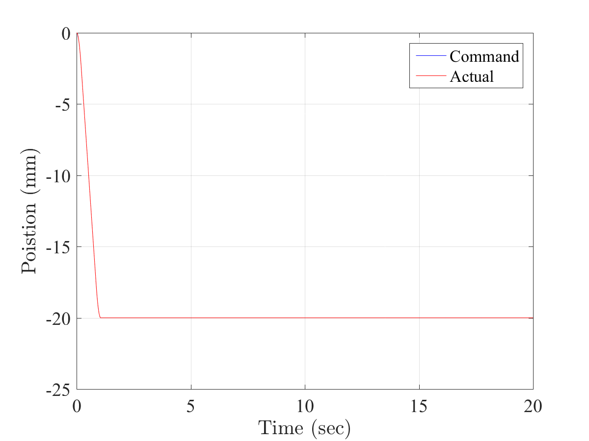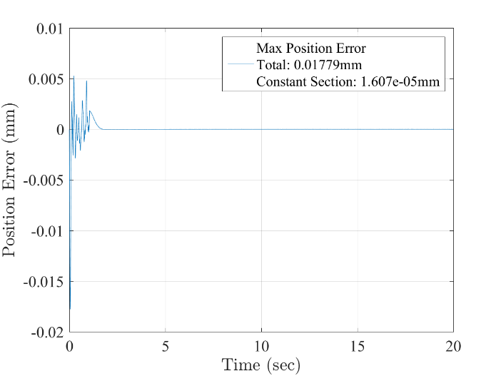

Figure ‑. Positioning accuracy of the VT Roller Rig in a *20mm* cant motion at *19.15mm/s*: *17.79µm* error in motion, *16.07nm* error at steady state

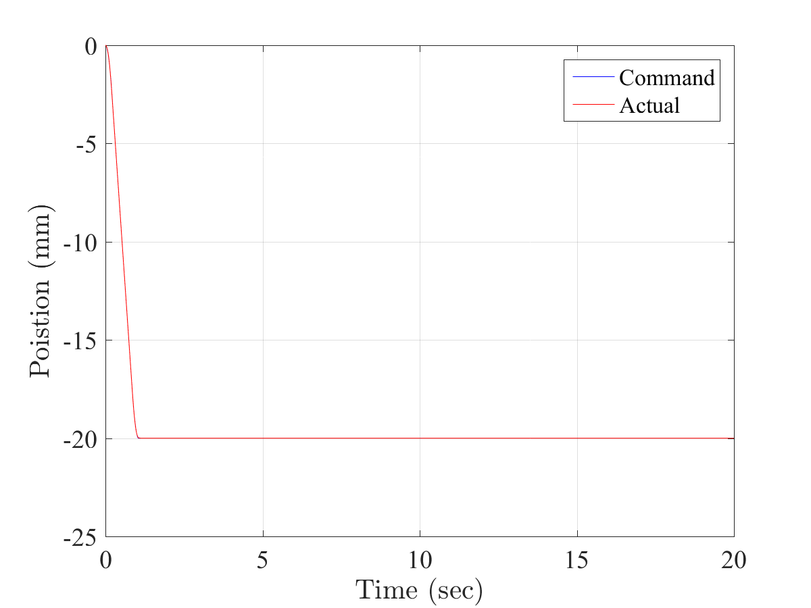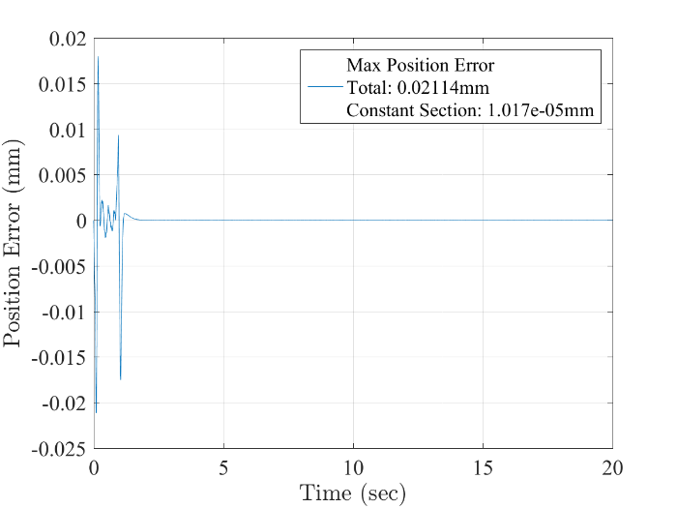

Figure ‑. Positioning accuracy of the VT Roller Rig in a *20mm* AoA motion at *17.2mm/s*: *21.14µm* error in motion, *10.17nm* error at steady state

### Scaling PID Parameters for Different Controller Update Rates

When tuning the Roller Rig, it may be necessary to adjust the controller's sample rate for optimum performance. Changing the sample rate will directly affect the closed-loop response of the PID control algorithm. To maintain stability and performance, the PID parameters must be scaled to match the change in sample rate. The table below has been taken from a document published by Motion Engineering (now part of Kollmorgen) [73]. It explains how to scale the tuning parameters properly. This document only addresses scaling for the PID closed-loop algorithm. It does not compensate for resonances caused by increased system bandwidth or system nonlinearities.

Table ‎4‑11. Compensations for PID parameters at different controller update rates

|  |  |
| --- | --- |
| **Term** | **Compensation** |
| Proportional - $K_{p}$ | None |
| Integral - $K_{i}$ | new $K_{i}$ = old $K_{i}×$ (old SR / new SR) |
| Derivative - $K_{d}$ | new $K_{d}$ = old $K_{d}×$ (new SR / old SR) |
| Acceleration Feedforward - $K_{aff}$ | new $K_{aff}$ = (new SR / old SR)2old Kaff |
| Velocity Feedforward - $K_{vff}$ | new $K_{vff}$ = (new SR / old SR) $×$ old Kvff |
| Friction Feedforward - $K_{fff}$ | None |
| Position Feedforward - $K_{pff}$ | None |

## Accurate Measurement of Contact Forces and Moments

The maximum tangential, and normal forces at the contact patch of the VT Roller Rig are calculated based on the scaling strategy (INRET) and scale factor of 1/4th. These forces are tabulated in Table ‎4‑12. Figure ‎4‑41 shows how these contact creep forces are reacted at the positioning systems. Considering the forces in Table ‎4‑12 and the position of dynamometers, the reaction moments taken by the transducers are calculated.

|  |  |
| --- | --- |
|  | Z  X  Linear Bearings  Y |

Figure ‑. Contact creep forces are reacted by the positioning system

Table ‎4‑12: Maximum estimated creep forces at the contact patch

|  |  |  |  |
| --- | --- | --- | --- |
| Unit | Longitudinal ($F_{x}$) | Lateral ($F_{y}$) | Vertical ($F_{z}$) |
| Newton (N) | +/- 4265 | +/- 4265 | -10664 |

As discussed in powertrain chapter, a direct driveline is selected to rotate the wheel and roller via two independent motors, without any flexible joints. This causes a contact force shunt through the driveshaft connected to the wheel. In other words, the load path of the contact forces to ground is not solely through the wheel bearings (Figure ‎4‑42). This can affect the load cell readings using only one force measurement system under the wheel. The loading component that passes through the driveline needs to be measured and compensated in the sensor readings for obtaining accurate contact forces. To this end, a secondary force platform is implemented under the motor. Figure ‎4‑43 shows both force platforms (dynamometers) installed under the wheel driveline.

If there are any other elements such as shear loading that passes through the driveline, the motor dynamometer will be able to resolve them from the readings. The motor platform measures the motor torque in addition to the force shunt components. Assuming the motor is mounted exactly between left and right sensors, the motor torque can be resolved to the left and right sensors as a force couple. Therefore, it can be subtracted from the sensor readings, and it would be possible to resolve all force shunt components of the driveline from the motor dynamometer’s readings.



Figure ‑: The path for the contact forces to the ground includes two routes: one through the wheel bearings, and the other one through the motor mounting plate (force shunt)

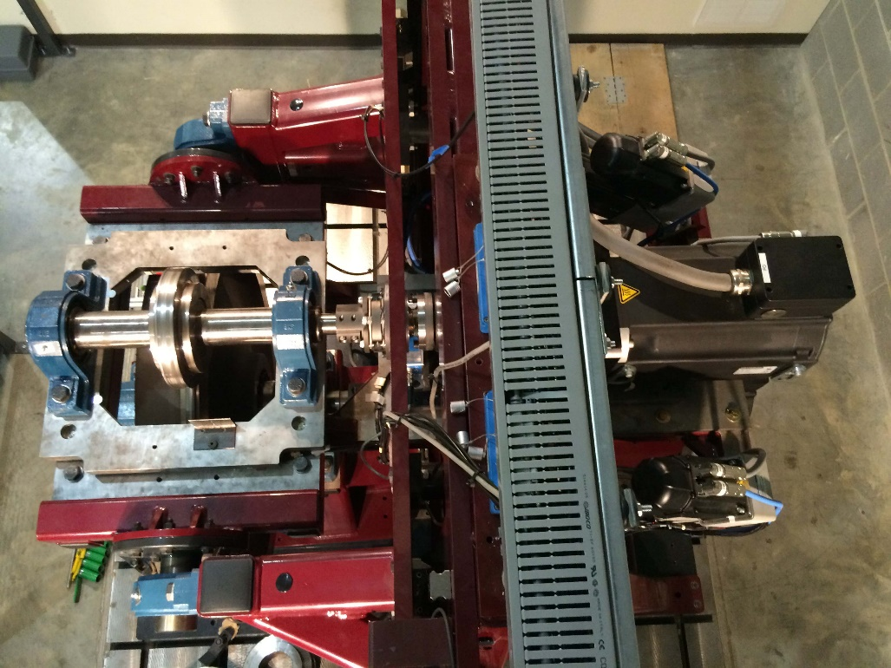

Wheel Dynamometer

Motor Dynamometer

Instrumentation Cable Trough

Figure ‑: Top view of the rig showing wheel and motor dynamometers installed under the wheel driveline

Two specially designed dynamometers are used to measure the contact forces and moments. The dynamometers are embedded in the load-path of the contact forces from the wheel-roller interface to the ground. The position of the dynamometers are selected such that they minimize the reaction moments of the contact forces, and simplify resolving the contact forces from the sensor readings. Each dynamometer is comprised of four triaxial piezoelectric load cells (Kistler, Amherst, NY) preloaded between two plates. The four triaxial sensors are aligned and installed on the base plate. The cover plate and pretensioning set are then installed to preload the sensors. Figure ‎4‑44 shows the motor (left) and wheel (right) dynamometers. Figure ‎4‑45 illustrates the arrangement of loadcells in each dynamometer.

|  |  |
| --- | --- |
| C:\Users\MHP\Desktop\IMG_0238.jpg | C:\Users\MHP\Desktop\IMG_02282.jpg |

Figure ‑: Contact force measurement dynamometers consist of four triaxial sensors preloaded between two plates (left: motor, right: wheel)

Each triaxial loadcell[[3]](#footnote-3) is capable of conducting dynamic and quasi-static measurements. The preloading of the sensors between the base and cover plates would ensure that tensile forces are measured as a relief of the preloaded sensor, shear forces are transmitted between sensor and plates, and micro-gaps are closed ensuring high rigidity and a wide frequency range. Each triaxial loadcell is a quartz force sensor that works based on the piezoelectric principle. The generated electrostatic charges are picked up by built-in electrodes and transferred to the corresponding connector. Table ‎4‑13 summarizes the technical specification of triaxial loadcells.

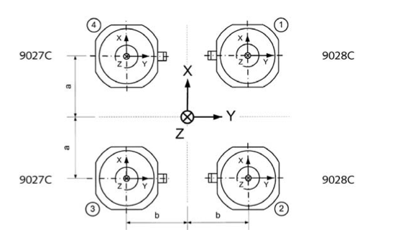

Figure ‑: Arrangement of loadcells in each dynamometer [74]

Table ‎4‑13: Technical specification of piezoelectric triaxial loadcells [74]

|  |  |  |  |
| --- | --- | --- | --- |
| Range | $F_{x}$, $F_{y}$ | kN | -4 … 4 |
| $$F_{z}$$ | kN | -8 … 8 |
| Sensitivity | $F_{x}$, $F_{y}$ | pC/N | $$≈-7.8$$ |
| $$F_{z}$$ | pC/N | $$≈-3.8$$ |
| Overload | $F_{x}$, $F_{y}$ | kN | -5/5 |
| $$F_{z}$$ | kN | -10/10 |
| Linearity, each axis | | %FSO | $$≤±0.25$$ |
| Hysteresis, each axis | | %FSO | $$≤0.25$$ |
| Crosstalk | $F_{z}→F_{x}$, $F_{y}$ | % | $$≤±0.5$$ |
| $$F_{x}{↔F}_{y}$$ | % | $$≤±2$$ |
| $F_{x}$, $F_{y}→F_{z}$ | % | $$≤±2$$ |

The electrostatic measurement signals of the four sensors in each dynamometer can be summated via a summing box[[4]](#footnote-4) (Kistler, Amherst, NY) to reduce the number of outputs from 12 to 8. The summated signal corresponds to the algebraic total charge of the individual sensors. The summing box provides the following summated and individual outputs:

|  |  |  |  |
| --- | --- | --- | --- |
| $F_{x1+x2}$ $F_{x3+x4}$ | $F_{y1+y4}$ $F_{y3+y4}$ | $F_{z1}$ $F_{z2}$ | $F_{z3}$ $F_{z4}$ |

The eight outputs from each summing box are conditioned and amplified by a multichannel charge amplifier[[5]](#footnote-5) (Kistler, Amherst, NY). The charge amplifier converts the eight measuring electrostatic signals into the following fourteen ±10VDC signals [75]:

|  |  |
| --- | --- |
| $F_{x1+x2}$ $F_{x3+x4}$ $F_{y1+y4}$ $F_{y3+y4}$ $F_{z1}$ $F_{z2}$ $F_{z3}$ $F_{z4}$ | $Sum F_{x}$ $Sum F_{y}$ $Sum F_{z}$ $M_{x}$ $M_{y}$ $M_{z}$ |

The output signals of the charge amplifier are put into the SynqNet MIXEDMODULE data acquisition units. Figure ‎4‑52, Figure ‎4‑49, and Figure ‎4‑46 show the accumulative baseline error of both dynamometers in X, Y, and Z directions with no motion and the wheel drive disabled. The measurements are taken when the wheel and roller are not in contact, i.e. zero dynamic force in the three direction. The error in these figures can be attributed to the imperfections in the sensors, summing boxes, charge amplifiers, data acquisitions units, and cables.

Figure ‎4‑53, Figure ‎4‑50, and Figure ‎4‑47 show the baseline error when the wheel is rotating at *91.553rpm* not in contact with the roller. The added error can be contributed to the vibrations of the motor. In order to find the force measurement accuracy of the dynamometers, the force histograms with probability normalization are plotted in Figure ‎4‑54, Figure ‎4‑51 and Figure ‎4‑48. The force measurement accuracy of the VT Roller Rig in the X, Y, and Z directions with 90% probability band are found 13.59N, 11.48N and 10.57N, respectively. Table ‎4‑14 summarizes these results.

Table ‎4‑14. Force measurement accuracy of the VT Roller Rig in three directions

|  |  |  |  |
| --- | --- | --- | --- |
| Direction | Accumulative baseline error with no motion and drive disabled | Accumulative baseline error in motion (motor contribution) | Force measurement accuracy with 90% probability band |
| X | 1.003N | 13.923 (92.80%) | 13.59N |
| Y | 1.046N | 11.342 (90.78%) | 11.48N |
| Z | 2.036N | 8.801N (76.87%) | 10.57N |

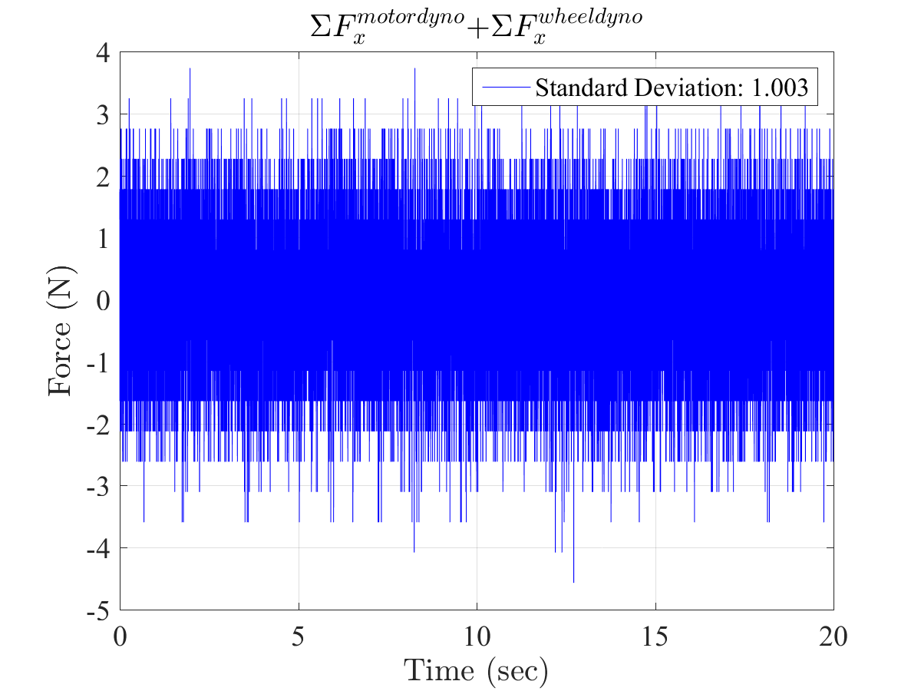

Figure ‑. Accumulative baseline error of both dynamometers in X direction with no motion and wheel drive disabled (*∑Fxmotor dyno + ∑Fxwheel dyno*)

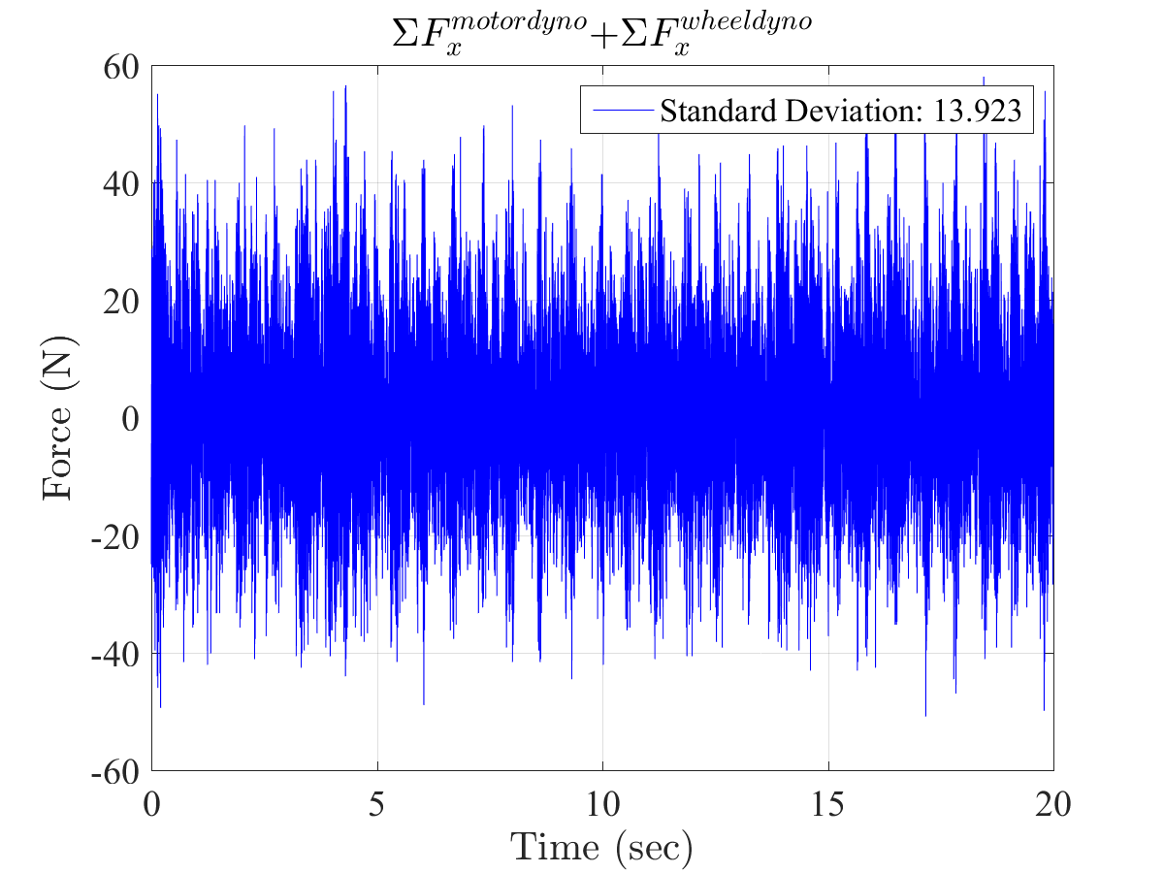

Figure ‑. Accumulative baseline error of both dynamometers in X direction at *91.553rpm* (*∑Fxmotor dyno + ∑Fxwheel dyno*)

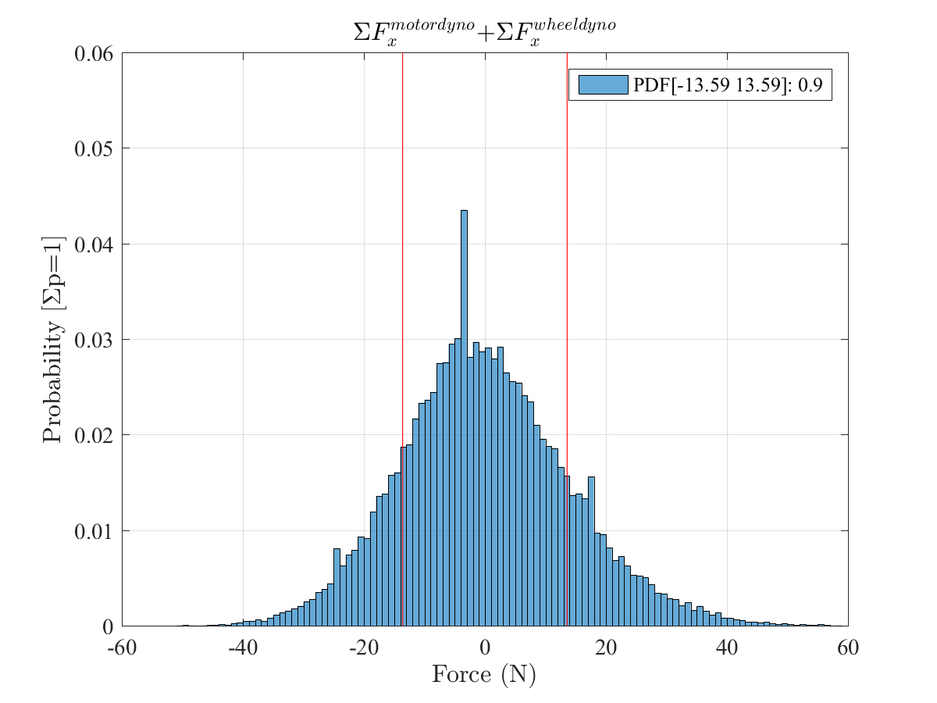

Figure ‑. Force measurement accuracy of both dynamometers in X direction at *91.553rpm with 90% probability band* (*∑Fxmotor dyno + ∑Fxwheel dyno*): *13.59N*

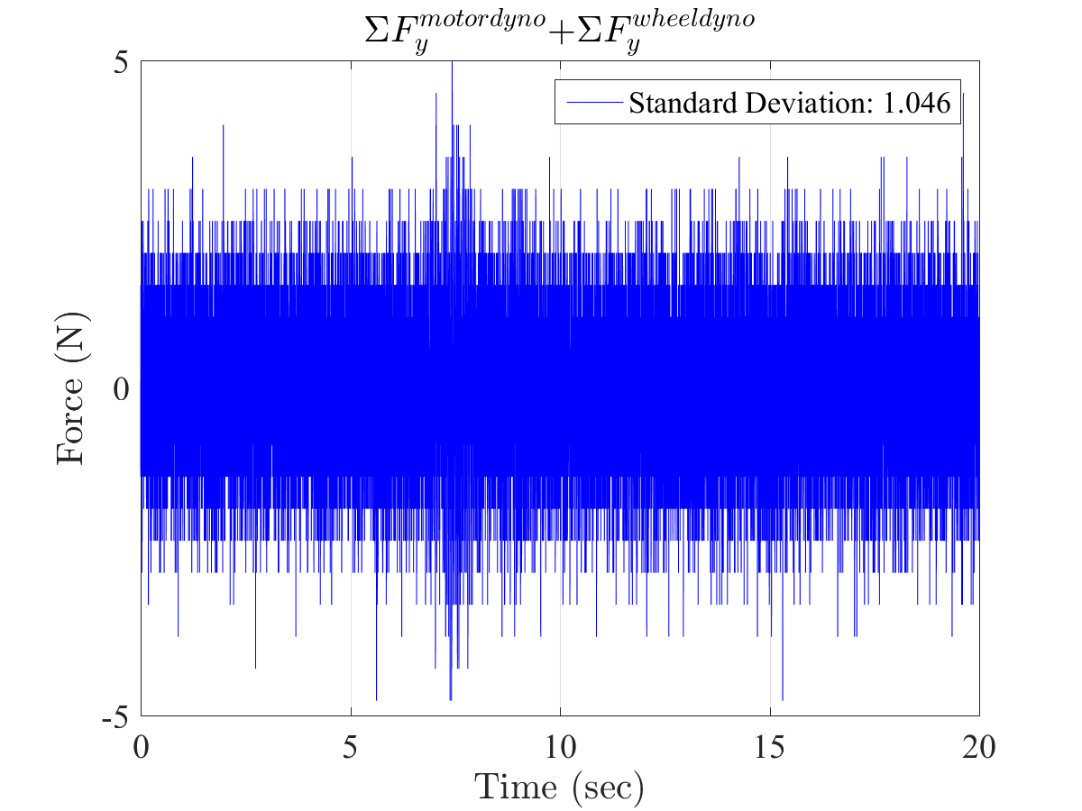

Figure ‑. Accumulative baseline error of both dynamometers in Y direction with no motion and wheel drive disabled (*∑Fymotor dyno + ∑Fywheel dyno*)

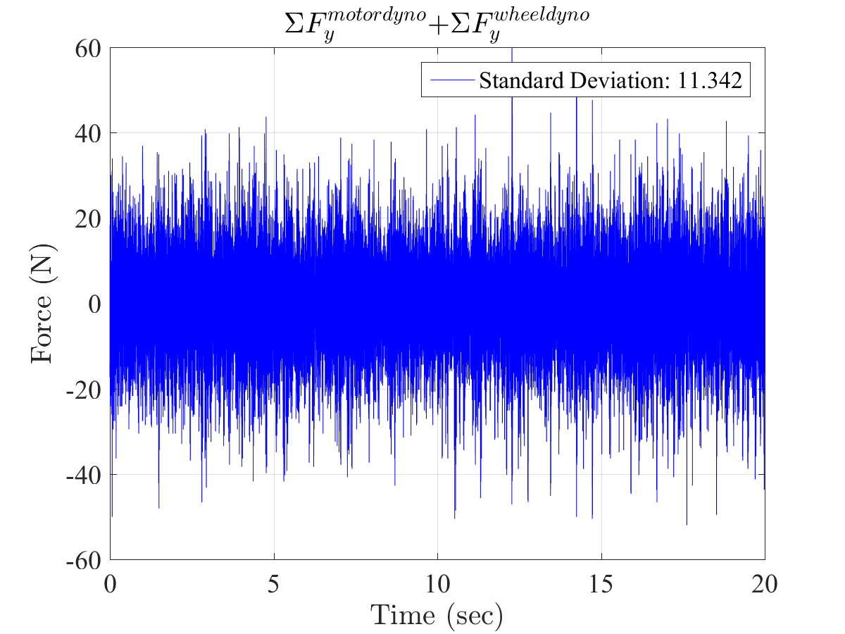

Figure ‑. Accumulative baseline error of both dynamometers in Y direction at *91.553rpm* (*∑Fymotor dyno + ∑Fywheel dyno*)

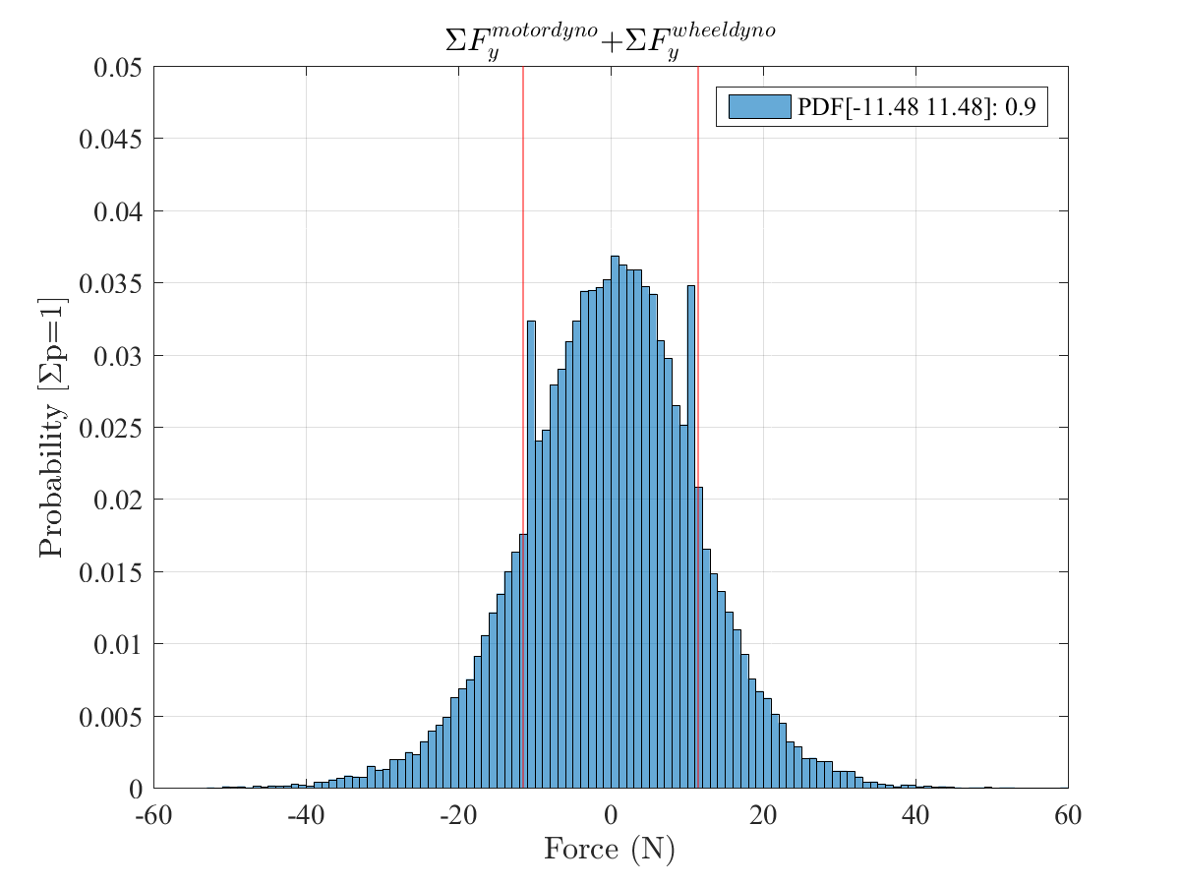

Figure ‑. Force measurement accuracy of both dynamometers in Y direction at *91.553rpm with 90% probability band* (*∑Fymotor dyno + ∑Fywheel dyno*): *11.48N*

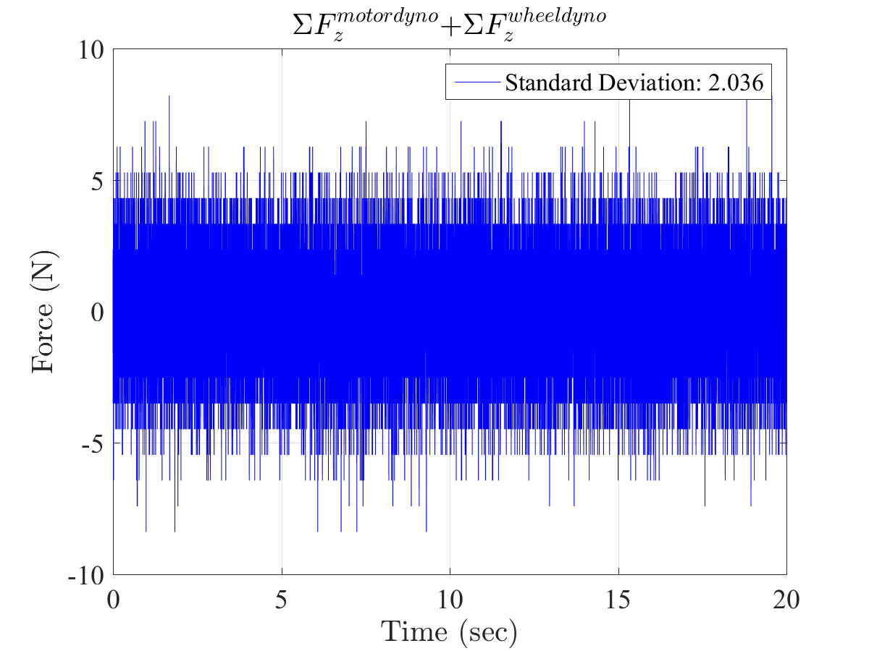

Figure ‑. Accumulative baseline error of both dynamometers in Z direction with no motion and wheel drive disabled (*∑Fzmotor dyno + ∑Fzwheel dyno*)

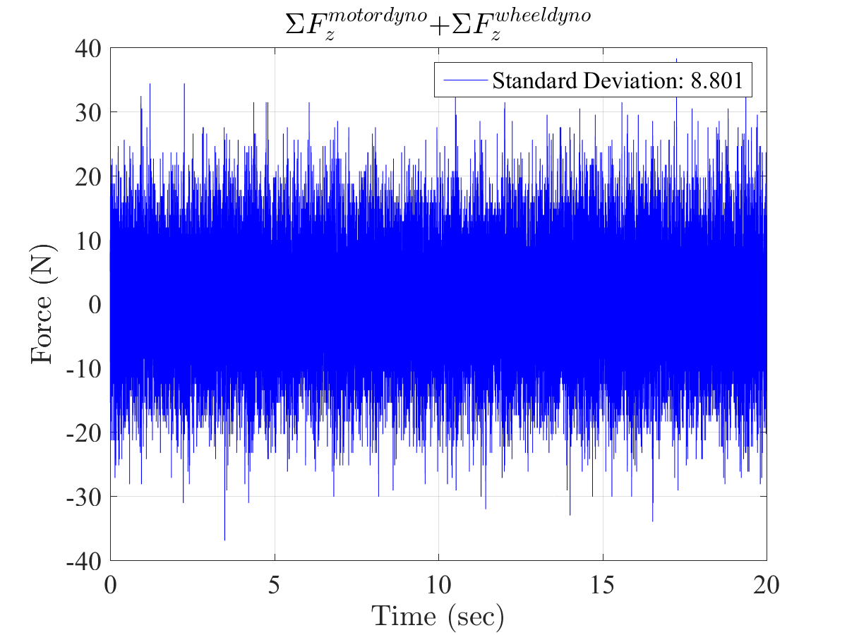

Figure ‑. Accumulative baseline error of both dynamometers in Z direction at *91.553rpm* (*∑Fzmotor dyno + ∑Fzwheel dyno*)

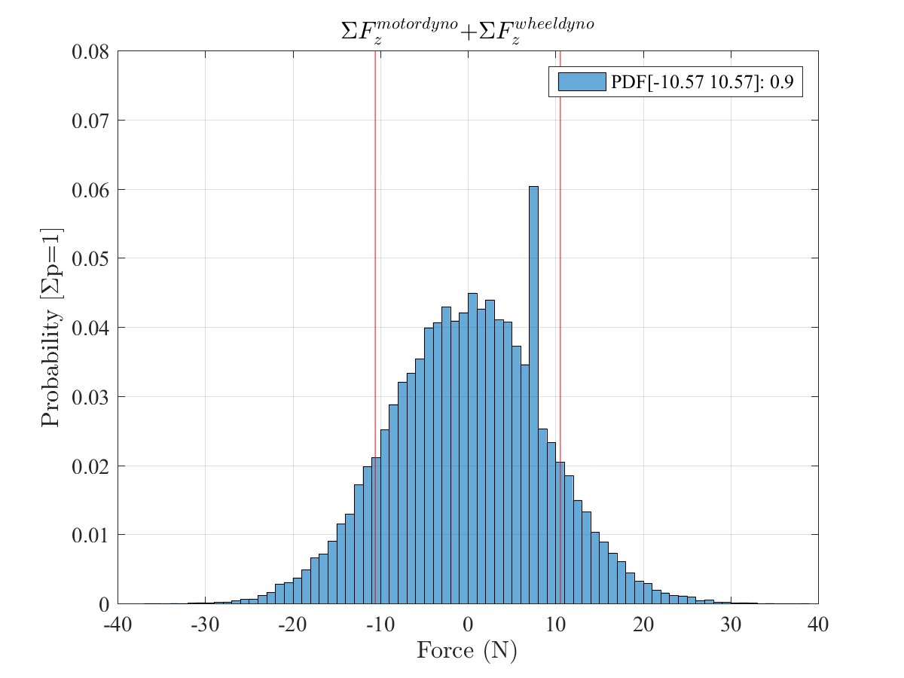

Figure ‑. Force measurement accuracy of both dynamometers in Z direction at *91.553rpm with 90% probability band* (*∑Fzmotor dyno + ∑Fzwheel dyno*): *10.57N*

## Accurate Torque Measurement

A flange torque sensor is embedded in each driveline to measure the instantaneous torque between the rotating bodies and the motor. Each sensor is comprised of two parts: a measurement flange, and an evaluation unit (

Figure ‎4‑55). KiTorq[[6]](#footnote-6) measuring unit (Kistler, Amherst, NY) is used in both drivelines. It measures the torque using strain gauges. The measuring range for the wheel and roller drivelines are 1000Nm and 5000Nm, respectively. The measurement specifications of the KiTorq units are summarized in Table ‎4‑15.

A KiTorq[[7]](#footnote-7) stator torque evaluation unit (Kistler, Amherst, NY) inductively samples the measurements picked up by the strain gages inside the measurement unit at 35 kS/sec. It conditions and amplifies the analog and digital output signals, while powering the measuring unit. The evaluation unit is equipped with an integrated speed-measuring encoder and provides both torque and speed measurements. It provides the same outputs on different digital interfaces. This makes it possible, for instance, to use the output for measuring the torque with a different low-pass filter than a second torque output used for control purposes. It also allows to convert speed into a voltage signal.

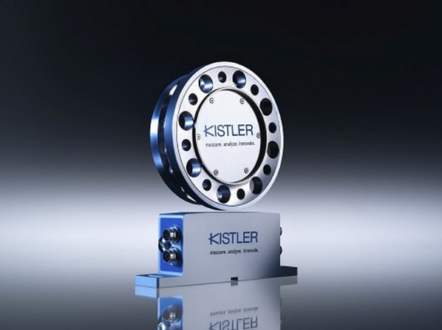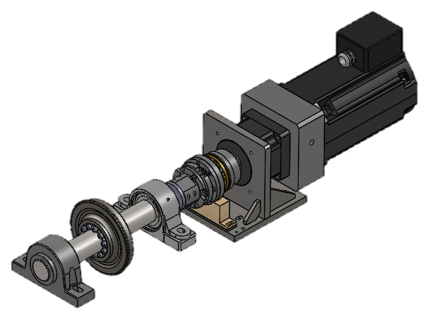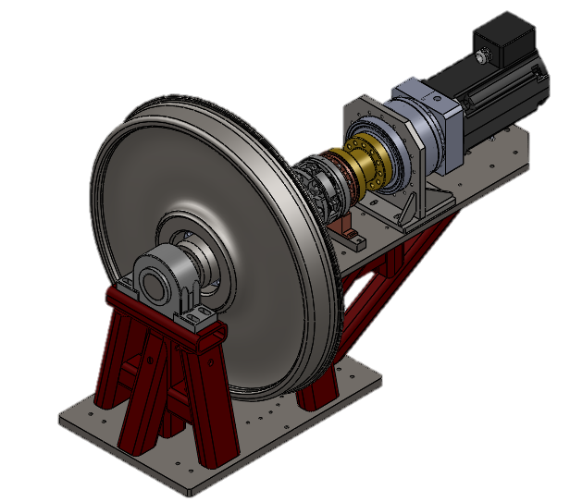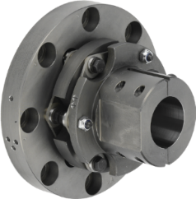

Figure ‑: KiTorq measuring system comprising of a KiTorq measuring flange and a KiTorq stator evaluation unit. Each torque flange is connected to the shaft via a torsion-proof multi-disk coupling [76,77]

Table ‎4‑15: Measurement specification of the Roller Rig torque measuring system (Including a KiTorq-4550A measuring unit and a KiTorq-4542A evaluation unit) [76,78]

|  |  |
| --- | --- |
| Accuracy class | 0.05 |
| Linearity (*% FSO*) | 0.03 |
| Hysteresis (*% FSO*) | 0.03 |
| Limit Frequency -3 dB (*kHz*) | 10 |
| Scanning rate (*kS/Sec*) | 35 |
| Speed resolution (*pulse/rev*) | 60 |
| Speed pulse level | Active TTL |
| Jitter – Oscillation Period (%) | 2 |
| Temperature influence on the zero point TK0 (*% FSO/10k*) | 0.05 |
| Temperature influence on the nominal value TKC (*% FSO/10k*) | 0.05 |

Each flange is connected to the driveline via torsion-proof multi-disk couplings (Kistler, Amherst, NY). These special couplers allow for minor misalignments when incorporating the measuring flange into the shaft assembly. Table ‎4‑16 shows the permissible shaft misalignments in the wheel and roller torque flange couplings. These multi-disc coupling use a two disc assembly to compensate for angular, axial, and radial shaft offsets. If multiple offsets occur simultaneously, they influence one another. The permissible values for displacement are therefore depending on each other. The sum of the actual displacements, in percent of the maximum values, may not exceed 100%. Figure ‎4‑56 illustrates the shaft misalignments and the chart for calculating the maximum value for the third misalignment, if two are known. The dashed blue line depicts an example where the axial offset is 0.16mm that corresponds to 40% of permissible value in the wheel driveline. With an angle offset of 0.06deg, the maximum permissible radial offset will be 30%, or 0.03mm.

Table ‎4‑16. Permitted misalignments in the wheel and roller multi-disk couplings

|  |  |  |
| --- | --- | --- |
|  | Wheel | Roller |
| Permitted axial offset ΔKa (mm) | 0.4 | 0.5 |
| Permitted radial offset ΔKr (mm) | 0.1 | 0.1 |
| Permitted angle offset ΔKw (deg) | 0.2 | 0.2 |

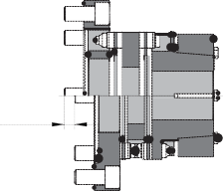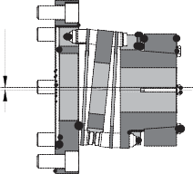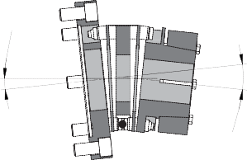

ΔKa

ΔKr

ΔKw

2×ΔKw

Radial offset $∆ K_{r}(\%)$

20

40%

60

80

100

20

40

60

80

100

30%

30%

Axial offset $∆ K_{a}(\%)$

Angular offset $∆ K_{w}(\%)$

Figure ‑. Permissible shaft misalignments in the wheel and roller drivelines [77]

Figure ‎4‑57 and Figure ‎4‑58 show two examples of wheel and roller torque measurements with no motion and drives disabled. Since there is no motion, the motors cannot have any contribution to the noise shown in these two figures. These baseline noises are attributed to the sensor and calculations unit, or the noise picked up by Kistler cables between the summing boxes and charge amplifiers. Figure ‎4‑59 and Figure ‎4‑61 show the same measurements in motion. The difference between the two measurement sets can be attributed to the motor vibrations. Similar to the analysis for velocity control accuracy, the torque measurement accuracy of the VT Roller Rig for the wheel and roller axes in motion using 90% probability band are found 4.94Nm and 6.10Nm, respectively. Figure ‎4‑60 and Figure ‎4‑62 show these probability band measurements. Table ‎4‑17 summarizes these results.

Table ‎4‑17. Torque measurement accuracy of the VT Roller Rig for the wheel and roller axes

|  |  |  |  |
| --- | --- | --- | --- |
| Axis | Baseline standard deviation with no motion and drives disabled | Standard deviation at constant speed (motor contribution) | Measurement accuracy using 90% probability band |
| Wheel | 1.484Nm | 3.874Nm (61.69%) | 4.94Nm |
| Roller | 7.908Nm | 7.951Nm (0.54%) | 6.10Nm |

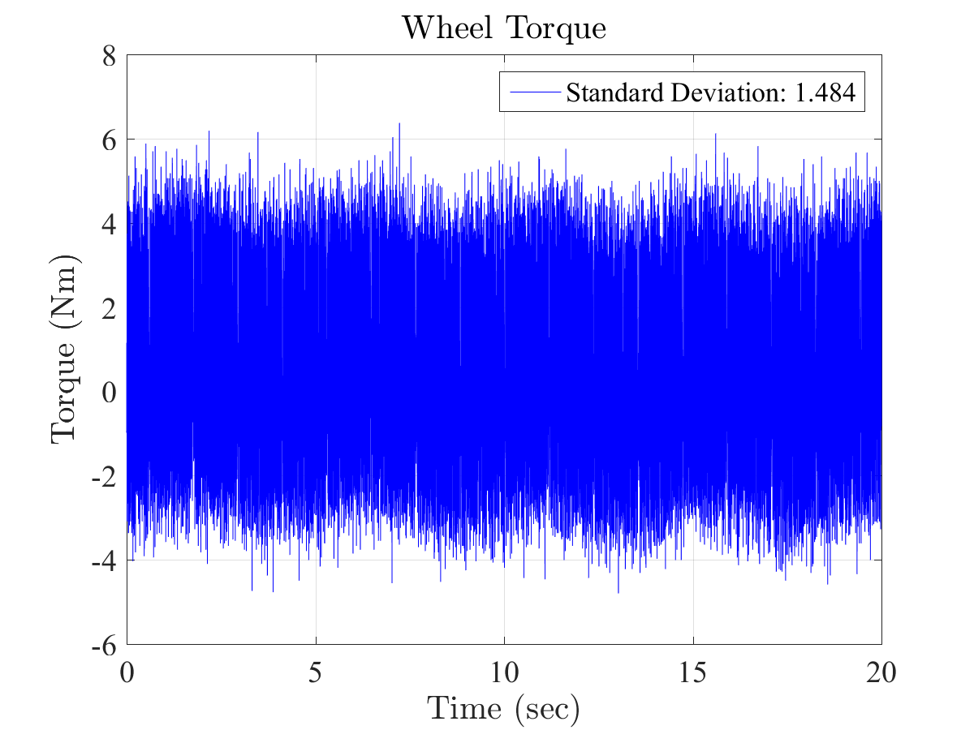

Figure ‑. An example of torque measurements in the wheel axis of the VT Roller Rig (no motion and drive disabled)

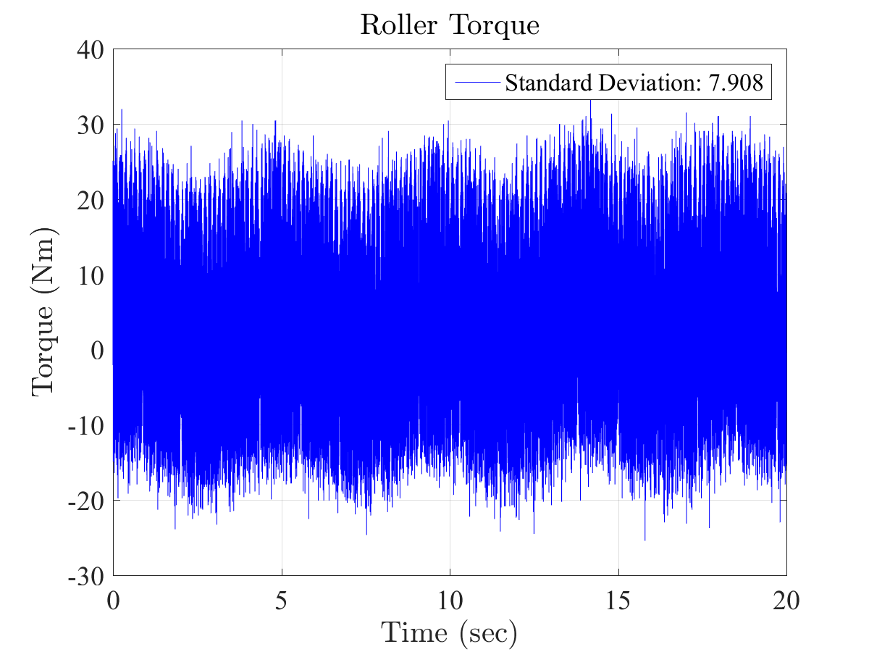

Figure ‑. An example of torque measurements in the roller axis of the VT Roller Rig (no motion and drive disabled)

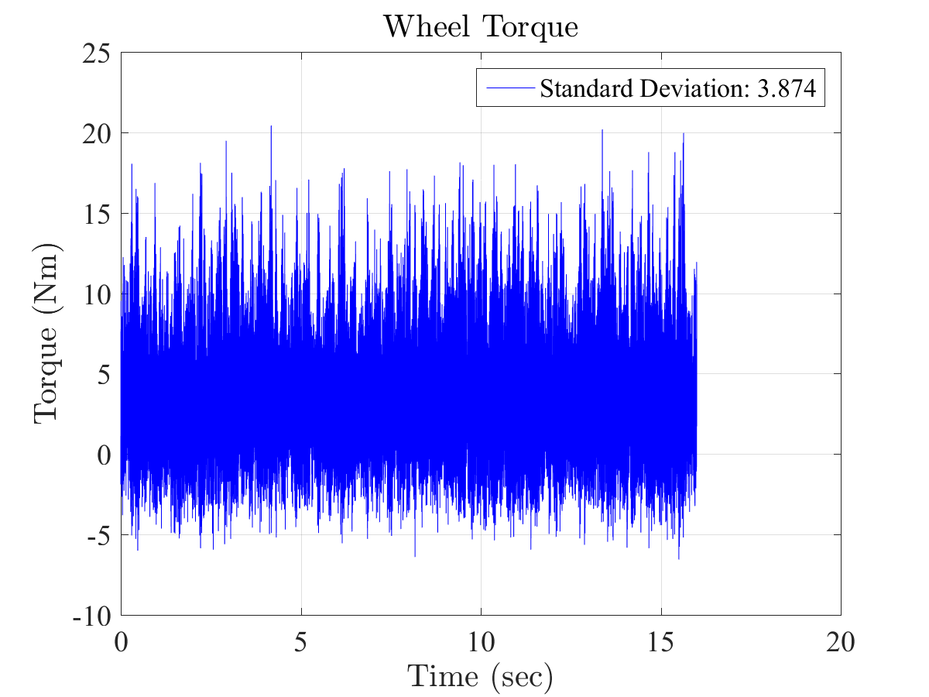

Figure ‑. Wheel torque measurement in the VT Roller Rig at *91.553rpm* constant speed

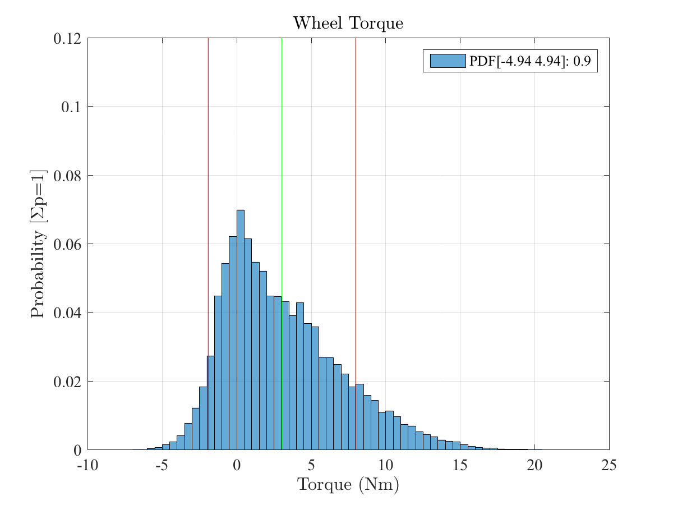

Mean: 3.04Nm

Figure ‑. Torque measurement accuracy of the VT Roller Rig for the wheel axis at *91.553rpm* with 90% probability band: *4.94Nm*

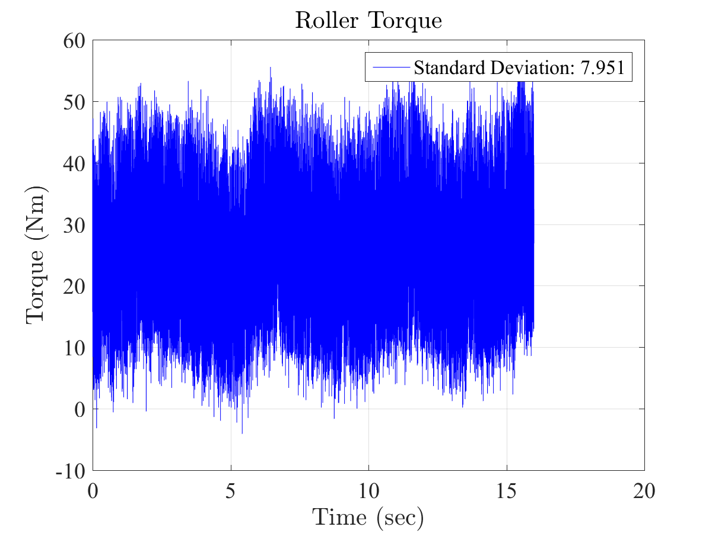

Figure ‑. Roller torque measurement in the VT Roller Rig at *91.553rpm* constant speed

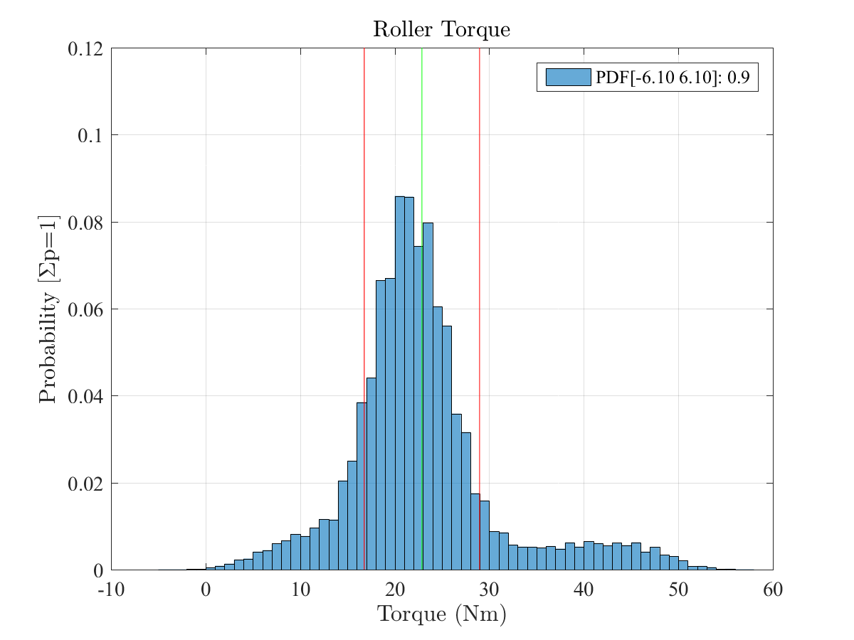

Mean: 22.88Nm

Figure ‑. Torque measurement accuracy of the VT Roller Rig for the roller axis at *51.090rpm* with 90% probability band: *6.10Nm*

## Unified Operating User Interface for Non-Electrically Certified Personnel

The powering scheme of the rig provides 150kVA power for the 200A load of the rig at 480VAC 3-phase. It guarantees the least susceptibility to electromagnetic noise and assures safe operation for the rig and the personnel based on IEC and ISO standards. A control cabinet, shown in Figure ‎4‑63, is configured for providing a unified user interface for control, safety, and power systems. It facilitates the cable management.



Figure ‑: The control cabinet of the rig including S700 drives, AKD drives, regenerative and dynamic brake resistors, safety/control circuits, etc. All the components are placed inside a Faraday cage and are controlled through operator interface panel.

To have the best isolation between the control cabinet including the digital drives, and the rig, a dedicated electronics room, right next to the Roller Rig, is devoted to accommodating the control cabinet and all the safety, and powering elements. The room is equipped with an industrial cooling system for controlling the temperature and humidity of the electronics room.

## Hardware-In-The-Loop Testing Infrastructure

The VT Roller rig provides the required infrastructure for performing hardware-in-the-loop testing for validation of complex railcar dynamics models, traction/braking controllers, and derailment prevention measures in real-time. This study will also include the tasks associated with developing the software tools for connecting commonly used simulation environments to the VT Roller Rig motion control architecture that can be used for future studies that FRA and railroad industry wishes to carry out. A research proposal for HIL testing using the VT Roller Rig is currently submitted to the Federal Railway Administration. It is fully recognized that the studies proposed here do not encompass the complete domain of studies that can be performed on the Rig. Other studies are expected to materialize after the initial studies included here, based on the FRA and industry’s needs. Such studies will form follow-up efforts that can be included in future proposals.

Hardware-in-the-loop testing is a real-time experiment for validating models of complex physical systems. It is a well-known procedure in other fields such as automotive and aerospace [79] It is ideal for the design and test of complex equipment such as traction and braking systems, active steering controllers, and active tilting algorithms. Much of the test environment is replaced with mathematical models. For unknown complex physics, such as contact mechanics, the system is replaced with a controlled test setup. HIL allows for comparing the performance of models against actual measurement in real-time to calibrate parameters, find singularities in models, and develop smarter models. HIL has significant benefits in measuring the performance of controllers. HIL testing shows how the controller responds, in real-time, to realistic virtual stimuli. Without HIL, validation of controllers involves using the actual complex system in the field. Using precise test setups, HIL testing offers benefits in cost and practicality.

There are several areas in which HIL testing offers safety and cost saving over field testing. HIL testing is significantly safer when it comes to testing hazardous conditions. Design changes are considerably less expensive using HIL. Finding problems before field implementation includes these benefits:

1. Testing and diagnostics are less expensive
2. Controlled laboratory environment minimizes the safety risks
3. Design changes are more likely to be approved

Regarding scheduling, HIL testing is less expensive and more practical than field testing because it can be set up to run on its own. Benefiting from the safety systems embedded in the VT Roller Rig, the HIL can be adjusted to improve itself iteratively. HIL testing is the most reliable means for testing a dynamic system’s response to unusual events. For example, it is possible to model extreme weather conditions like earthquakes and blizzards, or abnormal working conditions due to damaged components caused by natural causes or terrorism. The laboratory setting will provide for precise measurements of the software and hardware performance in real-time, thereby enabling us to achieve the earlier-stated goals of the study.

The work will be performed by the Virginia Polytechnic Institute and State University (VT) that is in the final stages of commissioning a new wheel/rail test Rig to enhance the government’s capability to study wheel/rail contact interaction. The Rig also provides experimental tools to the government to study the effects of the various wheel and rail profiles on wheelset and truck performance, and the elements that can cause a derailment.

To meet the objectives of HIL research program, the work that is proposed here will continue the efforts that are underway at VT. Specifically, VT needs to perform the following tasks during this project:

1. HIL Workflow: VT can provide a hardware-in-the-loop workflow that combines new numerical solvers and software tools with Rig’s digital communications, data acquisition, instrumentation and motion control. It describes how the Rig will be utilized to simplify development and design processes for complex systems as well as their testing and validation.
2. Developing Modeling Libraries: VT can develop libraries in MATLAB and a common programming language like C or C++ for connecting complex dynamic models to the motion control of the Roller Rig. The modeling libraries are important because they will provide the basis for interfacing existing third-party software with existing hardware at the Virginia Tech. Once developed, these libraries can be used as elements of future HIL tests that the government or railroad industry wish to perform.
3. Assessing HIL Areas of Research: VT can prepare a white paper on the key opportunities for HIL testing of ongoing researches in railroad systems and controllers that are compatible with the tools developed in ‎2. One key area of research is how to achieve numerical solutions of existing wheel/rail contact models at sufficient speed for real-time applications. Other possible topics of research are:

* Real-time software for rail vehicle dynamics
* Real-time testing in conjunction with multibody simulation software
* HIL prototyping of complex systems and their components
* Test automation processes based on HIL
* Real-time simulation of rail geometry for better ride comfort
* Communication interfaces between software and hardware products

1. HIL Testing: VT will perform HIL testing in one area of research in ‎3 based on FRA’s feedback using the tools developed in ‎2. The validity of the models will be checked versus realistic results of the Roller Rig to calibrate the model parameters. Controller’s response to desired disturbances will be measured to allow for real-time tuning. If required, closed-loop HIL-tests will be set up to perform reinforced learning on the models or controllers for smarter optimization.
2. Verification of HIL Results: VT will verify the validity of the HIL testing results through running cases that can be crossed check with analytical data or, possibly, field measurements. Any sources of error will be identified, and steps will be taken to eliminate or reduce errors. Particular attention will be paid to standardizing the developed modeling libraries for future HIL testing on the VT Roller Rig in other areas of research that the FRA or railway industry wish to perform.

# Realizable Tests with the Virginia Tech Roller Rig

The wheel-rail contact mechanics and dynamics is one of the most complex aspects of railroading. Although there is a broad, high-level understanding of *what* happens at the wheel-rail interface, much of the science behind *why* it happens is lacking. The Roller Rig that is designed and fabricated by the Virginia Tech’s Railway Technologies Laboratory (RTL) is intended to provide a better understanding of the physics of the wheel-rail interface through its unique electro-mechanical configuration and highly precise instrumentation. Some of the studies that are possible with the Roller Rig include:

## Precise Measurement of Creep-Creepage Curves

This includes measuring the:

* Influence of angle-of-attack (AoA), rail cant angle, and rail lateral shift
* Velocity-dependent coefficient of friction

The test rig is capable of controlling the differential speed (creepage) at the wheel-rail interface with a high level of precision. Also, a novel force measurement system is configured to accurately read the contact (creep) forces and moments. Therefore, the rig is capable of conducting precise creepage-creep studies both on straight and curved tracks, for developing new models or improving the existing ones. The contact studies will be generalized to investigate the effect of angle of attack, cant angle, and a lateral shift in creep models. The rig will also shed more light on the spin creepage studies, and creep forces due to spin creepage.

Furthermore, the rig will allow verifying theories related to velocity-dependent friction coefficient. In particular, the falling friction phenomenon (friction forces reducing at higher speeds) could be investigated extensively. Since both the rotating bodies (wheel and roller) are actively controlled, both positive and negative creepage values could be studied, and the resulting creepage-creep curves could be compared.

## Accurate Measurement of Contact Geometry

The test rig can accurately measure the wheel-rail contact geometry to a high degree of precision that surpasses all other rigs that currently exist, worldwide. It is equipped with a state-of-the-art vision system that can provide a precise image of the interface between the wheel and rail. This high-definition imaging system is capable of precisely investigating the contact geometry using advanced image-processing methods and extracting measurements from every frame. Therefore, the area and shape of the contact patch could be recorded at every instant in time. The major and minor axes for the elliptical contact patch can then be measured from the recorded data. This also enables studying the conditions under which double-point contact occurs. Other sensory measurements will be synchronized with the vision data to accurately measure the resulting forces from the single- or double-point contact geometry.

## Precise Evaluation of Third Body Layers

Third body layers refer to any material that is placed in between the wheel and rail interface as a third layer to the wheel and rail surface. This includes:

* Friction modifier
* Surface conditioning elements, such as water, oil, sand, leaves, etc.

The test rig can accommodate the equipment necessary for studying the effect of surface condition and friction modifiers. The rig is also capable of studying the characteristics of surface roughness and different interfacial layers at the wheel-rail contact surface, to an accuracy that is unmatched among any other equipment that is currently in existence. Other aspects of the wheel-rail contact dynamics that can be measured precisely include the slope reduction phenomenon in contact curve models and wheel/rail damage due to a contaminant at the interface.

## Dynamic Creepage Analysis

The test rig is capable of performing a full range of dynamic creepage studies that will allow the scientists and engineers to get a better understanding of many of the fundamental aspects of the wheel-rail contact physics. The unique design that is used for the rig enables easily controlling the cant angle, the angle of attack, and lateral displacement, among other critical parameters. A state-of-the-art instrumentation system provides precise measurement of the forces and moments that occur as a result of the changes. This enables accurately measuring the key aspects of wheel-rail dynamics that have not been studied in the past (due to limitations of the previous roller rigs), such as the time-varying spin creepage (an important factor in the generation of squeal noise) and effect of wheel speed on traction forces.

## Wheel-rail Vibration Analysis

The stick-slip dynamics at the wheel-rail interface can result in excessive wheel/rail wear, and noise and vibrations that are difficult to measure in the field. This applies in particular at high AoA, high adhesion, and flanging conditions. The strategic instrumentation of the rig provides for scientific analysis of this phenomenon to unmatched accuracies, specifically as it relates to:

* Vibration analysis of wheel and rail
* Longitudinal and lateral contact stiffness

Different stick-slip conditions can be emulated for performing lateral, longitudinal, and rotational vibration analyses. The test rig has a provisional design for installing multiple accelerometers for studying wheel-roller vibrations. Modal analysis studies for finding the natural frequencies can also be conducted. The accurate load cell platform of the rig also allows for precisely measuring the lateral and longitudinal contact stiffness of the wheel.

## Wheel-Rail Wear Analysis

Wear is a major source of concern to the U.S. railroads and their suppliers because of its high economic impact and also the effect it has on the efficient operation of rolling stock. Better understanding of

* Rolling contact fatigue (RCF)
* Plastic flow of material under high traction, high loads

will shed light on better understanding the causes and remedies of wear at the wheel-rail interface. The unique design of the rig and the ability to precisely change the wheel-rail contact conditions enables performing design of experiments that are necessary for better understanding wear in more realistic conditions, as compared with abstract equipment such as four-ball test machines that are often used.

The design of the rig enables accurately studying the effect of various parameters including loading, adhesion coefficient, the angle of attack, flanging, etc. The results of such studies will lead to better rail safety and also allow the U.S. railroads to optimize their maintenance practices for reducing total life cycle costs. Other wear effects such as rail corrugation and wave-like wear at the top of the rail can also be analyzed regarding their formation mechanisms and influence of the key parameters. Mechanisms by which RCF-induced cracks initiate and grow, which are strongly related to wheel and rail wear, can also be determined by a state-of-the-art vision system that is installed on the rig. The vision system will also allow for studying other effects, including the plastic flow of material at the contact patch.

## Derailment Mechanics

Benefiting from the modern force, torque, acceleration, and displacement sensors, the Virginia Tech’s Roller Rig enables investigating the dynamics of the wheel prior, during, and after the derailment. Because it is possible to control the wheel-rail relative motion and constraints in real time, the rig allows studying

* Derailment coefficient
* Wheel-climb derailment

Each parameter can be changed precisely and its effect on the forces and moments that cause derailment will be explored. Such design of experiments will allow scientists and practitioners get a better understanding of some of the track and wheel conditions that can result in derailment.

## Hardware-in-the-loop (HIL) Operation

One of the unique aspects of the Roller Rig is the ability to perform Hardware-in-the-Loop (HIL) studies. This allows merging the rig with rail vehicle dynamic simulation models, to bring an unprecedented level of accuracy to the models. HIL allows using the rig in synchronization with rail vehicle simulation models, such that the output of the rig becomes the input to the model and, conversely, the output of the model serves as input to the rig. HIL represents the state of the art in representing complex dynamics, such as wheel-rail interface, in high-fidelity simulation models. This effort will be the first of its kind in rail vehicle dynamics modeling and testing, to the best of our knowledge.

The immediate benefits of HIL are research and engineering development in

* Advanced train control algorithms
* Traction and braking studies

A unified communication protocol between actuators, drives, and data acquisition system eliminates data conversion between these units; hence, facilitating online high-speed measurements and control. The rig will serve as a unique platform for studying advanced train control algorithms, whereby instantaneous measurements from the rig are fed into the analytical model of the entire train to control the motion of the wheel about the rail in real time. The state-of-the-art measurement and control network used in the rig makes the sense-to-act process as fast as the sensors’ update rate.

# References

[1] Kumar S, Alzoubi MF, Allsayyed N a. Wheel/rail adhesion wear investigation using a quarter scale laboratory testing facility. Proc 1996 ASME/IEEE Jt Railr Conf n.d.:247–54. doi:10.1109/RRCON.1996.507984.

[2] Hosseinipour M, Meymand SZ, Craft MJ, Ahmadian M. Modeling of a roller rig for evaluation of wheel/rail contact mechanics. Proc. 2014 Jt. Rail Conf., Colorado Springs, CO, USA JRC2014-3842: 2014.

[3] Meymand SZ, Hosseinipour M, Ahmadian M. Development of a roller rig for experimental evaluation of contact mechanics for railway vehicles. Proc. 2015 Jt. Rail Conf., San Jose, CA: 2015.

[4] AirLoc Schrepfer. AirLoc Schrepfer Catalogue. 2016.

[5] Langdon JD. Design and Adaptive Control of a Lab-based, Tire-coupled, Quarter-car Suspension Test Rig for the Accurate Re-creation of Vehicle Response n.d.

[6] THK Ltd. THK General Catalogue - Linear Motion Systems. 2016.

[7] Hosseinipour M, Meymand SZ, Ahmadian M. Vibration Analysis for Improving Powertrain Design and Contact Measurements of a Roller Rig. 2015 Jt. Rail Conf., ASME; 2015, p. V001T10A002. doi:10.1115/JRC2015-5622.

[8] Kollmorgen Corporation. Kollmorgen AKM Servomotor Selection Guide with AKD Servo Drive Systems 2013:17–54.

[9] Kollmorgen. Digital Servo Amplifier S748 to S772 Instruction Manual. 2015.

[10] Mijno Precision Gearing. Mijno Catalogue. 2016.

[11] Thomson. TRUE PlanetaryTM Gearhead Installation Manual. 2010.

[12] SKF. SKF Roller Bearings Catalogue. 2016.

[13] AREMA. Manual for Railway Engineering. 2010.

[14] Fenner Drives. Fenner Drives Product Catalog. 2016.

[15] Kollmorgen Linear Positioners Catalog. 2014.

[16] Kollmorgen. ServoStar 600 Instructions Manual. 2010.

[17] International Electrotechnical Commission. IEC 60364. 2005.

[18] International Electrotechnical Commission. IEC 61800. 2015.

[19] Apalachian Power Company. Guide for Electric Service and Meter Installation 2014. https://www.appalachianpower.com/global/utilities/lib/docs/builders/meter/WV\_Guide\_to\_Electric\_Service.pdf (accessed May 17, 2016).

[20] American Electric Power. Requirements for Connection of New Facilities or Changes to Existing Facilities Connected to the AEP Transmission System 2014. https://www.aep.com/about/codeofconduct/OASIS/TransmissionStudies/Requirements/AEP\_Interconnection\_Requirements\_Rev1.pdf (accessed May 17, 2016).

[21] Aoyama T, Shibata Y, Kanie T, Noro Y, Takeo T. Adaptive Compensation Method for the Temperature Dependence of RF Transformer Isolation. J Int Counc Electr Eng 2012;2:358–63. doi:10.5370/JICEE.2012.2.4.358.

[22] Eaton. K-Factor transformers for low voltage electrical harmonics n.d. http://www.eaton.com/Eaton/ProductsServices/Electrical/ProductsandServices/ElectricalDistribution/Transformers/LowVoltageDry-TypeDistribution/K-Factor/ (accessed May 17, 2016).

[23] Schaffner. 3-Phase Filters FN 258 Book-style EMC/RFI Filter for Inverters and Power Drive Systems. n.d.

[24] Phoenix Contact. Quint-UPS/24dc/24dc/40. 2011.

[25] Stephens L. Wiring and Cabling Guideline & Specifications. 2012.

[26] Caniggia S, Maradei F. SPICE-Like Models for the Analysis of the Conducted and Radiated Immunity of Shielded Cables. IEEE Trans Electromagn Compat 2004;46:606–16. doi:10.1109/TEMC.2004.837841.

[27] Ott HW. Ground - A Path for Current Flow 1979:167–70.

[28] Stephens L. Grounding and Shielding Existing Equipment. Kollmorgen White Pap 2012:1–6.

[29] Pelleymounter D. Practical Instructions for Proper Grounding. Adv Energy Ind Inc White Pap 2013.

[30] Rich A. Shielding and Guarding APPLICATION NOTE. Analog Devices 1983;AN-347:1–6.

[31] González Arteche FJ. EMC: A mapping for the CMS experiment. Oviedo U., 2004.

[32] Paul CR. The concept of dominant effect in EMC. IEEE Trans Electromagn Compat 1992;34:363–7. doi:10.1109/15.155857.

[33] Kollmorgen. Calculation of brake power n.d.

[34] Bross R. Calculation of Deceleration Time and Angular Displacement in a D-C Motor with Dynamic Braking, Technical note: TN-33. n.d.

[35] Ott HW. Noise reduction techniques in electronic systems. 1988.

[36] Schlicke HM. Electromagnetic compossibility: applied principles of cost-effective control of electromagnetic interference and hazards. New York : M. Dekker,; 1982.

[37] Kaiser KL. Electromagnetic Compatibility Handbook. 2004.

[38] Mardiguian M. Controlling radiated emissions by design. Van Nostrand Reinhold; 1992.

[39] Analog Devices I. Shielding and Guarding: How to Exclude Interference-Type Noise Application Note (AN-347) 2014:1–6.

[40] Commission USFC. Interference handbook. Federal Communications Commission; 1990.

[41] Kerkman RJ. Twenty years of PWM AC drives: when secondary issues become primary concerns. Proc. 1996 IEEE IECON. 22nd Int. Conf. Ind. Electron. Control. Instrum., vol. 1, IEEE; n.d., p. LVII – LXIII. doi:10.1109/IECON.1996.570890.

[42] Skibinski GL, Kerkman RJ, Schlegel D. EMI Emissions of Modern PWM AC Drives. IEEE Ind Appl Mag 1999;5:0–10. doi:10.1109/2943.798337.

[43] Kollmorgen Corporation. AKD, AKD BASIC, and AKD PDMM Installation Manual. 2013.

[44] Licari JJ. Coating Materials for Electronic Applications: Polymers, Processing, Reliability, Testing. William Andrew; 2003.

[45] Tong XC. Advanced Materials and Design for Electromagnetic Interference Shielding. vol. 19. CRC Press; 2008.

[46] Monk P. Finite Element Methods for Maxwell’s Equations. Clarendon Press; 2003.

[47] Robinson MP, Benson TM, Christopoulos C, Dawson JF, Ganley MD, Marvin a. C, et al. Analytical formulation for the shielding effectiveness of enclosures with apertures. IEEE Trans Electromagn Compat 1998;40:240–8. doi:10.1109/15.709422.

[48] Popovic ZPBD. Introductory Electromagnetics. 2000.

[49] Johnson WC. Transmission lines and networks. McGraw-Hill; 1950.

[50] Matheson M. SynqNet: high performance motion control based on Ethernet. Comput Control Eng 2004;15:32–8.

[51] Cline D, Mitchell JA, Pearce R. Method and system for removing and returning nodes in a synchronous network. US8072999 B1, 2011.

[52] Wilson D, Boulanger R, Feng X. The NEES geotechnical centrifuge at UC Davis. World Conf … 2004.

[53] Cline D, Mitchell JA, Pearce R. Method and system for scheduling, transporting, and receiving inbound packets efficiently in networks with cyclic packet scheduling. US7969985 B1, 2011.

[54] Pearce R, Cline D. System for motion control, method of using the system for motion control, and computer-readable instructions for use with the system for motion control. US20020110155A1, 2001.

[55] Kollmorgen Corporation. QMP SynqNet TM Controller Quick Start Guide. 2012.

[56] Freescale. QorIQ P2010 and P2020 Processors Brochure. 2016. doi:QP20XXFS REV 4.

[57] Kollmorgen Corporation. AKDTM SynqNet Communication. 2012.

[58] Motion Engineering Inc. SQIO Overview n.d. http://support.motioneng.com/Hardware/IO/SQIO/overview.htm (accessed June 25, 2016).

[59] Motion Engineering Inc. SynqNet I/O Hardware n.d. http://support.motioneng.com/Hardware/IO/SQIO/default.htm (accessed June 25, 2016).

[60] Motion Engineering Inc. MPI Software Guide. 2006.

[61] Motion Engineering Inc. Motion Console User Guide. 2005.

[62] Motion Engineering Inc. MPX Quickstart Guide for LabVIEW. 2002.

[63] Kollmorgen Corporation. Optimize Motion Performance Improve Mechanical Performance, Quickly and Easily with MechaWareTM . 2009.

[64] Motion Engineering Inc. MechaWare Overview 4.02 (beta) n.d. http://support.motioneng.com/Software-Mechaware\_04\_02/default.htm (accessed June 25, 2016).

[65] Motion Engineering Inc. XMP Seires Quick Start Guide. 2001.

[66] Motion Engineering Inc. Bode Tool 04.00 n.d. http://support.motioneng.com/Utilities/Bode/default.htm (accessed June 25, 2016).

[67] Motion Engineering Inc. SynqNet Cable Length n.d. http://support.motioneng.com/Technology/SynqNet/cable\_length.htm (accessed June 25, 2016).

[68] Motion Engineering Inc. Should I Use PID or PIV? n.d. http://support.motioneng.com/Downloads-Notes/Tuning/pid\_or\_piv.htm (accessed June 25, 2016).

[69] Hahn W. Stability of Motion. Berlin, Heidelberg: Springer Berlin Heidelberg; 1967. doi:10.1007/978-3-642-50085-5.

[70] Kaiser D, Compumotor P. Fundamentals of servo motion control. Park Compumotor 2001.

[71] Zhou K, Doyle J, Glover K. Robust and optimal control. 1996.

[72] Motion Engineering Inc. PID Algorithm and D-Rate n.d. http://support.motioneng.com/Downloads-Notes/Tuning/pid\_drate.htm (accessed June 25, 2016).

[73] Motion Engineering Inc. Scaling PID Tuning Parameters for Different Controller Sample Rates n.d. http://support.motioneng.com/Downloads-Notes/Tuning/scaling\_pid\_param.htm.

[74] Kistler. 3-Component Quartz Force Sensor 9028. 2013.

[75] Kistler. Multichannel Charge Amplifier 5070A. 2010.

[76] Kistler. KiTorq Rotor Torque Measuring Unit (Rotor) 4550A. 2012.

[77] Kistler. Torsion Proof Multi-Disk Coupling 2305A. 2012.

[78] Kistler. KiTorq Stator 4542A. 2011.

[79] Qi C, Zhao X, Gao F, Ren A, Sun Q. Contact stiffness and damping identification for hardware-in-the-loop contact simulator with measurement delay compensation. Acta Astronaut 2016;123:171–80. doi:10.1016/j.actaastro.2016.03.013.

1. A trademark of Motorola [↑](#footnote-ref-1)
2. The EEPROM (U801) is a 2kbit memory that is used to hold certain data required for the correct start-up of the network. [↑](#footnote-ref-2)
3. Type 9027C and 9028C [↑](#footnote-ref-3)
4. Type 5417 [↑](#footnote-ref-4)
5. Type 5070A [↑](#footnote-ref-5)
6. Type 4550A [↑](#footnote-ref-6)
7. Type 4542A [↑](#footnote-ref-7)